
• Character, Grade II Listed House with Garth
• Spectacular Views
• 3 Double Bedrooms
• Bathroom
• 2 Reception Rooms & Kitchen\Diner
• Washhouse/Store
• Garden & Patio to Front
• Ample Parking & Lean-to Store
• Modernisation Required
• Popular Village Location
• 6.5 Acres Of Land Available To Rent
Postcode: DL8 3TD

Tenure: Freehold

Council Tax Band: E

Energy Efficiency Band: EPC Exempt

Local & Planning Authority:
North Yorkshire Council
Guide Price: £435,000 - £450,000
Town End Farm, Newbiggin In Bishopdale
J. R. Hopper & Co. is a trading name for J. R. Hopper & Co. (Property Services) Ltd. Registered: England No. 3438347.
Registered Office: Hall House, Woodhall, DL8 3LB. Directors: L. B. Carlisle, E. J. Carlisle
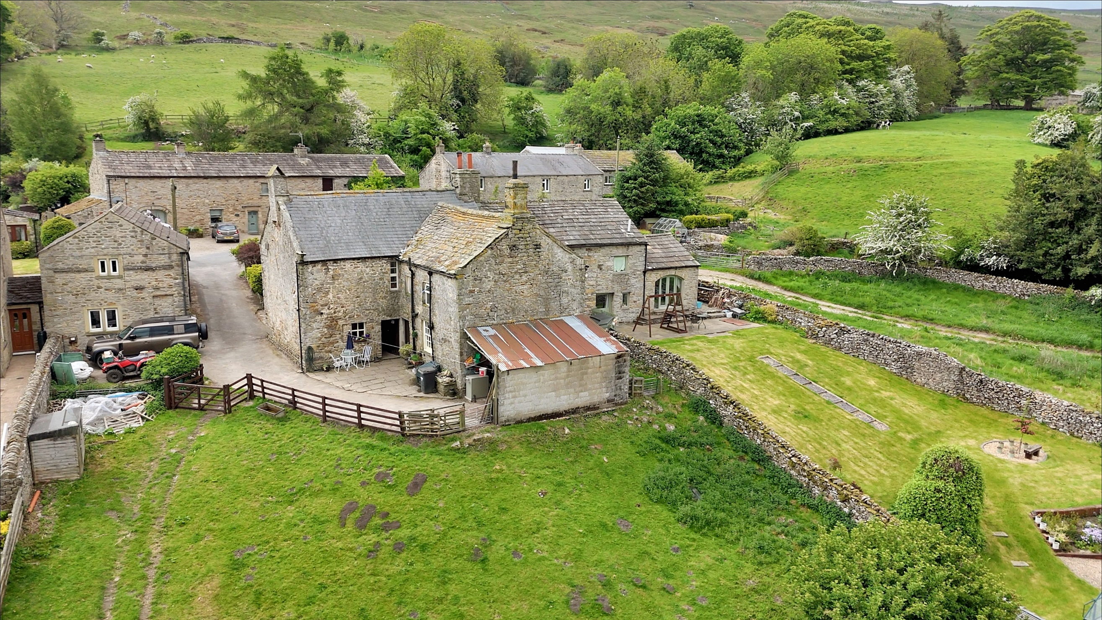
“For Sales In The Dales”
EST. 1886
Central Chambers
Market Place
Leyburn
North Yorkshire
DL8 5BD
Leyburn
Hawes
Settle
Kirkby Stephen
01969 622936
01969 667744
01729 825311
01768 258002
& Co.
www.jrhopper.com enquiries@jrhopper.com
J.R. HOPPER
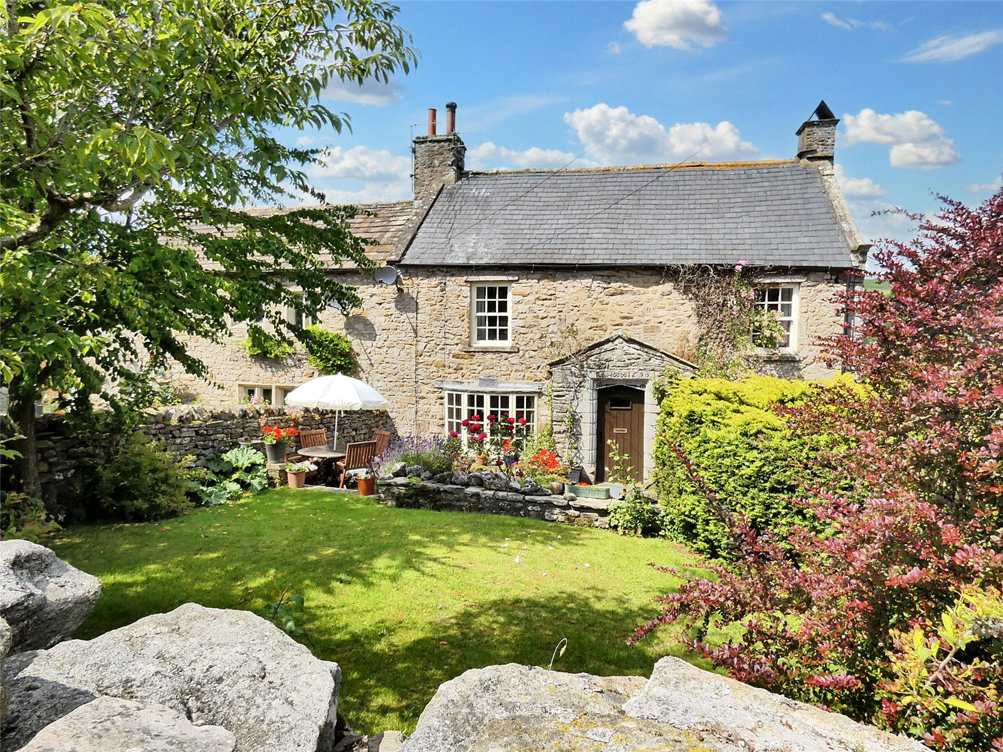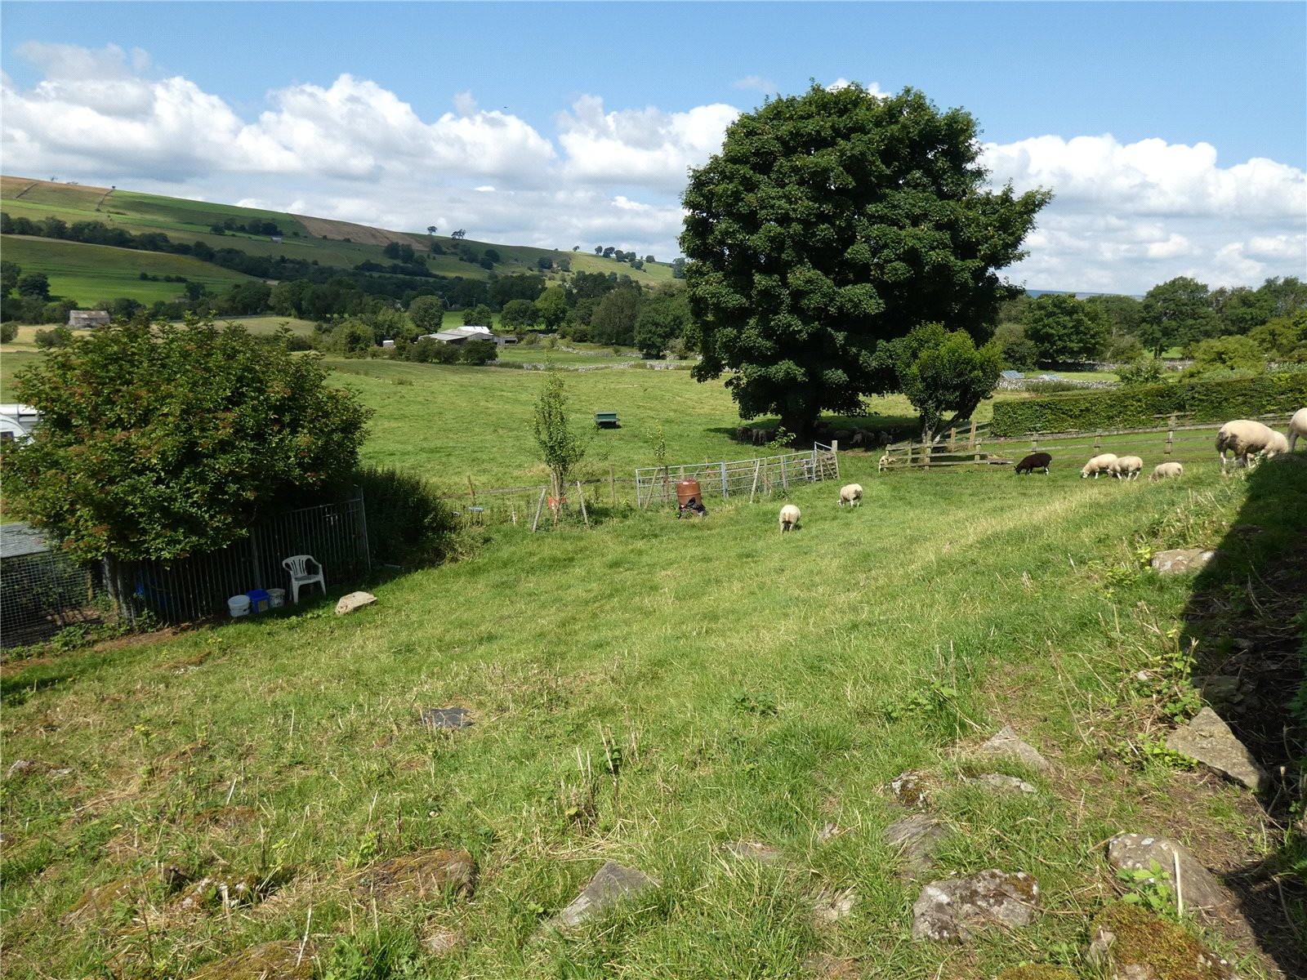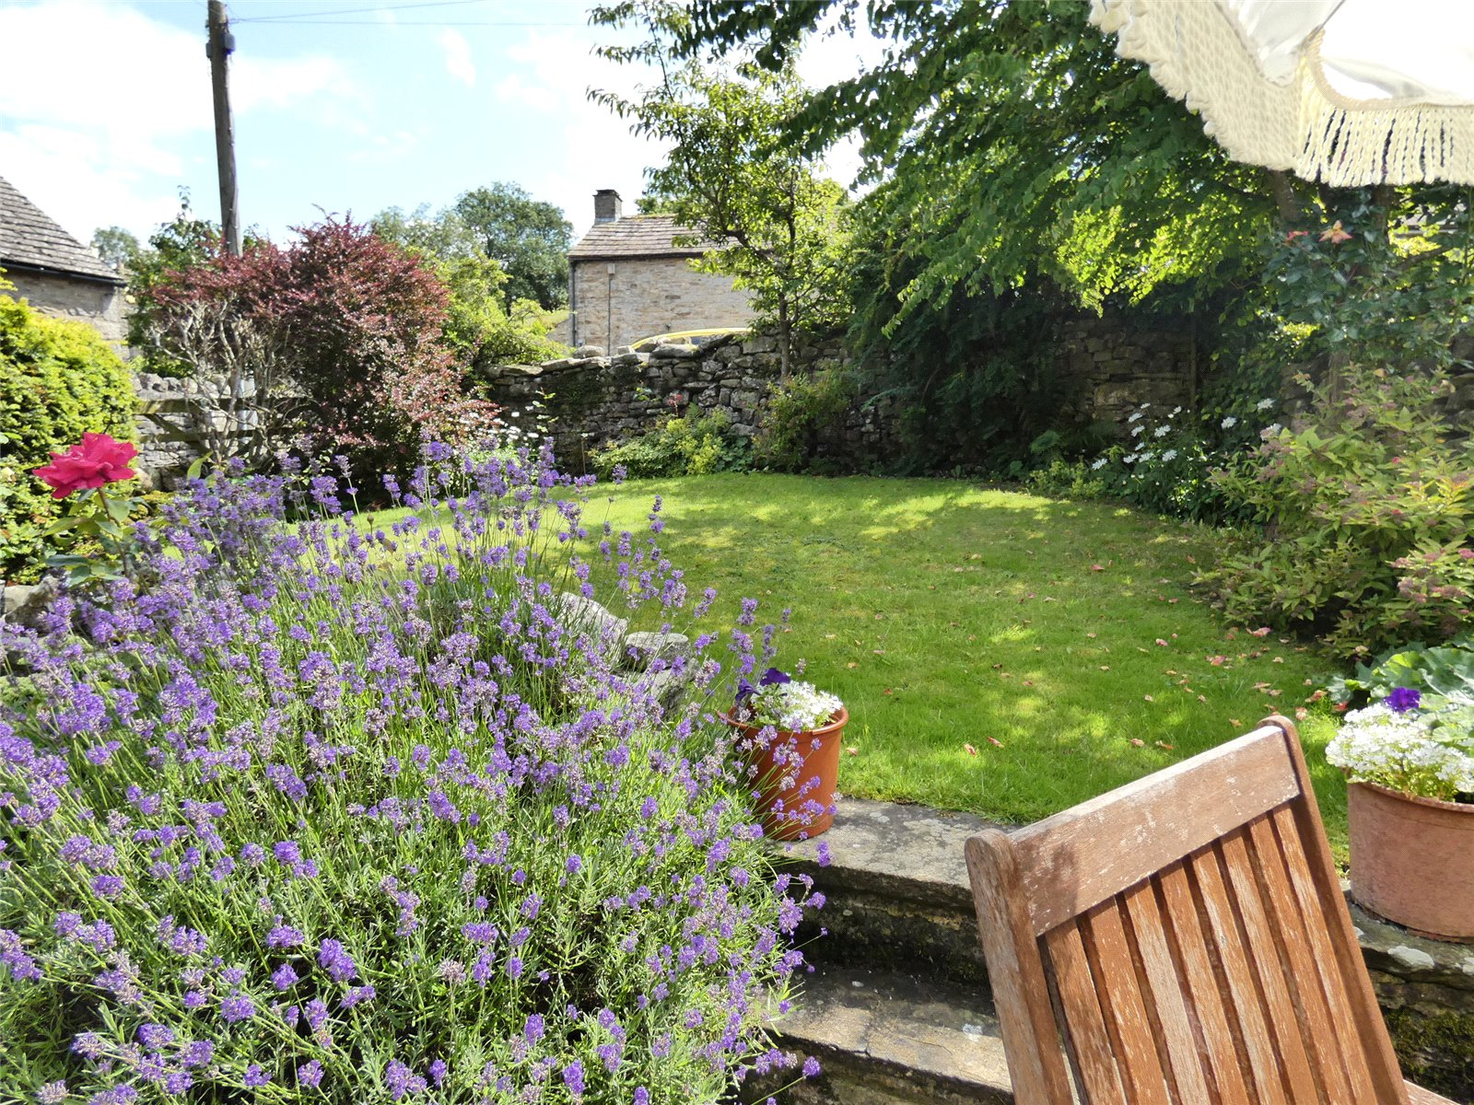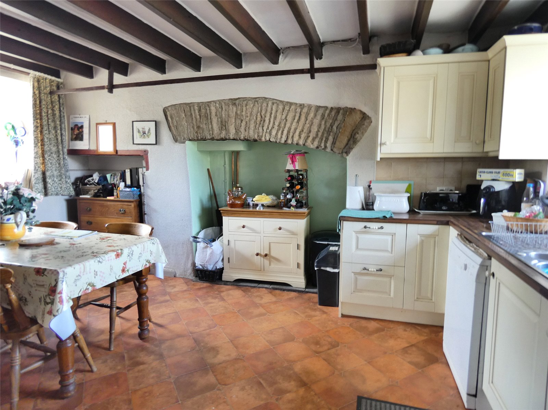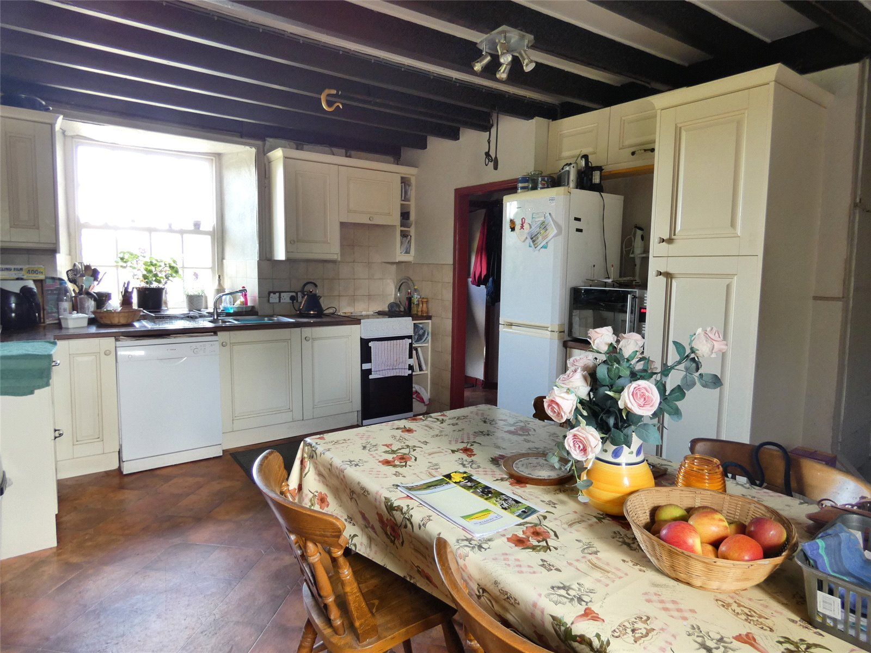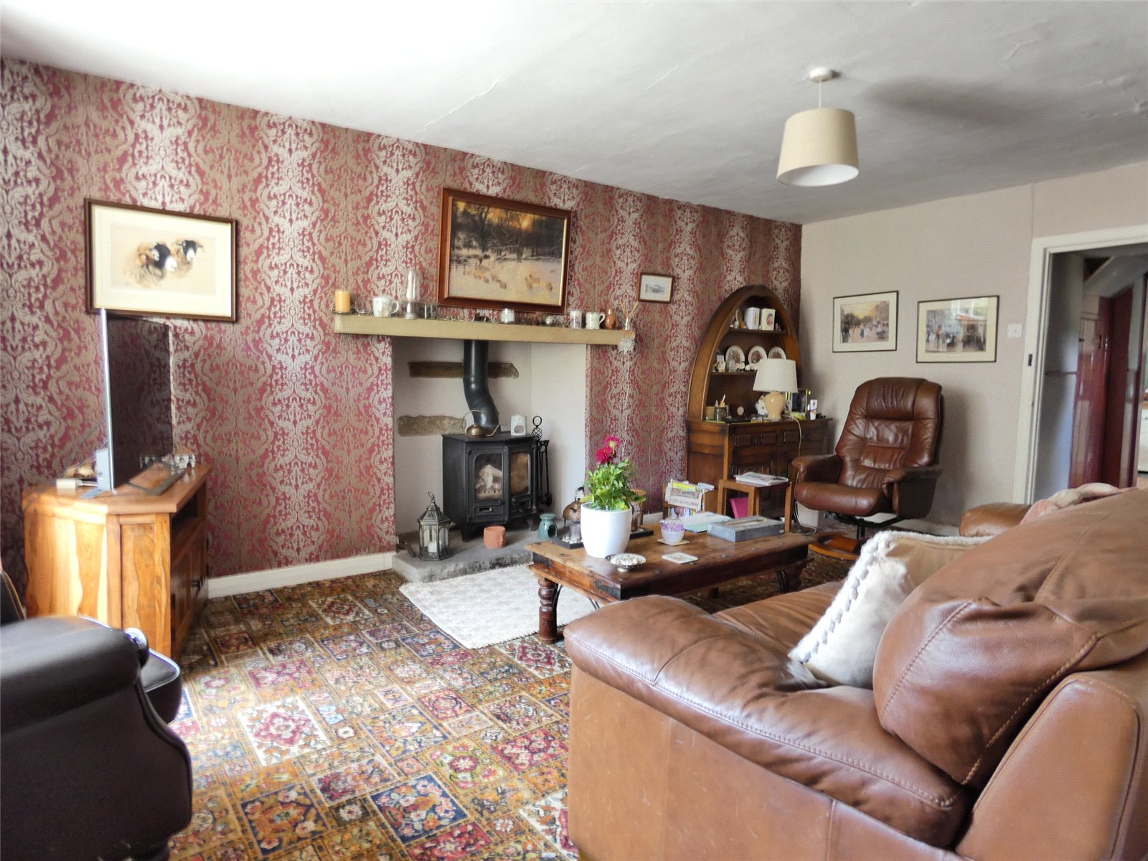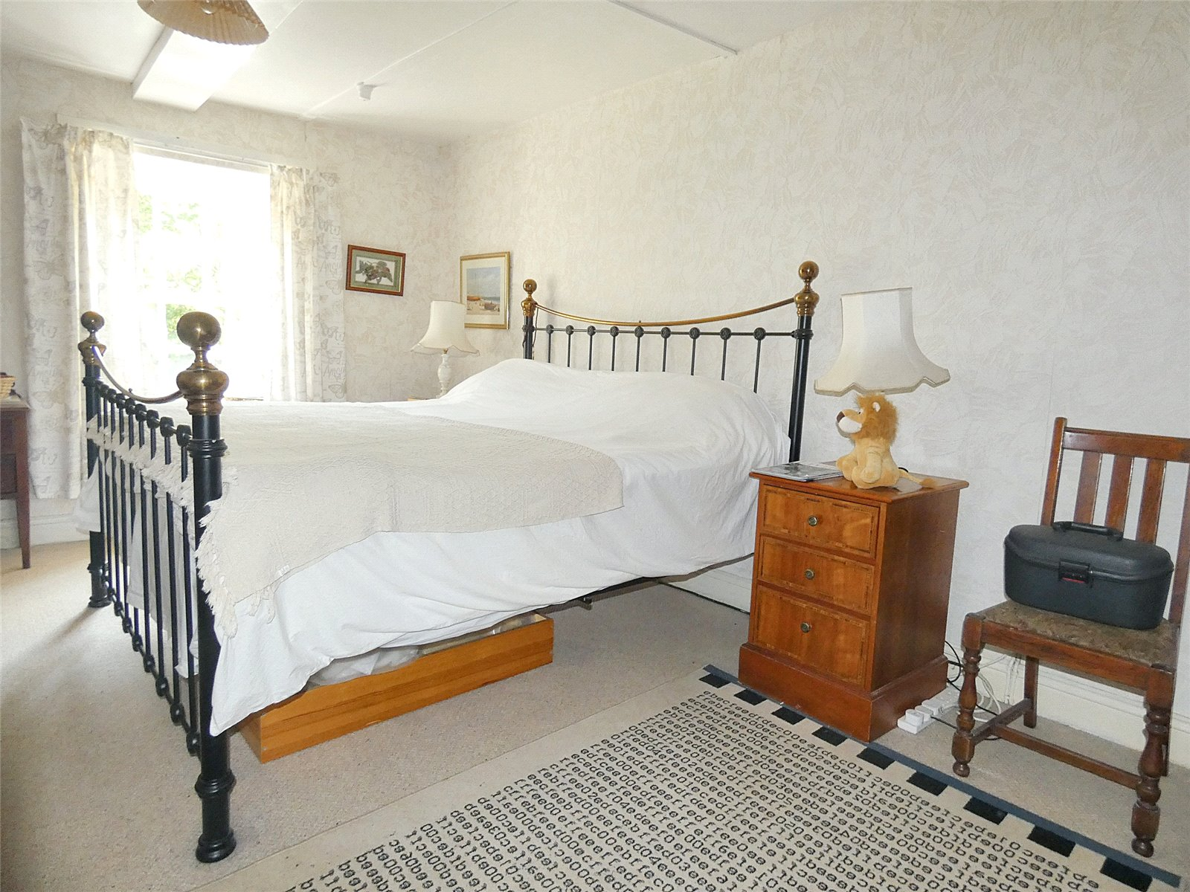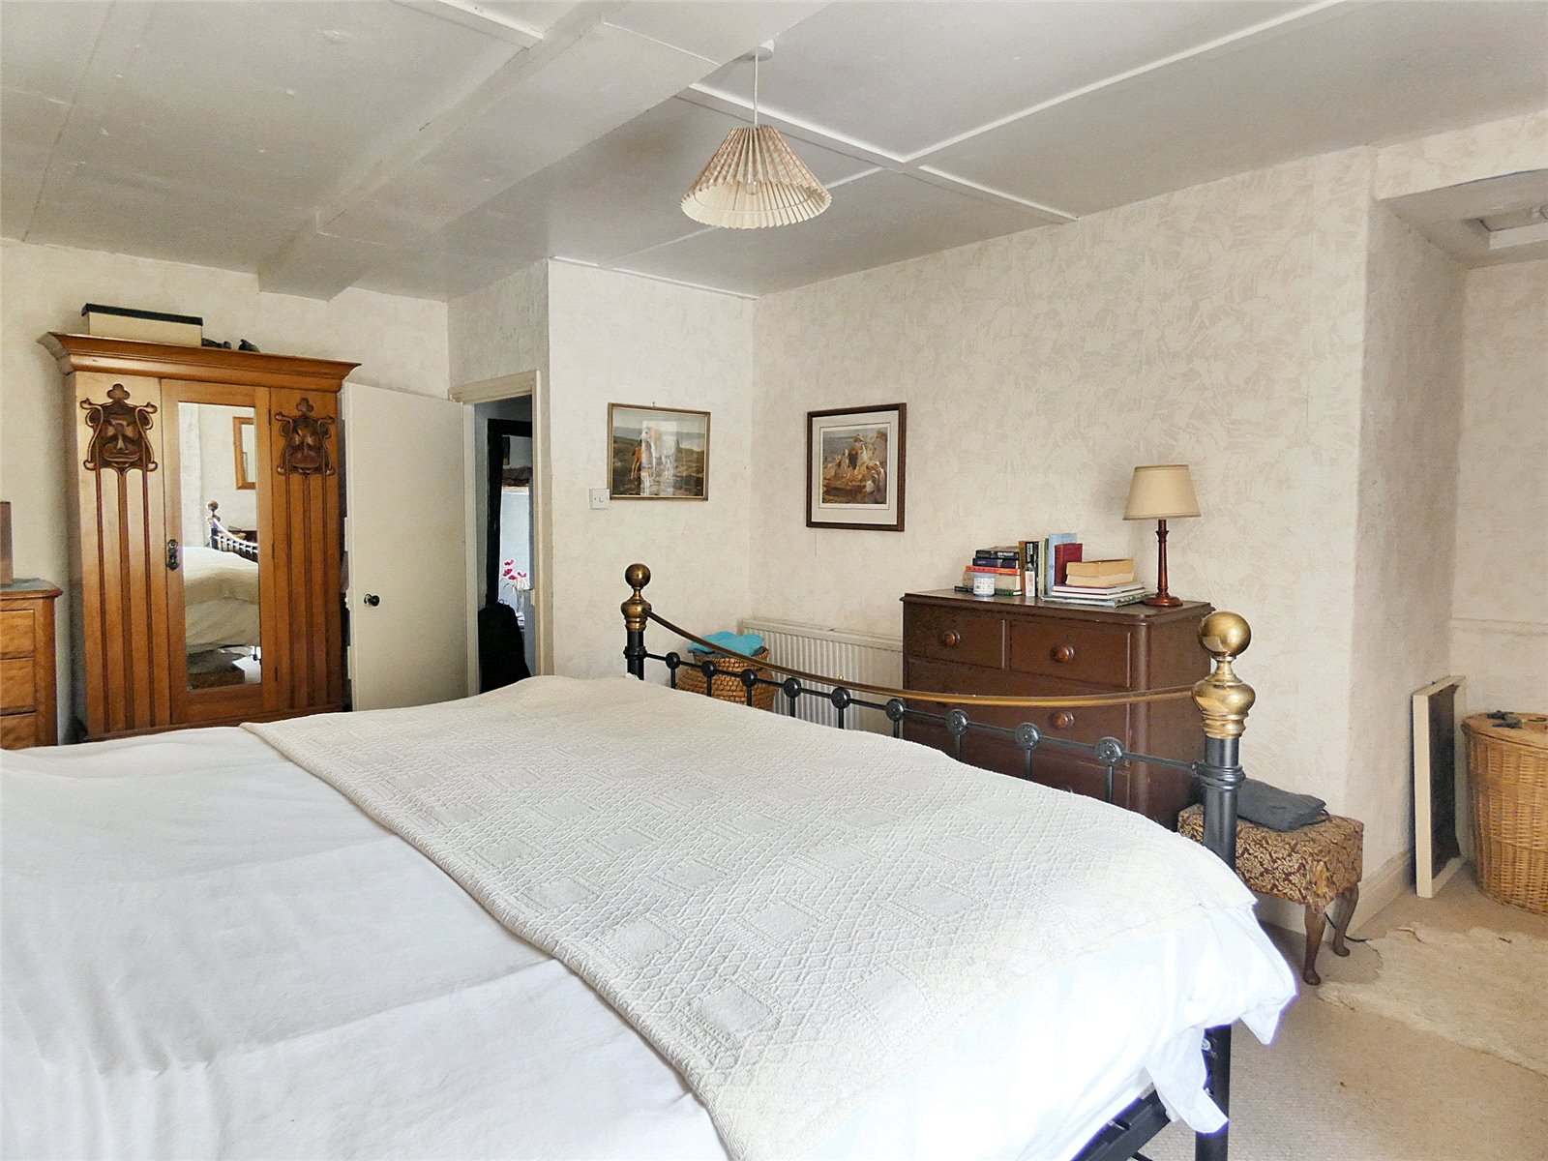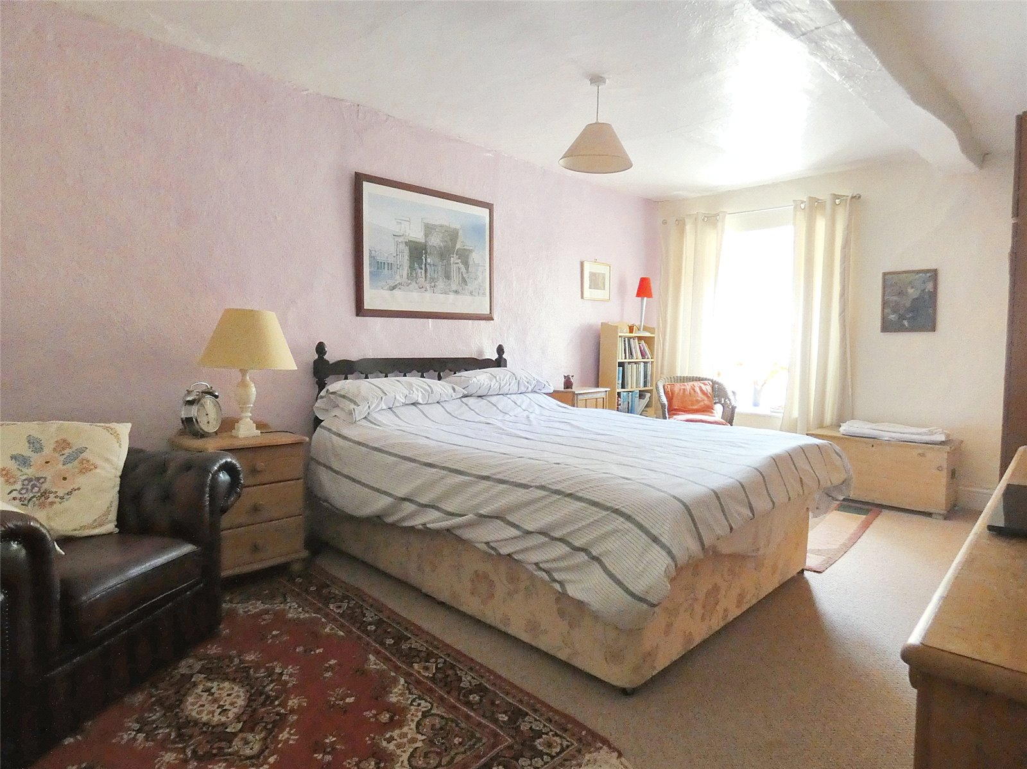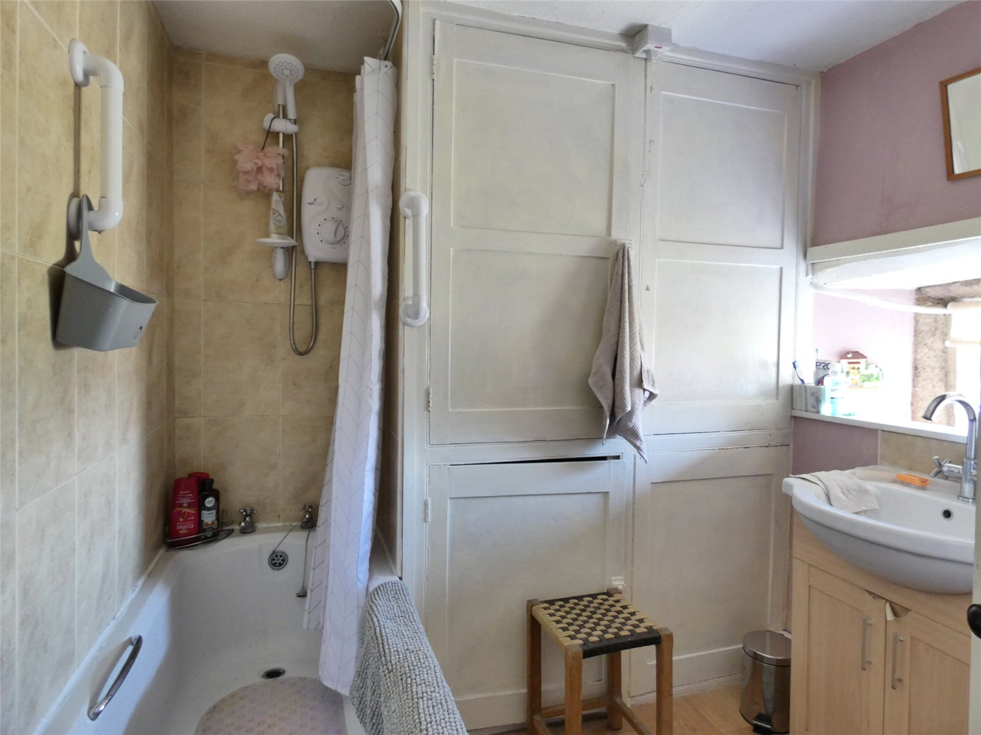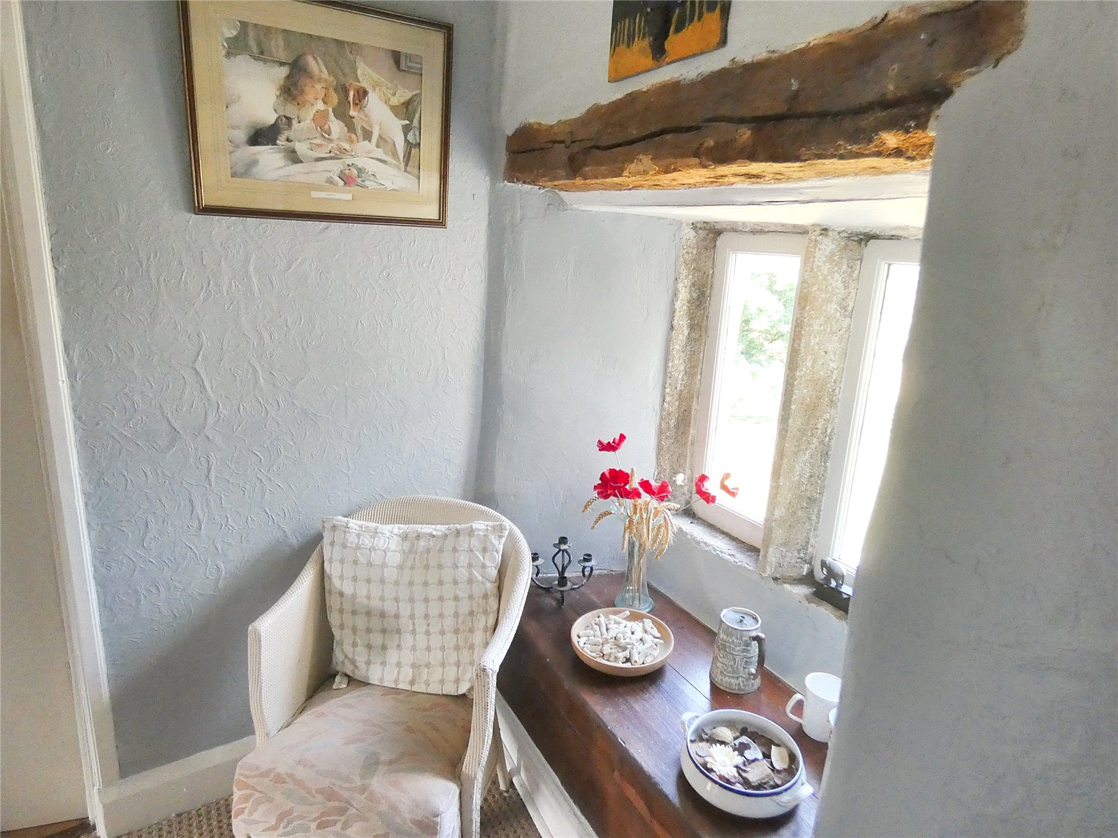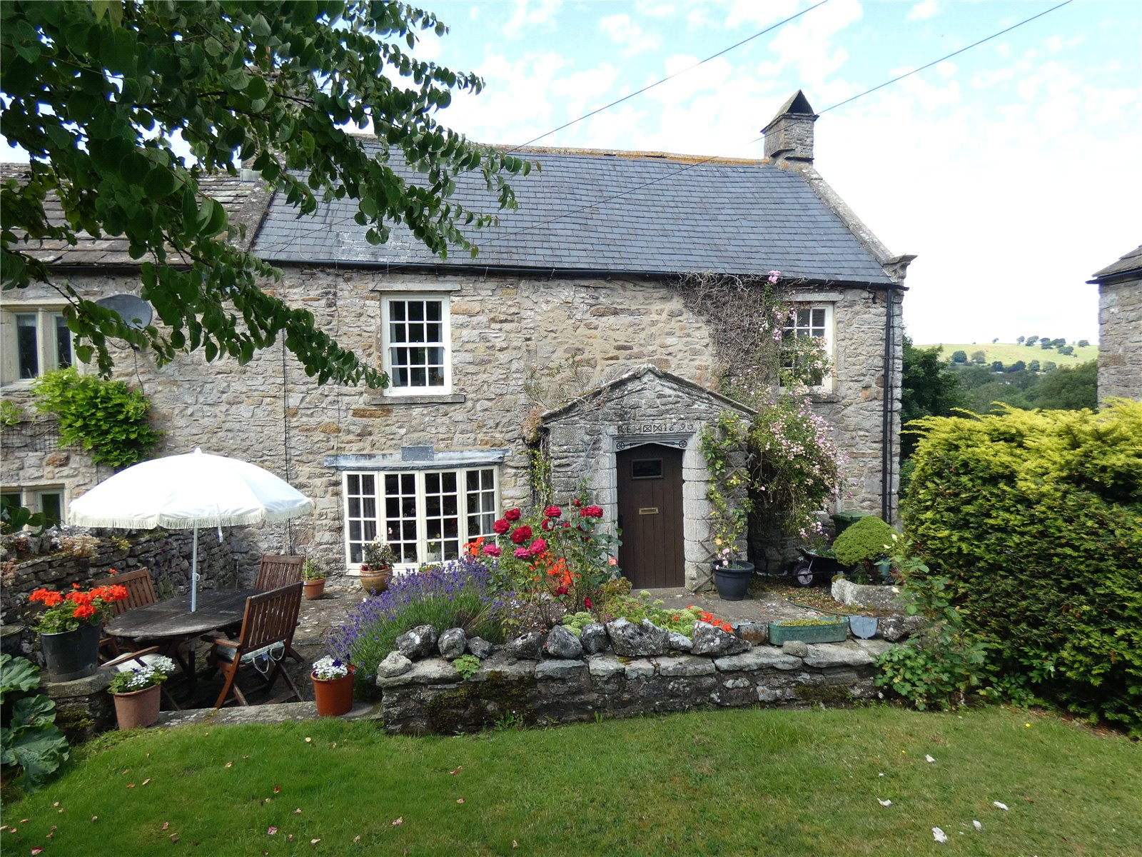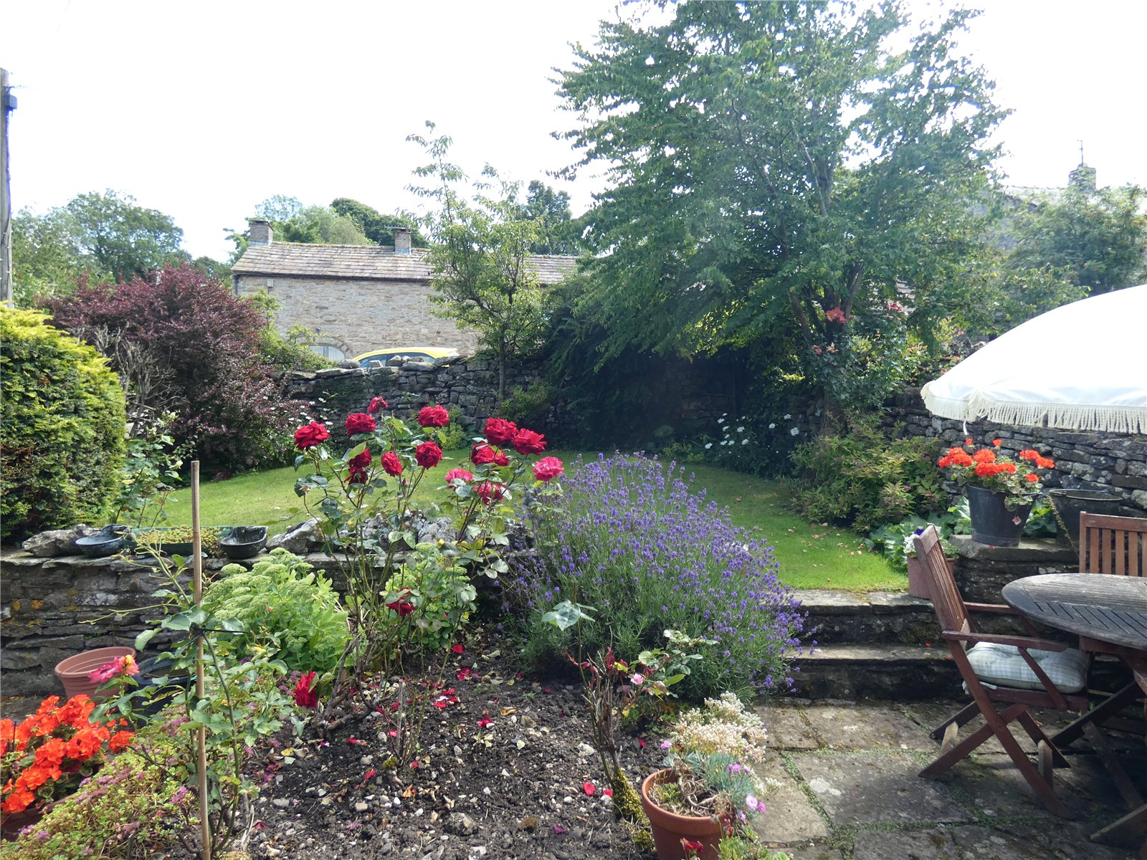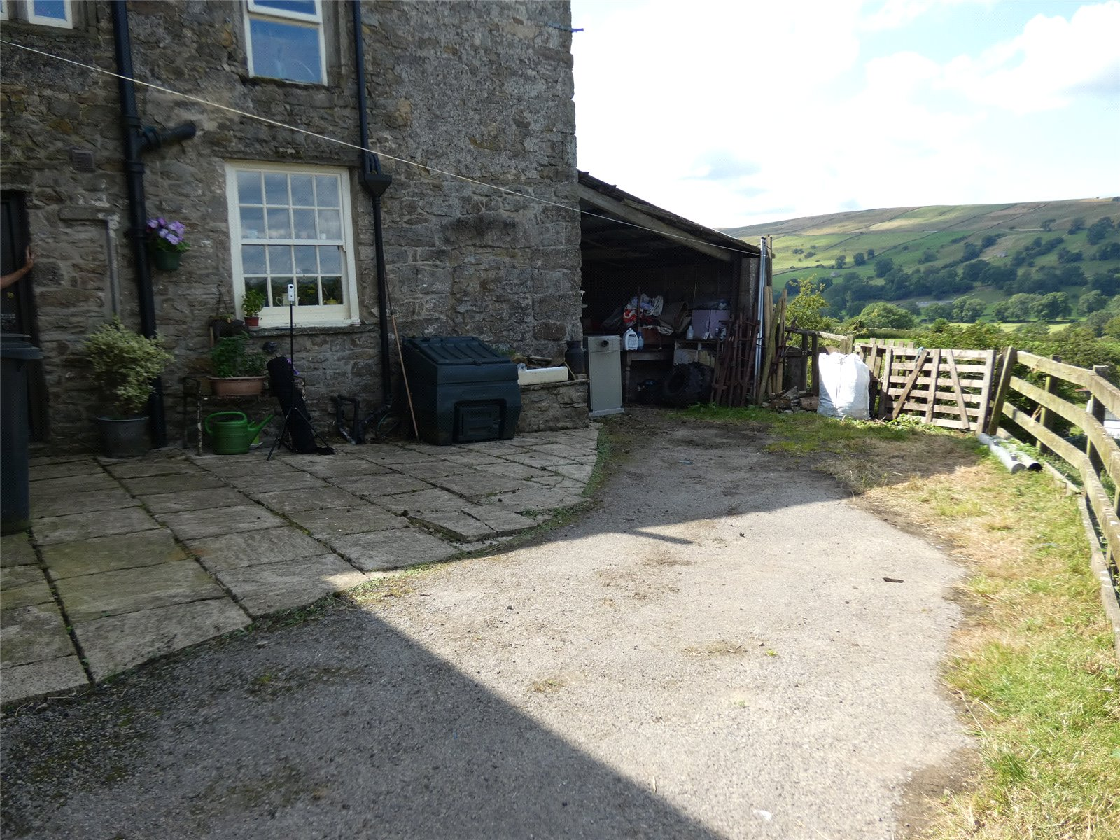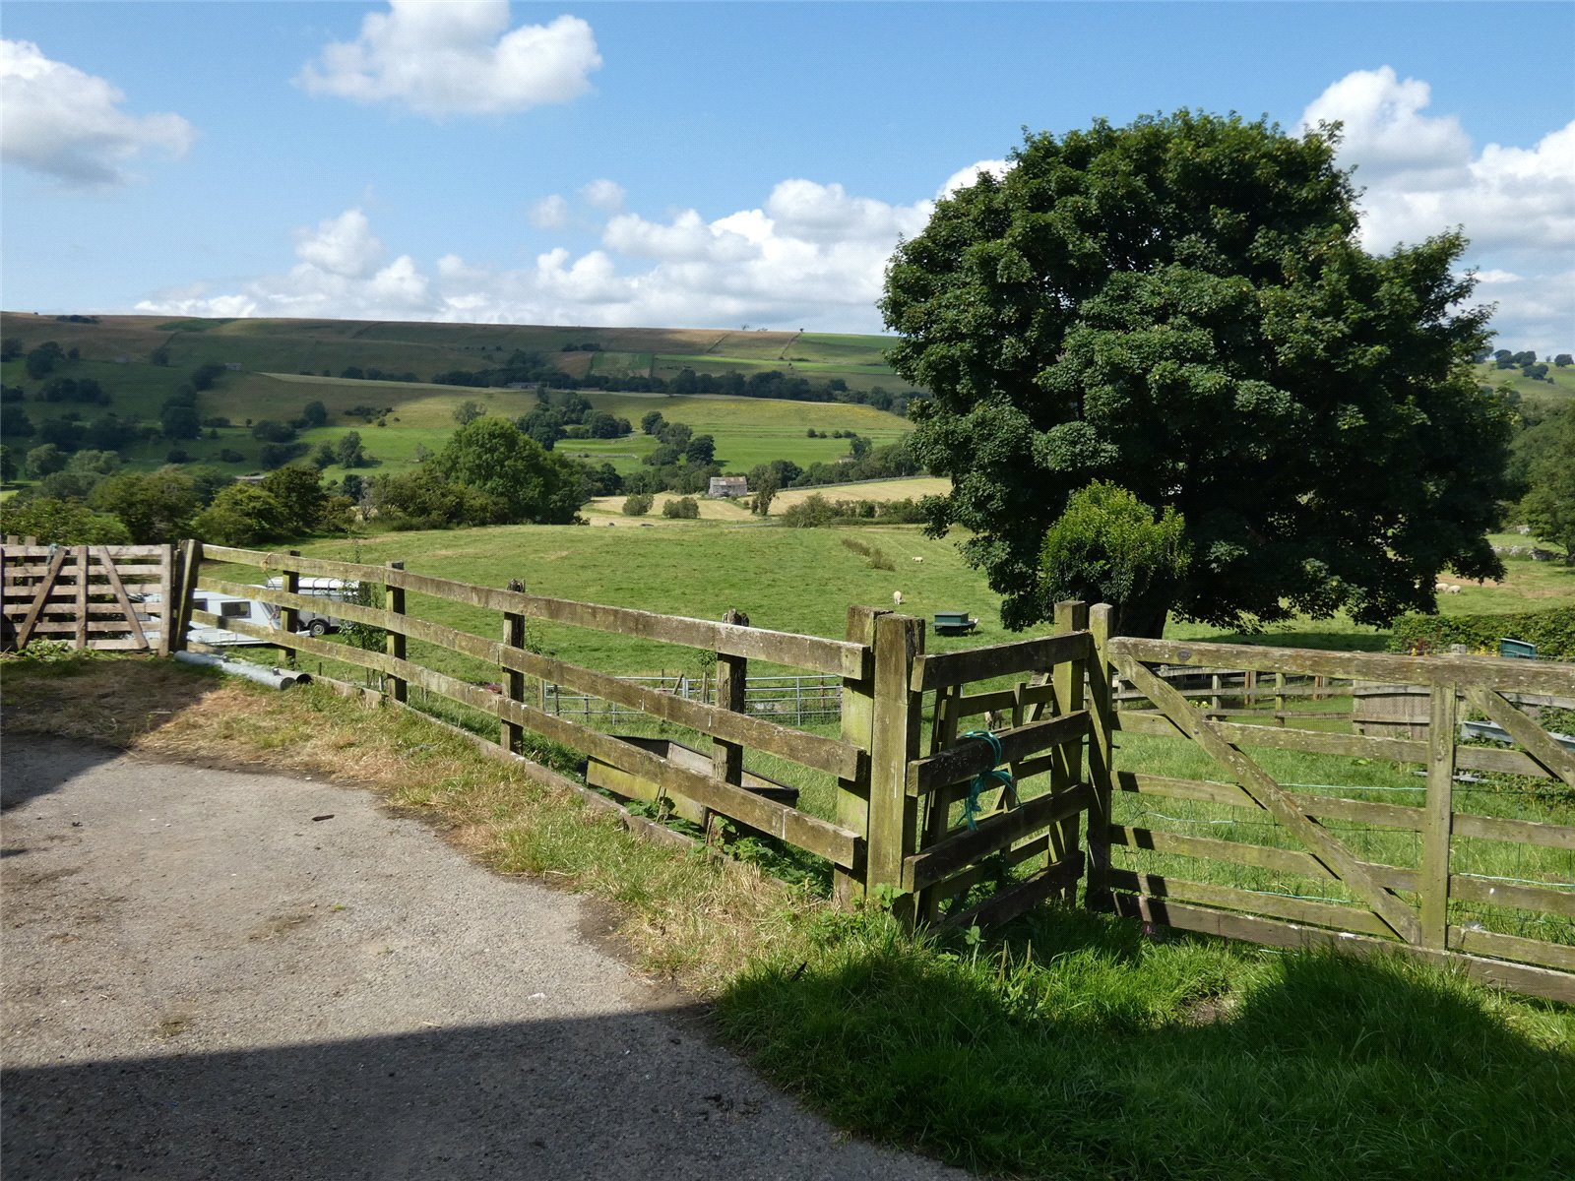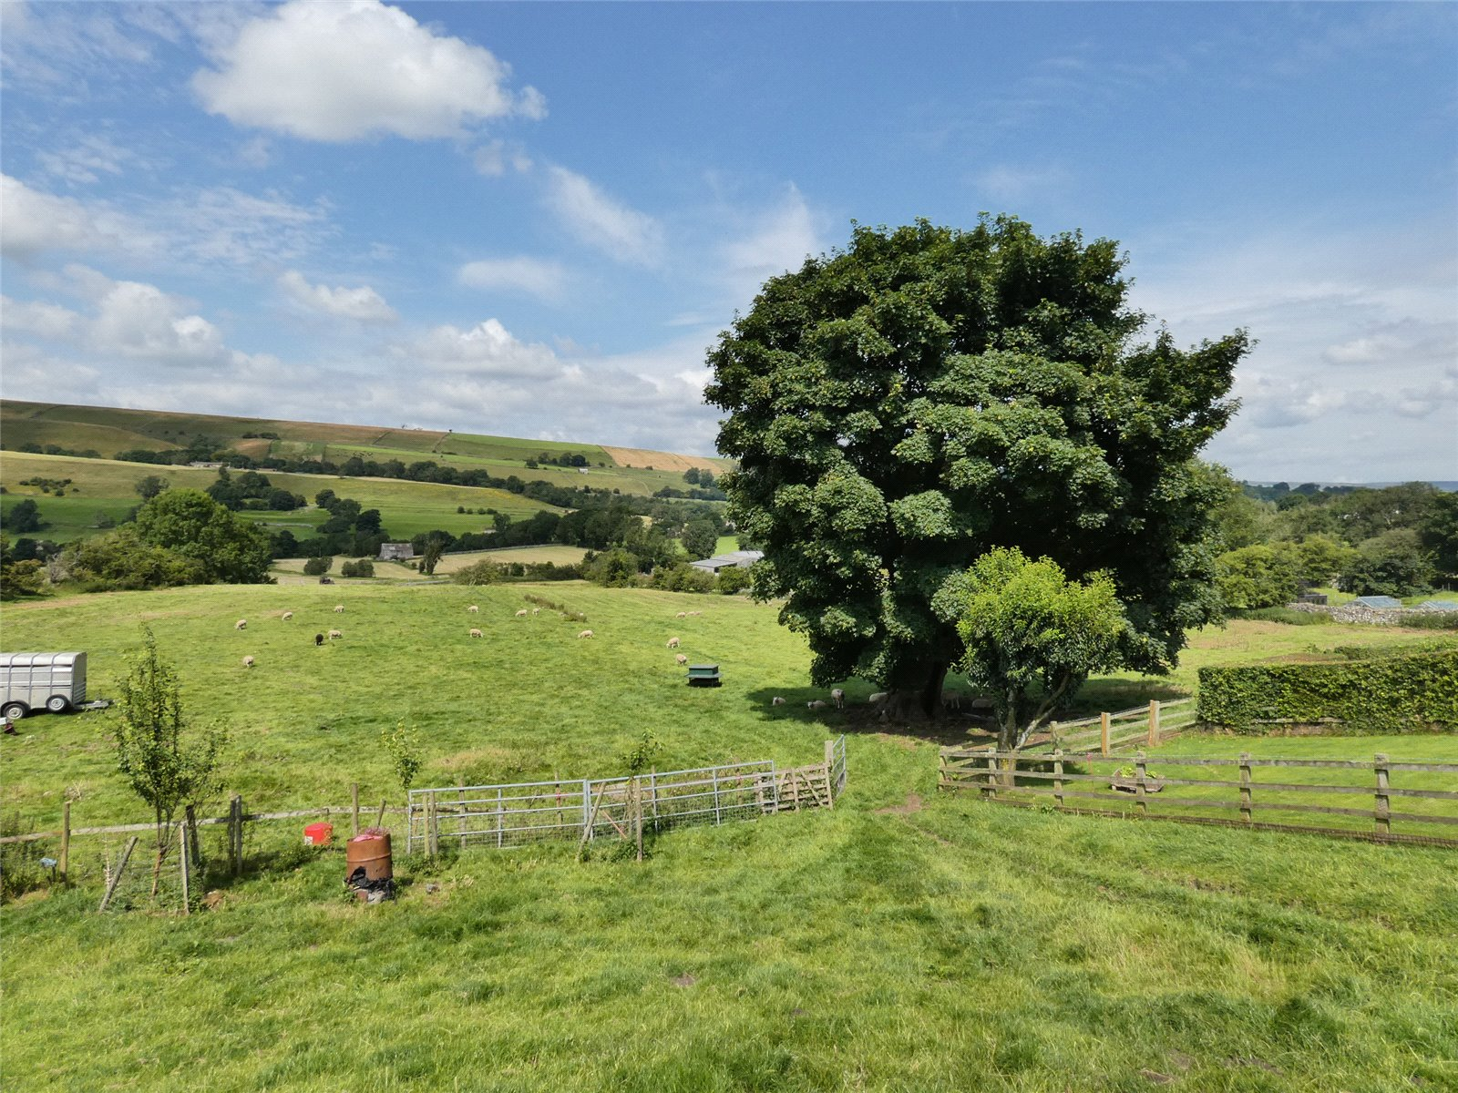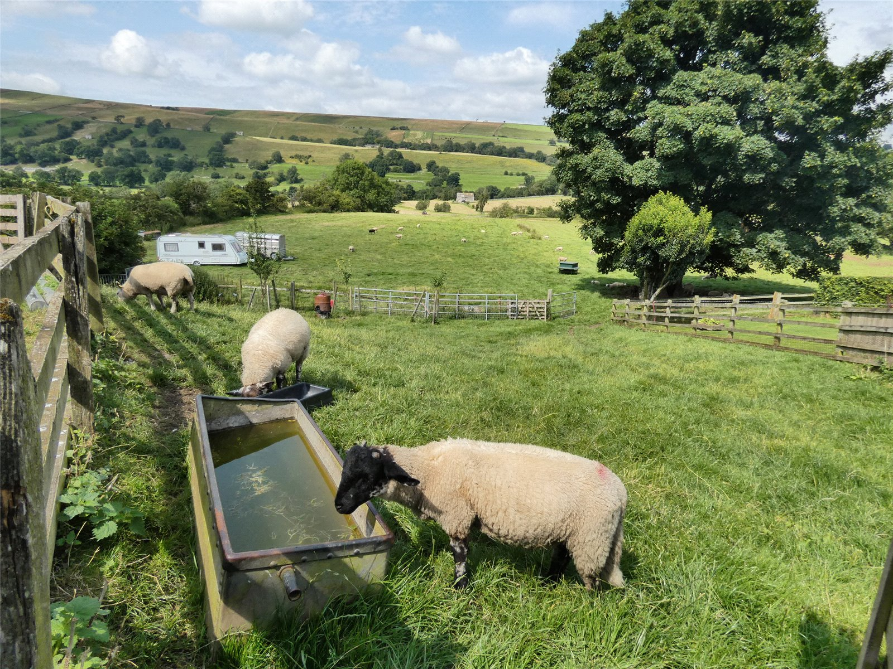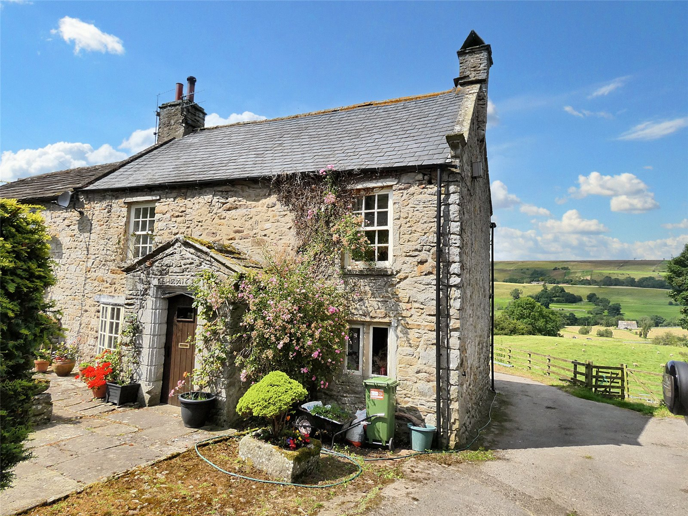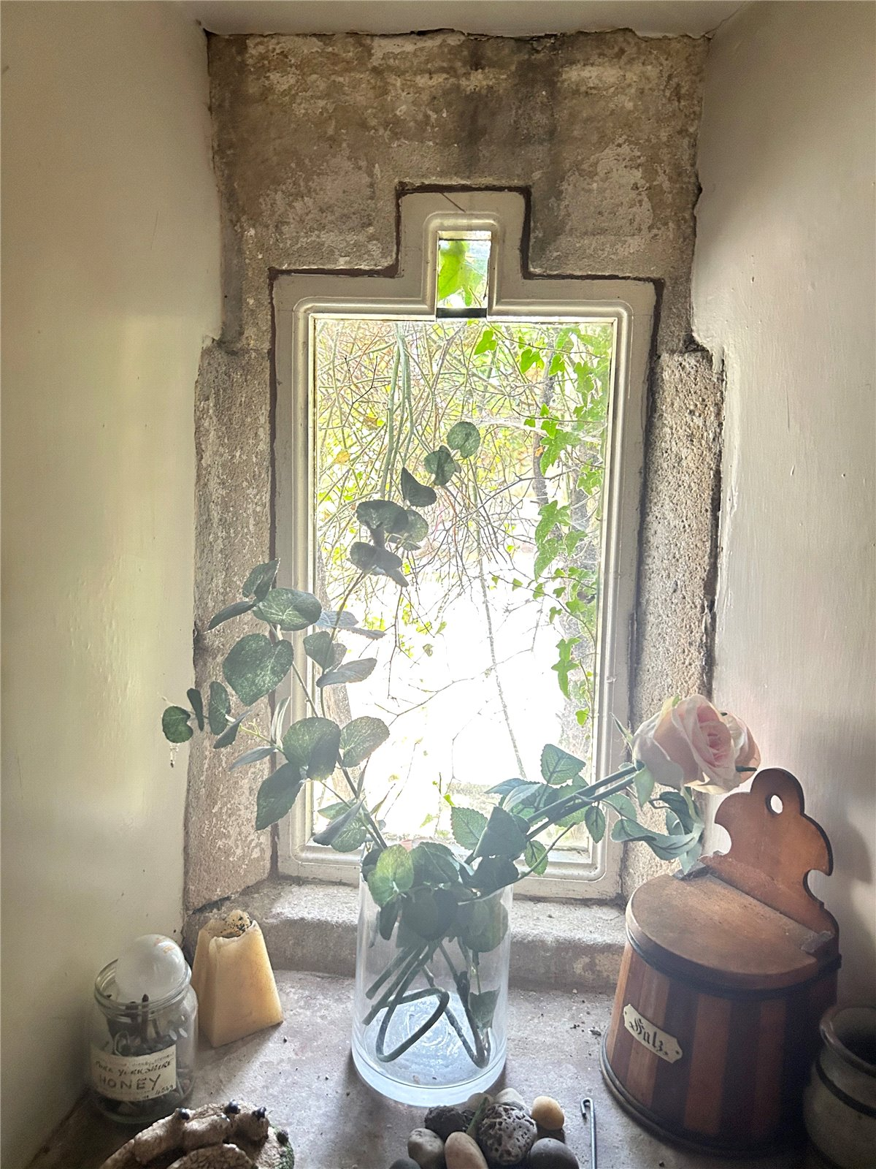
Town End Farm, is a traditional Grade II listed farmhouse, located in the sought-after village of Newbiggin In Bishopdale.

Newbiggin is a quiet hamlet within Bishopdale. Newbiggin is a picturesque location with beautiful views and walks in all directions. The renowned Street Head Inn is a short walk or drive, an excellent local pub. The village of West Burton is less than 2 miles, it is an active community, retaining a primary school, village hall, shop and tearoom, Pub, butchers & a number of small businesses. The market towns of Hawes & Leyburn are approximately 9 miles away in either direction.

Town End Farm dates back to 1690 and offers the charm and character one would expect from a Grade II Listed property.

The accommodation currently offers a good-sized sitting room with multi-fuel stove, a second reception room, kitchen diner, and an external utility. Upstairs there are three good double bedrooms and a bathroom, all of which command spectacular views.

Externally, there is a walled private garden to the front, with raised lawn, mature trees and shrubs, rose garden and Suntrap patio. The driveway leads to the rear, where there is ample parking. A lean-to outbuilding provides storage with a small, grassed area at the rear, additional landscaping could create a perfect sitting area to take in the views, gently sloping, ideal for 'The Good Life' and keeping hens, sheep etc.

Town End Farm is a great family, holiday or active retirement home in an idyllic setting.

Ground Floor

Entrance Original front door, with dated stone. Character exposed stone walls, and stone flagged floor. Inner door to bottom of the stairs, also gives access to the reception rooms.

Snug Second reception room. Fitted carpet. Beam and board ceiling. Radiator. Two mullion windows to the south.

Sitting Room Good sized room with fitted carpet. Feature ceiling beam. Radiator. Fireplace with multi fuel stove. TV point. Bay window to the south.

Rear Hall Vinyl flooring. Storage cupboard. Back door.

Kitchen\Diner Farmhouse kitchen with vinyl flooring. Exposed ceiling beams. Excellent range of wall base units. Stainless steel sink. Electric cooker point. Plumbing for dishwasher. Feature inglenook fireplace. Radiator. Pantry cupboard. Second staircase. Windows to each side with spectacular views.

Utility Room Outbuilding with plumbing for washing machine. Stone sink. Under stairs storage. Window and door to the rear.

First Floor

Stairs & Landing Traditional stone stairs, with carpet runner. Fitted carpet on landing. Exposed ceiling beam. Radiator. Staircase from kitchen. Two windows out to the rear with lovely views.

Bedroom One South facing, large double bedroom. Fitted carpet. Radiator. TV point. Loft access. Sash window to the front.

Bedroom Two Front, good double bedroom. Fitted carpet. Radiator. Sash window to the South.

Bedroom Three Rear double bedroom. Fitted carpet. Exposed ceiling beams. Radiator. Cupboard over the stairs. Window to the side with lovely views.

Bathroom Vinyl flooring. Bath with electric shower over WC. Wash basin. Good sized airing cupboard. Heated towel rail. Frosted window to the rear.

Outside

Front Private gated driveway. Stone flagged patio area, with a lovely cottage garden. Lawed area with well-established shrubs and raised beds.

Rear Flagged patio area. Lean to for storage, with new external oil boiler. Small grassed area, to the side of the store, with access to paddock. Gated access to paddock.

Garth Fenced paddock, approx quarter of an acre, ideal for small holding.

Parking Off road parking, in parking area and driveway.

Agents Notes Mains water. Private septic tank drainage. The septic tank is located in the garth.

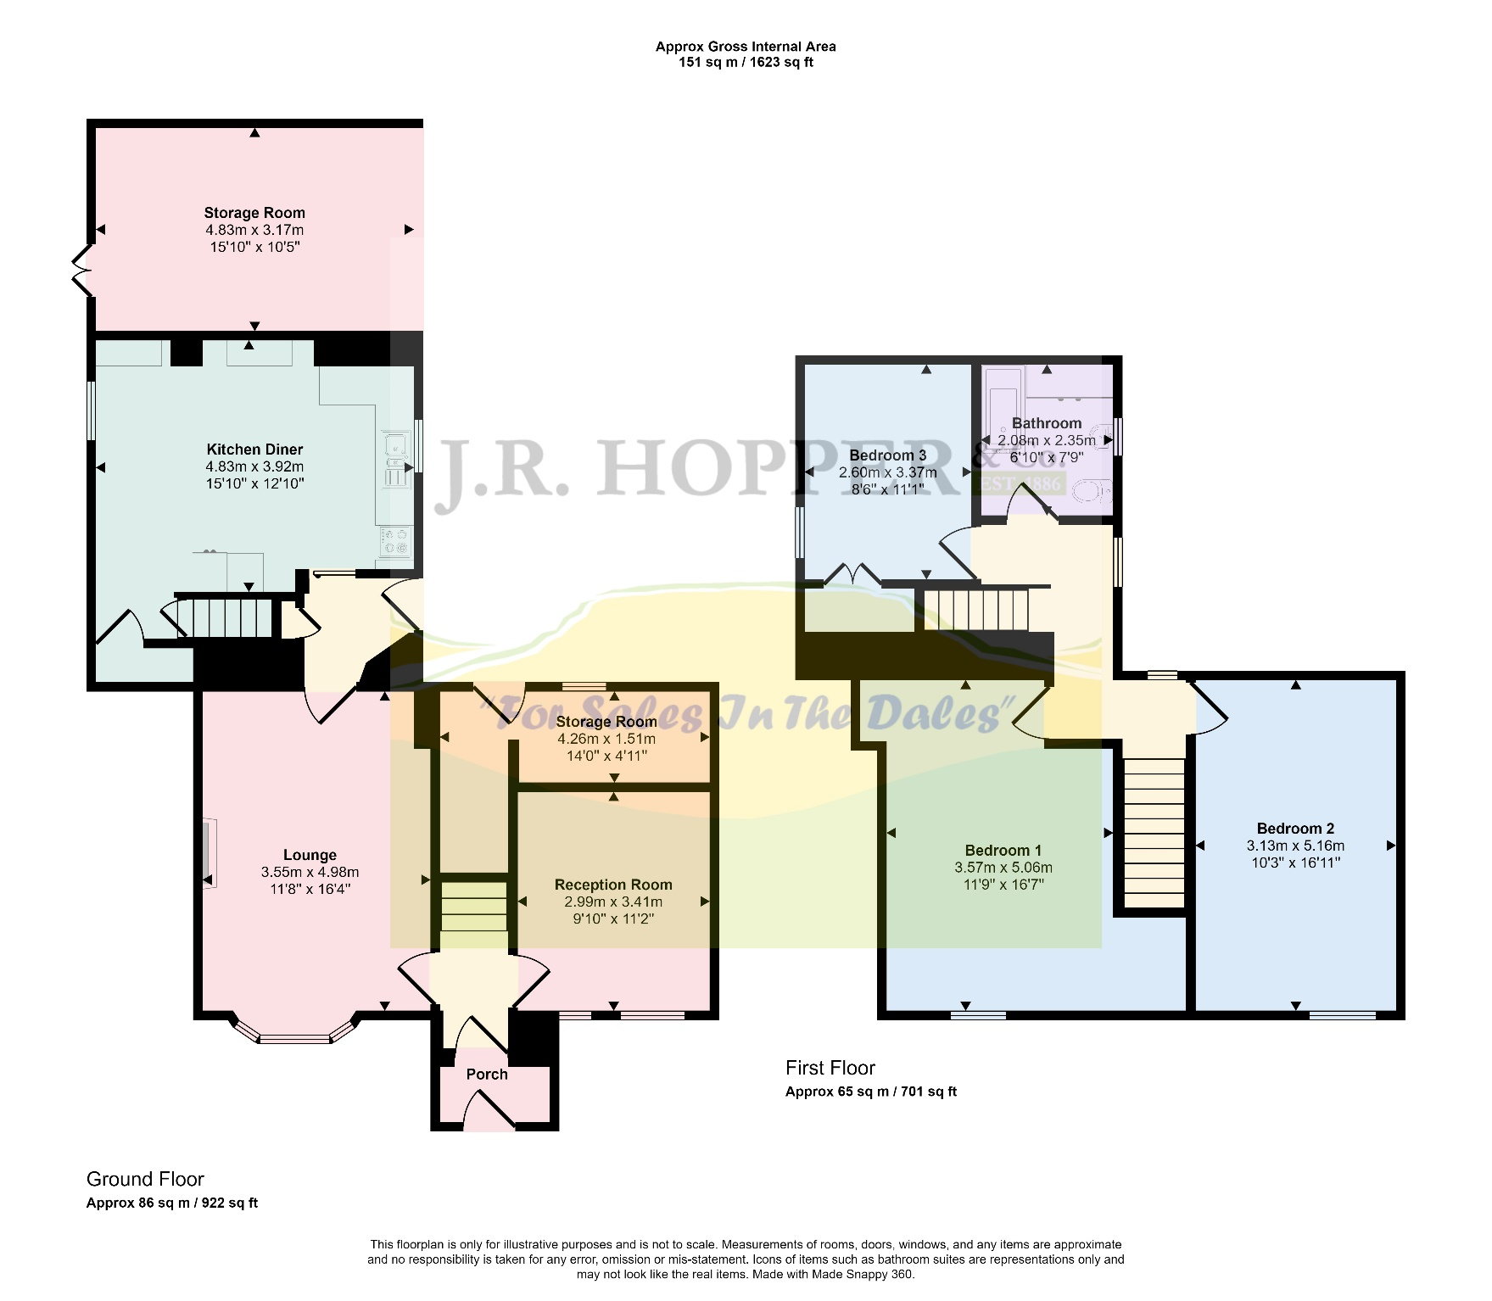
Items in these photographs and tours may not be included in the sale • J. R. Hopper & Co. has not tested services, fixtures, fittings, central heating, gas, and electrical systems. If in doubt, purchasers should seek professional advice • J. R. Hopper & Co, as Agents in the sale of the property will formally check the identification of prospective Purchasers. In addition, the Purchaser will be required to provide information regarding the source of funding as part of our offer handling procedure • Viewings by appointment only.

