
Guide Price: £290,000 - £325,000
- NO CHAIN
- Spacious And Cosy Cottage
- Pleasant South Facing Outlook
- 3 Large Double Bedrooms
- Lounge & Dining Room • Large Kitchen Diner• Large Hallway & WC
- House Bathroom & En-Suite
- Low Maintenance Sun Trap Patio Garden & Ample Private Parking
- Suitable For Full Time Living or Holiday Home In The Dales
- Contents Available By Separate Negotiation

Myrtle Cottage, Bellerby
Postcode: DL8 5QN

Tenure: Freehold

Council Tax Band: D

Energy Efficiency Band: C

Local & Planning Authority:
North Yorkshire Council
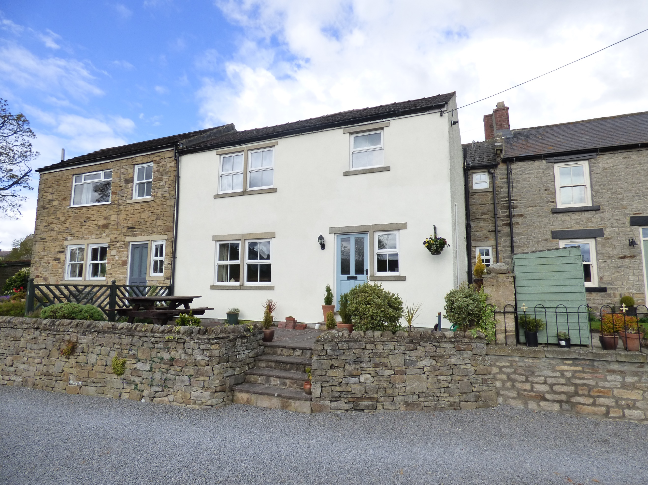
J. R. Hopper & Co. is a trading name for J. R. Hopper & Co. (Property Services) Ltd. Registered: England No. 3438347.
Registered Office: Hall House, Woodhall, DL8 3LB. Directors: L. B. Carlisle, E. J. Carlisle
“For Sales In The Dales”
EST. 1886
Central Chambers
Market Place
Leyburn
North Yorkshire
DL8 5BD
Leyburn
Hawes
Settle
Kirkby Stephen
01969 622936
01969 667744
01729 825311
01768 258002
& Co.
www.jrhopper.com enquiries@jrhopper.com
J.R. HOPPER
Myrtle Cottage is a generous, characterful property, located in the lovely village of Bellerby.
Bellerby is just 1.5 miles from the market town of Leyburn and is well placed for exploring the Dales or for commuting to Richmond and the A1. It has a lively community with a pub, church, village hall, playground and regular bus service. Leyburn has both primary and secondary schools, church, chapel, doctors, dentists and much more. It also has a weekly outdoor market and a good range of shops and restaurants.
The property is in very good condition, provides spacious living accommodation and benefits from mains gas central heating and double-glazed windows. The previous owners replaced the roof for a brand-new slate roof in 2016.
To the ground floor there is a welcoming large entrance hall, downstairs WC, large kitchen diner, lounge and dining room with exposed stone. The first floor offers 3 large double bedrooms, one of which has an en-suite shower room. There is also a house bathroom.
Externally there is a south facing patio garden to the front, which could easily be made more secure and pet friendly. Opposite is a large, gravelled private parking area for at least 3 vehicles, this equally could be made into parking for one plus a fenced in garden. The neighbouring property access their house via the shared gravel drive.
Myrtle Cottage has previously been a successful holiday let and would lend itself to continuing as such. Equally it would make an ideal family home.

Ground Floor

Entrance Hall 14'11" x 9'9" (4.55m x 2.97m). Large entrance hall. Laminate flooring. Radiator. Under stairs cupboard. Staircase. Front door. Window to the front.

WC 6'9" x 2'7" (2.06m x 0.79m). Laminate flooring. Hanging space. WC. Hand basin.

Kitchen Diner 15'7" x 12'8" (4.75m x 3.86m). Tiled floor. Ceiling beam and panelled ceiling. Good range of wall and base units. Gas range cooker and hob. Radiator. Stainless steel sink and drainer. Plumbing for automatic washing machine and dishwasher. Windows to the front and rear.

Dining Room 15'3" x 11'11" (4.65m x 3.63m). Laminate flooring. Beamed ceiling. Radiator. Exposed stone feature wall. Window to the rear.

Lounge 14'6" x 14'1" (4.42m x 4.3m). Laminate flooring. Fireplace. Radiator. Window to the front with pleasant outlook.

First Floor

Stairs/Landing Laminate flooring. Radiator.

Bathroom 11'1" x 6'6" (3.38m x 1.98m). Large light room. Wooden floorboards. Modern white suite. P shaped bath with shower over. Fitted cupboards. WC. Hand basin. Radiator. Airing cupboard with gas central heating boiler. Extractor fan. Frosted window to the front.

Bedroom 1 12'11" x 10'11" (avg) (3.94m x 3.33m (avg)). Lovely double bedroom. Laminate flooring. Radiator. Loft access. Window to the rear.
En-Suite: 7'1" x 4'3" (2.16m x 1.3m). Shower cubicle. WC. Hand basin. Window to the front.

Bedroom 2 15'9" x 12'10" (4.8m x 3.9m). Large rear double bedroom. Laminate flooring. Ceiling beams. Radiator. Loft access. Window to the rear with pleasant village outlook.

Bedroom 3 14'3" x 14'7" (4.34m x 4.45m). Front double bedroom. Laminate flooring. Ceiling beams. Radiator. Loft access. Window to front with pretty views to playing fields.

Outside
All outside space is currently low maintenance, which would suit if the property was run as a holiday cottage or someone who wasn’t too keen on gardening.

Patio South facing stone flagged patio with flowerbed borders. This space could easily be made more secure and pet friendly if required.

Parking Large gravelled private area with parking for 3 vehicles. Small shed. This space could easily be landscaped into a fenced garden with parking for 1 car, depending on preference.

AGENTS NOTE The drive is owned by the neighbouring property at the far end, but there is a full and unrestricted right of access in place.
The roof was fully replaced in 2016. Contents available via separate negotiation.

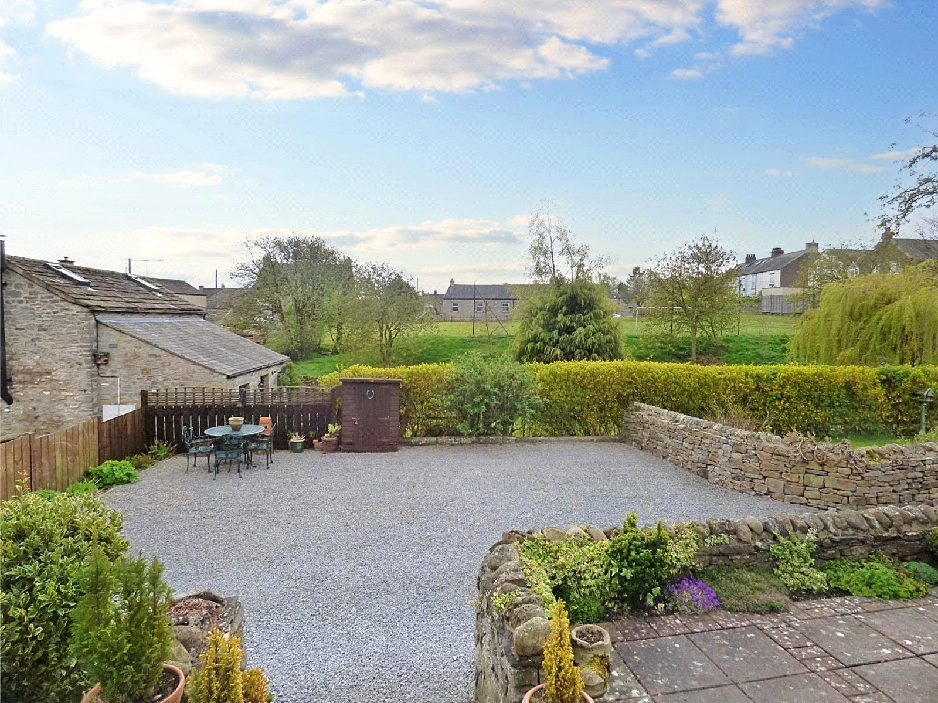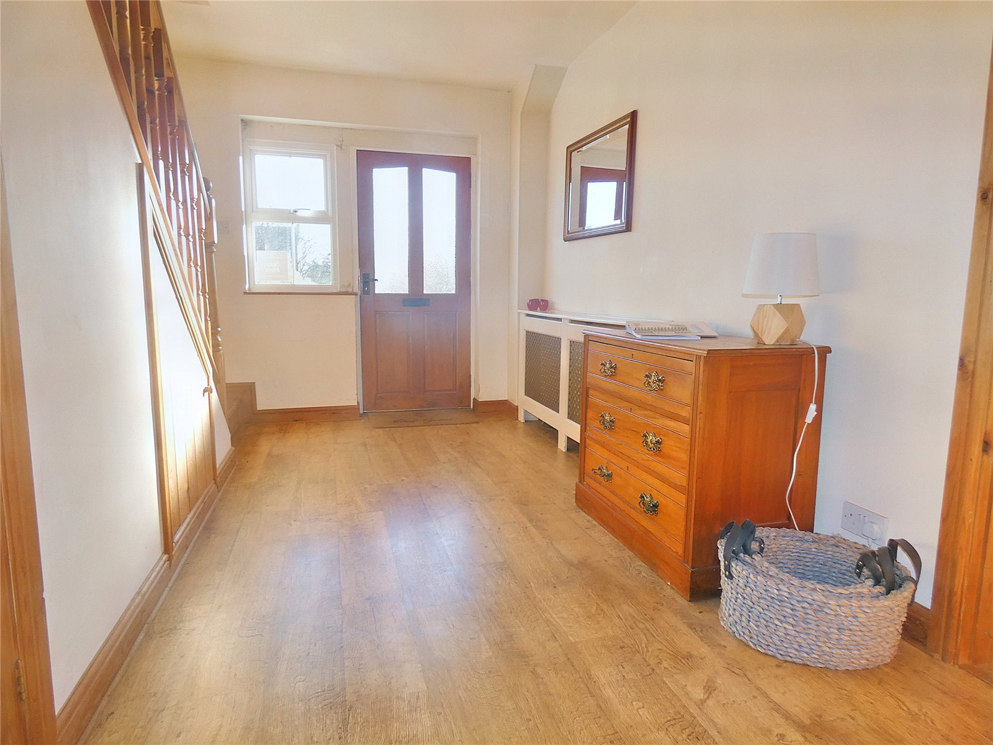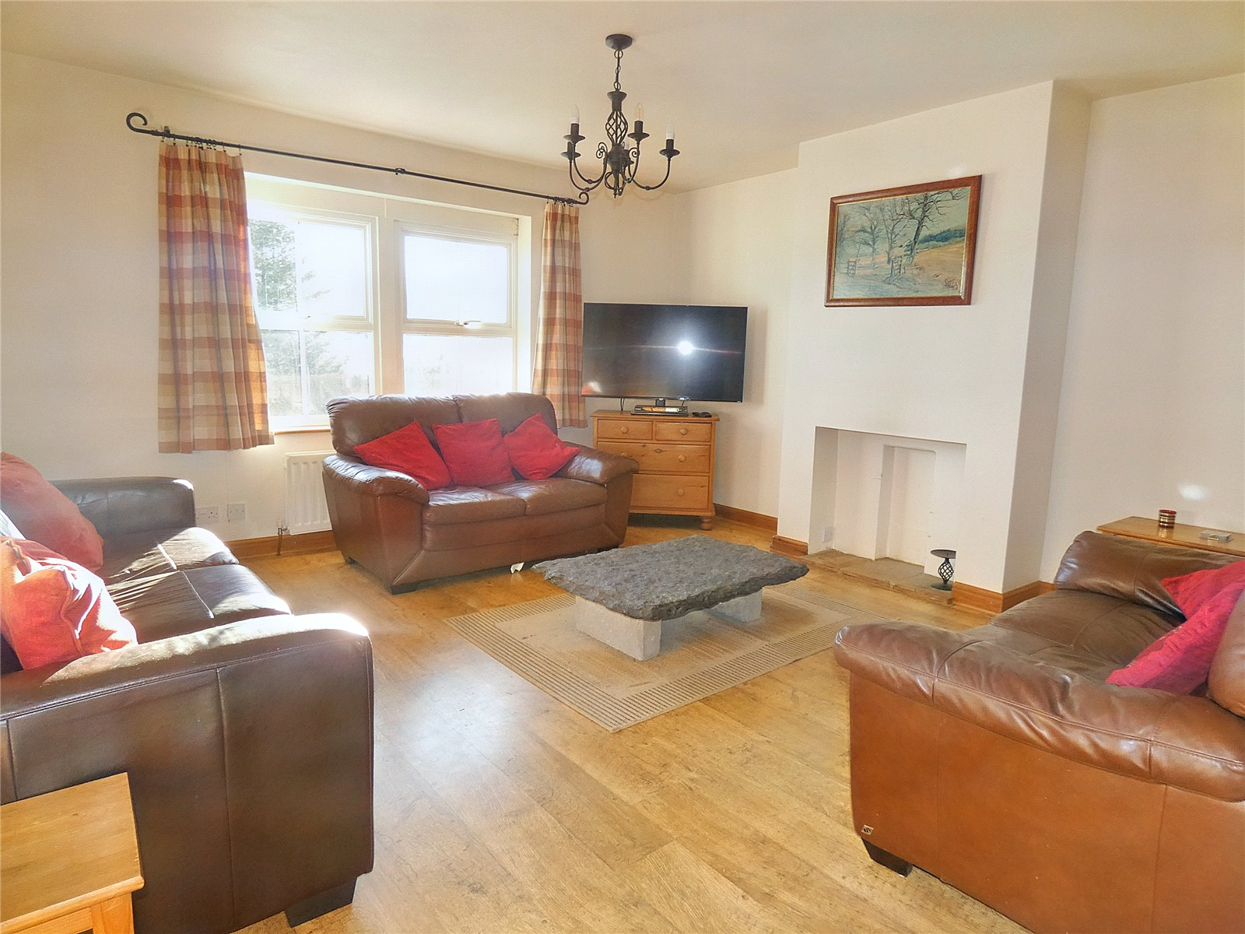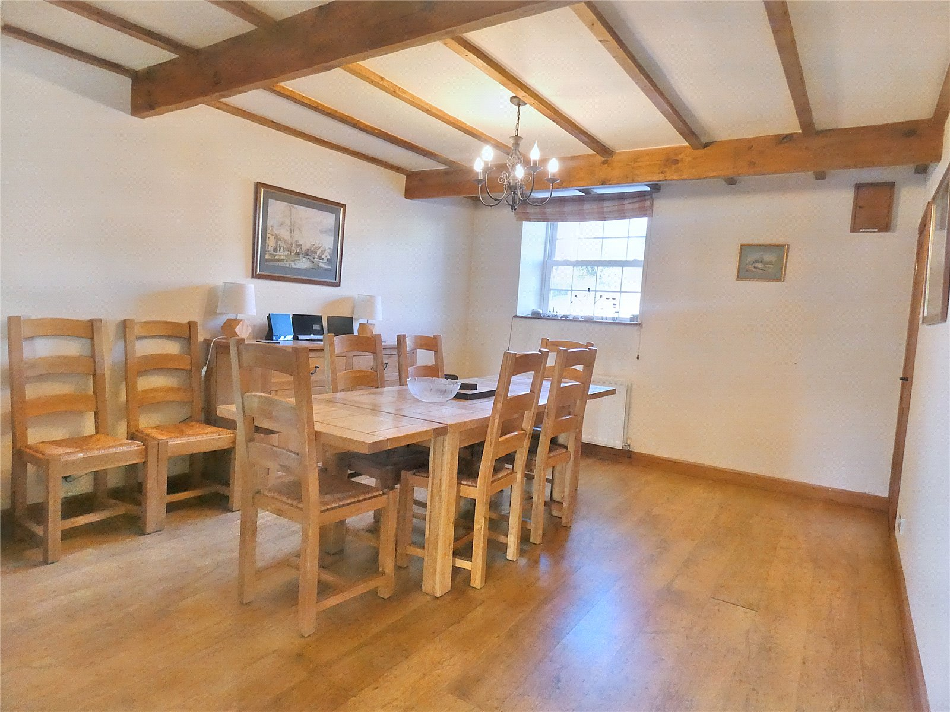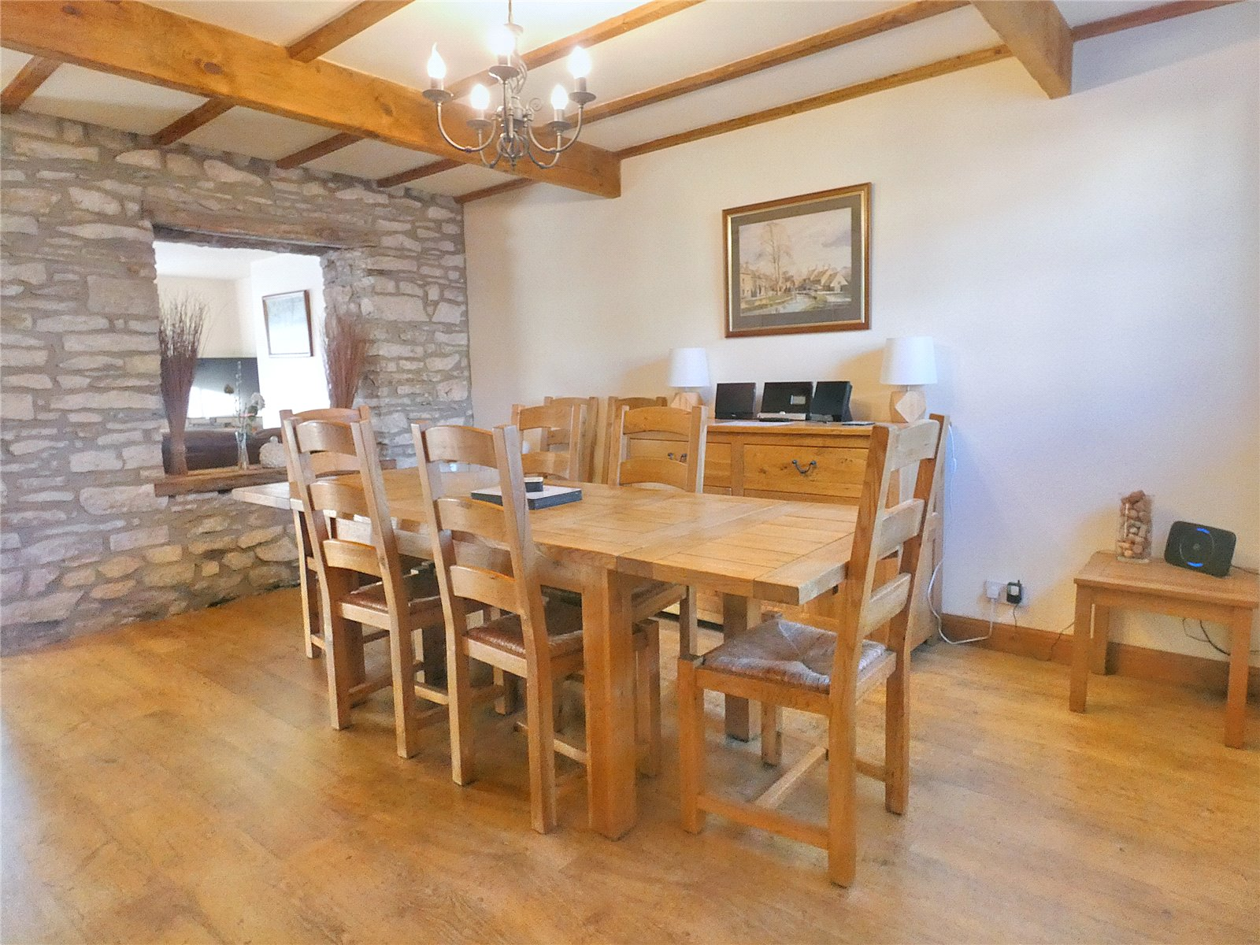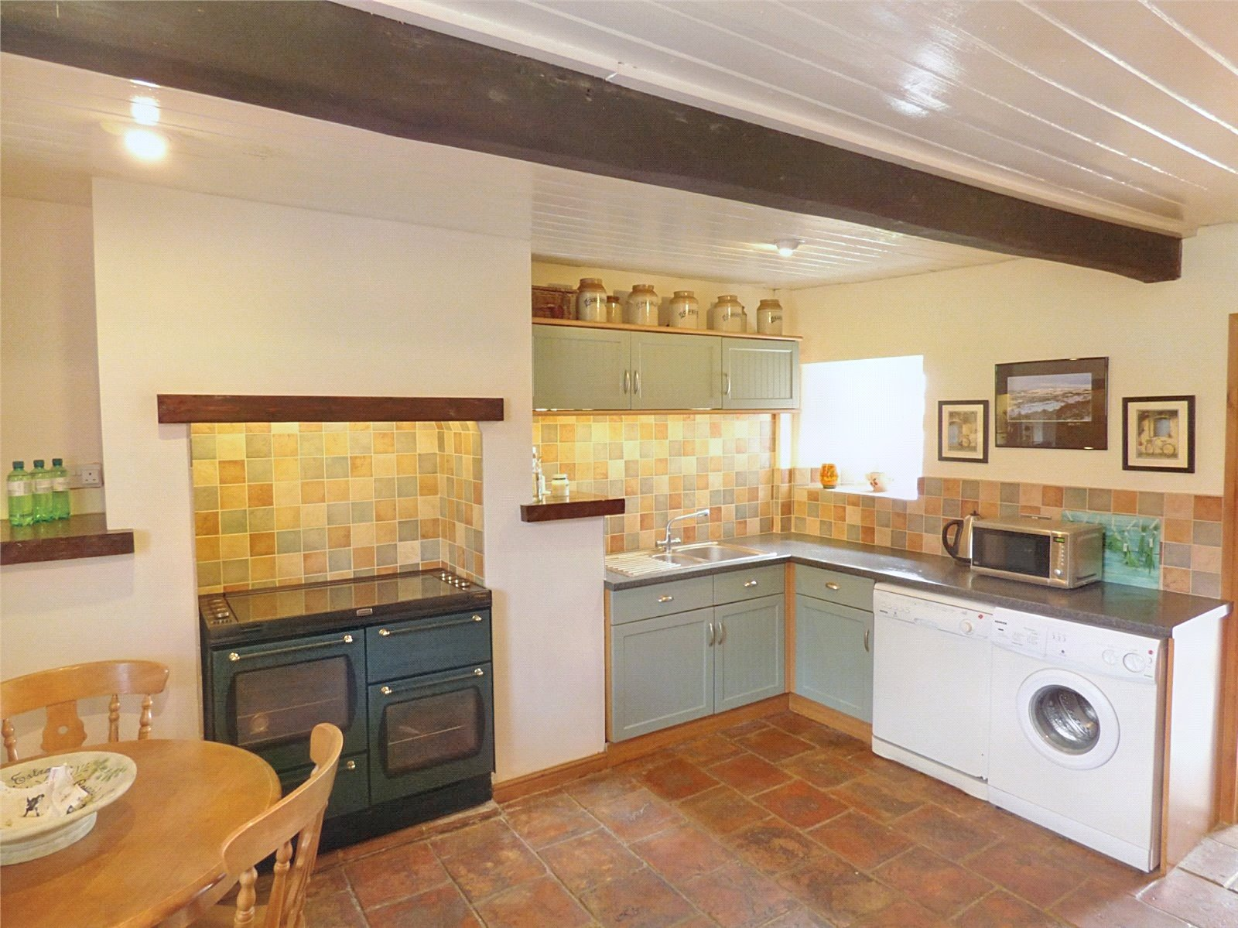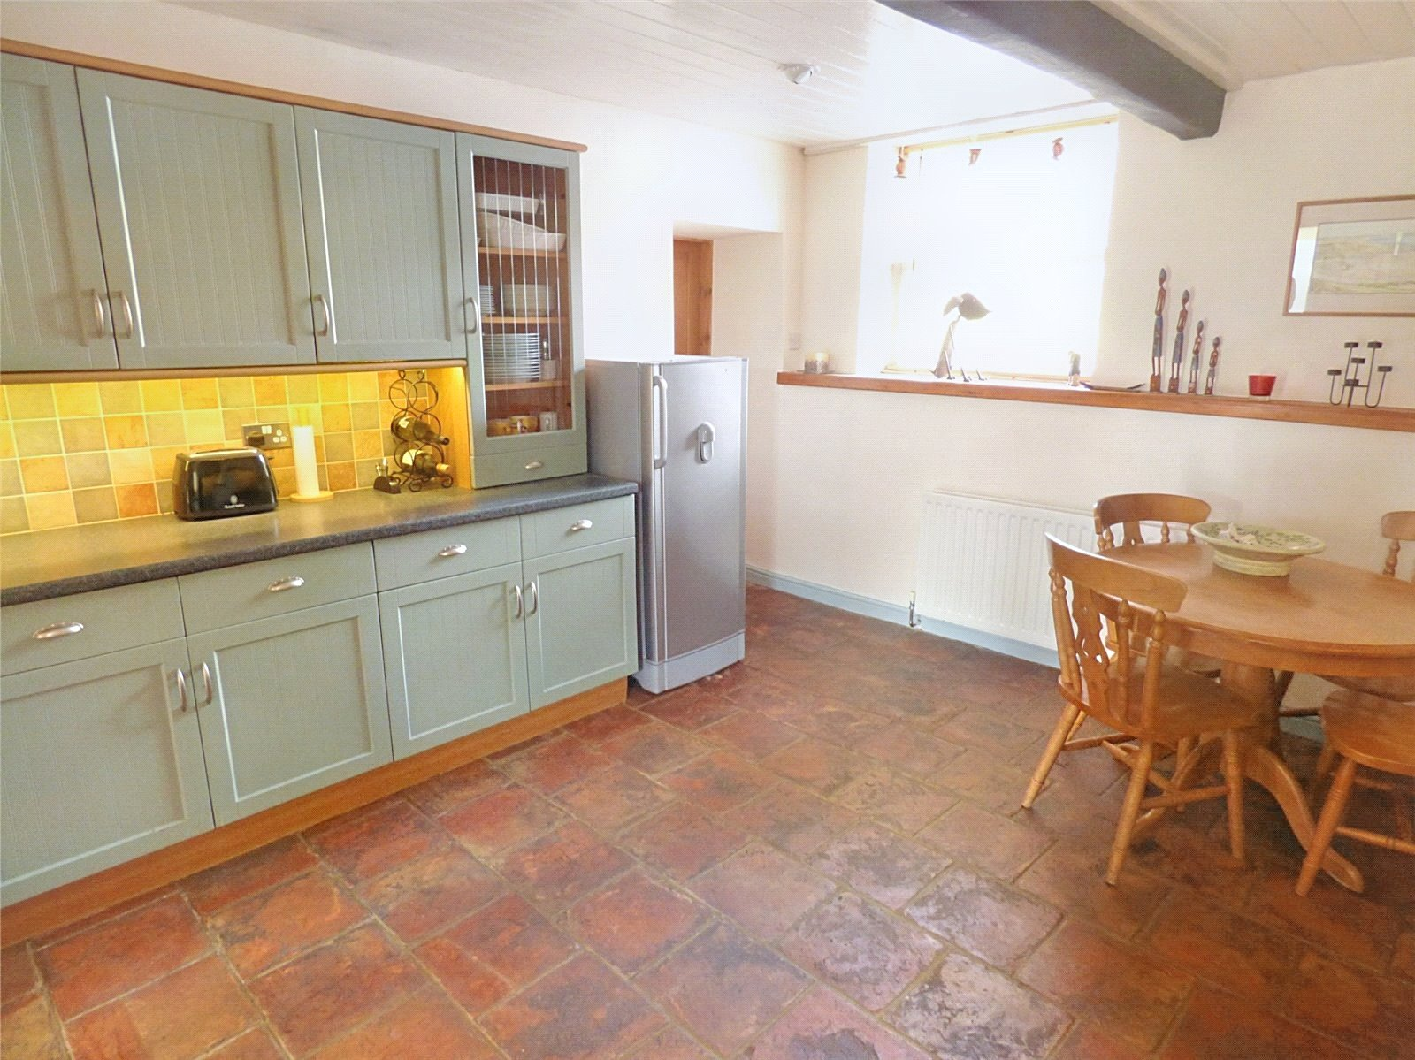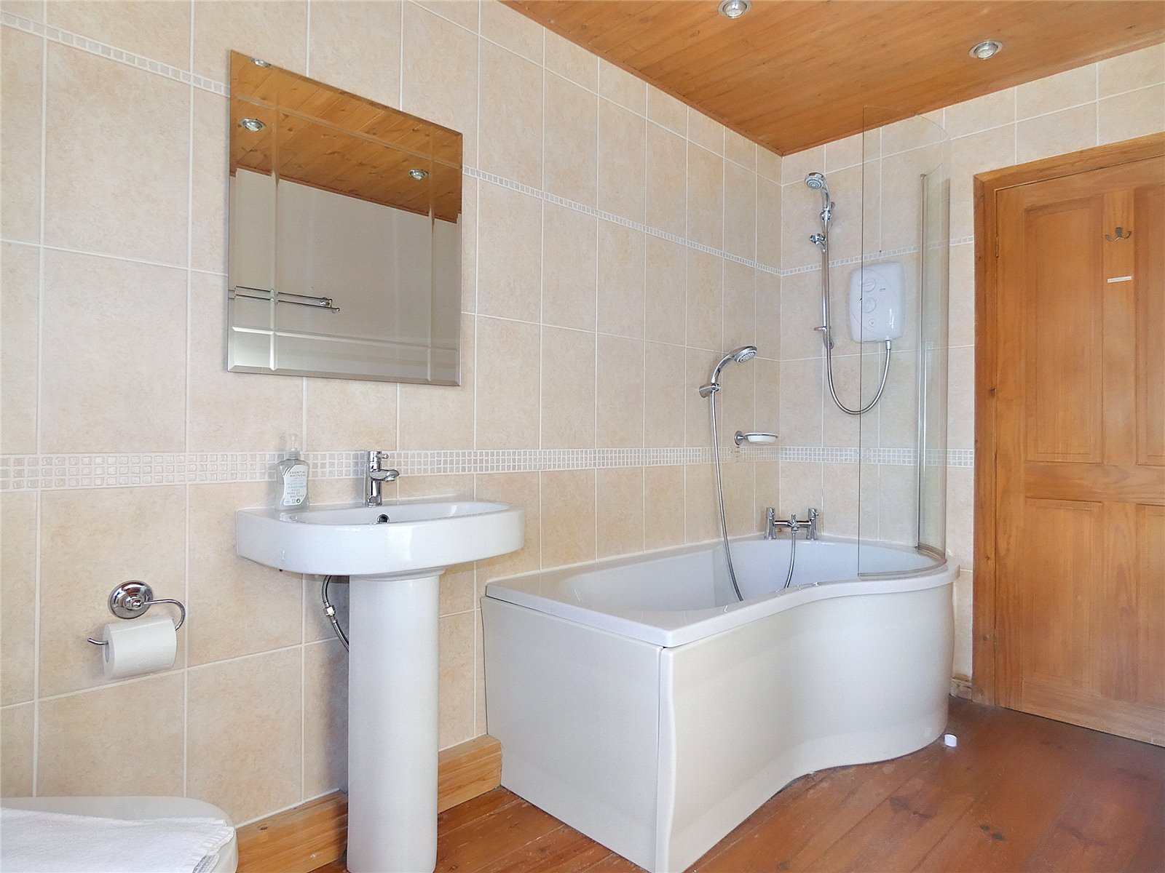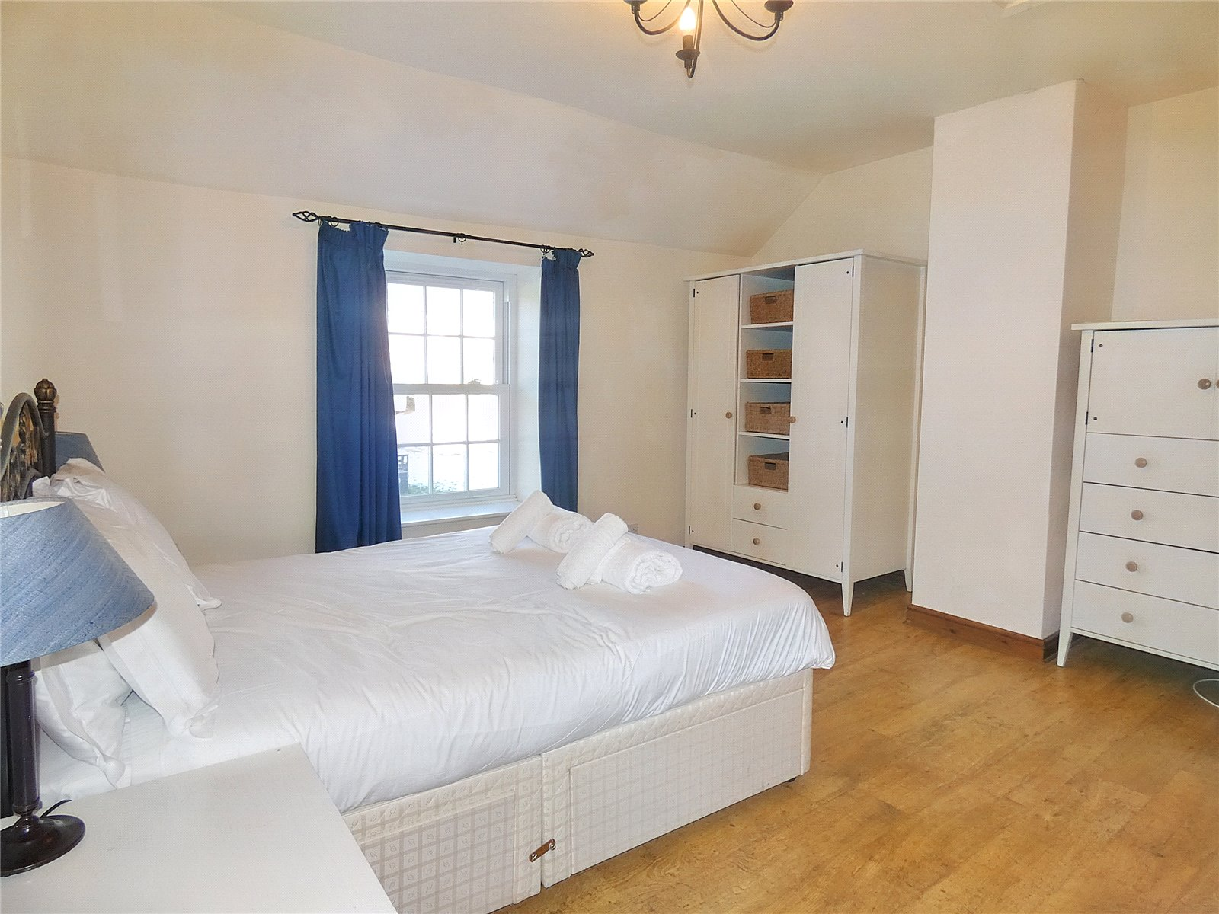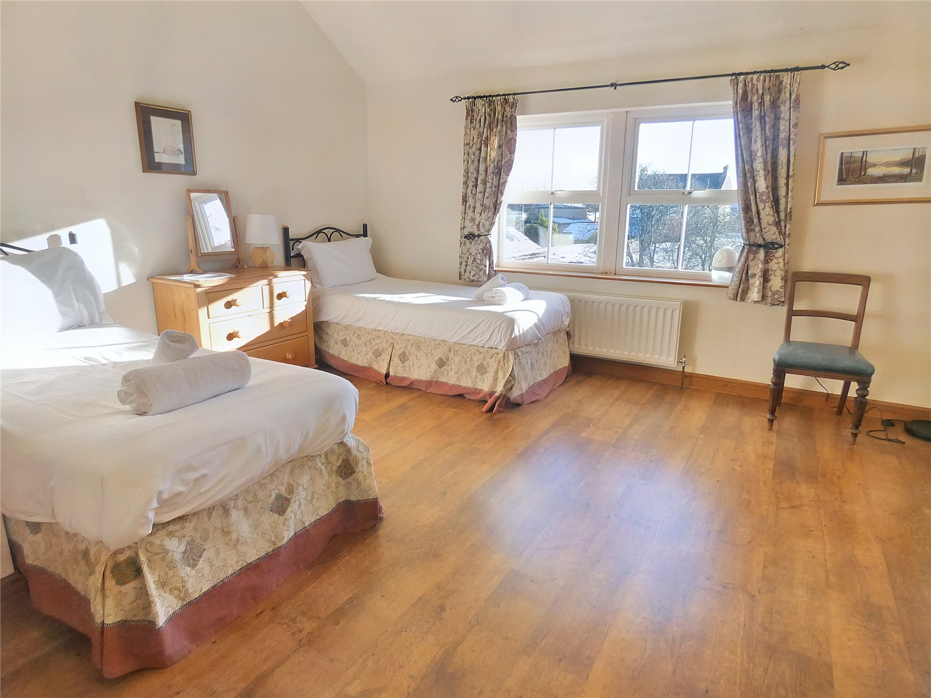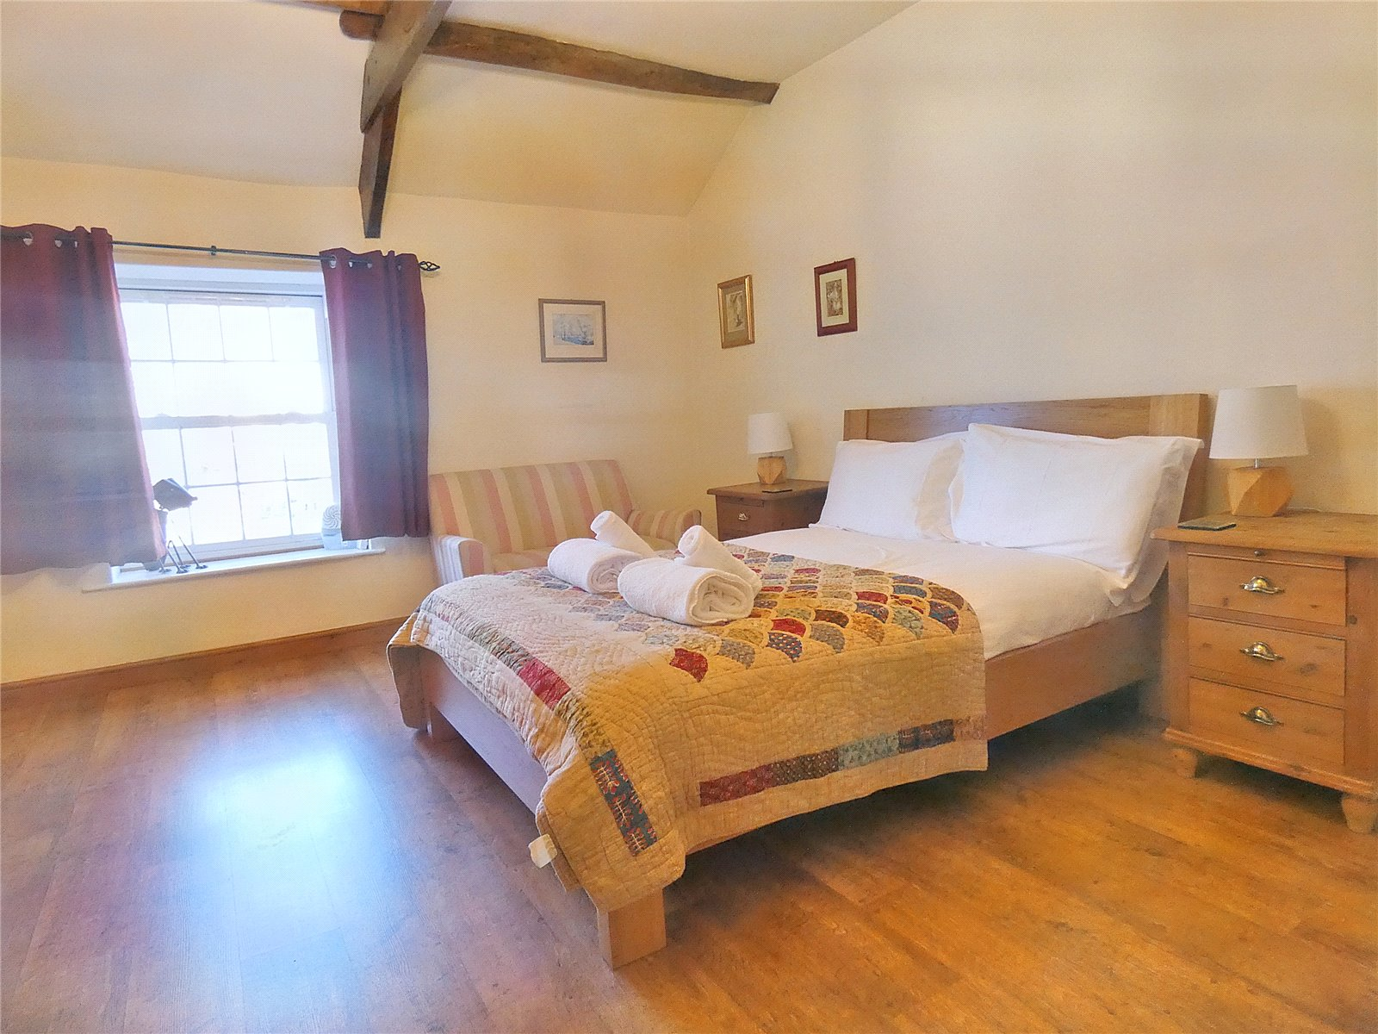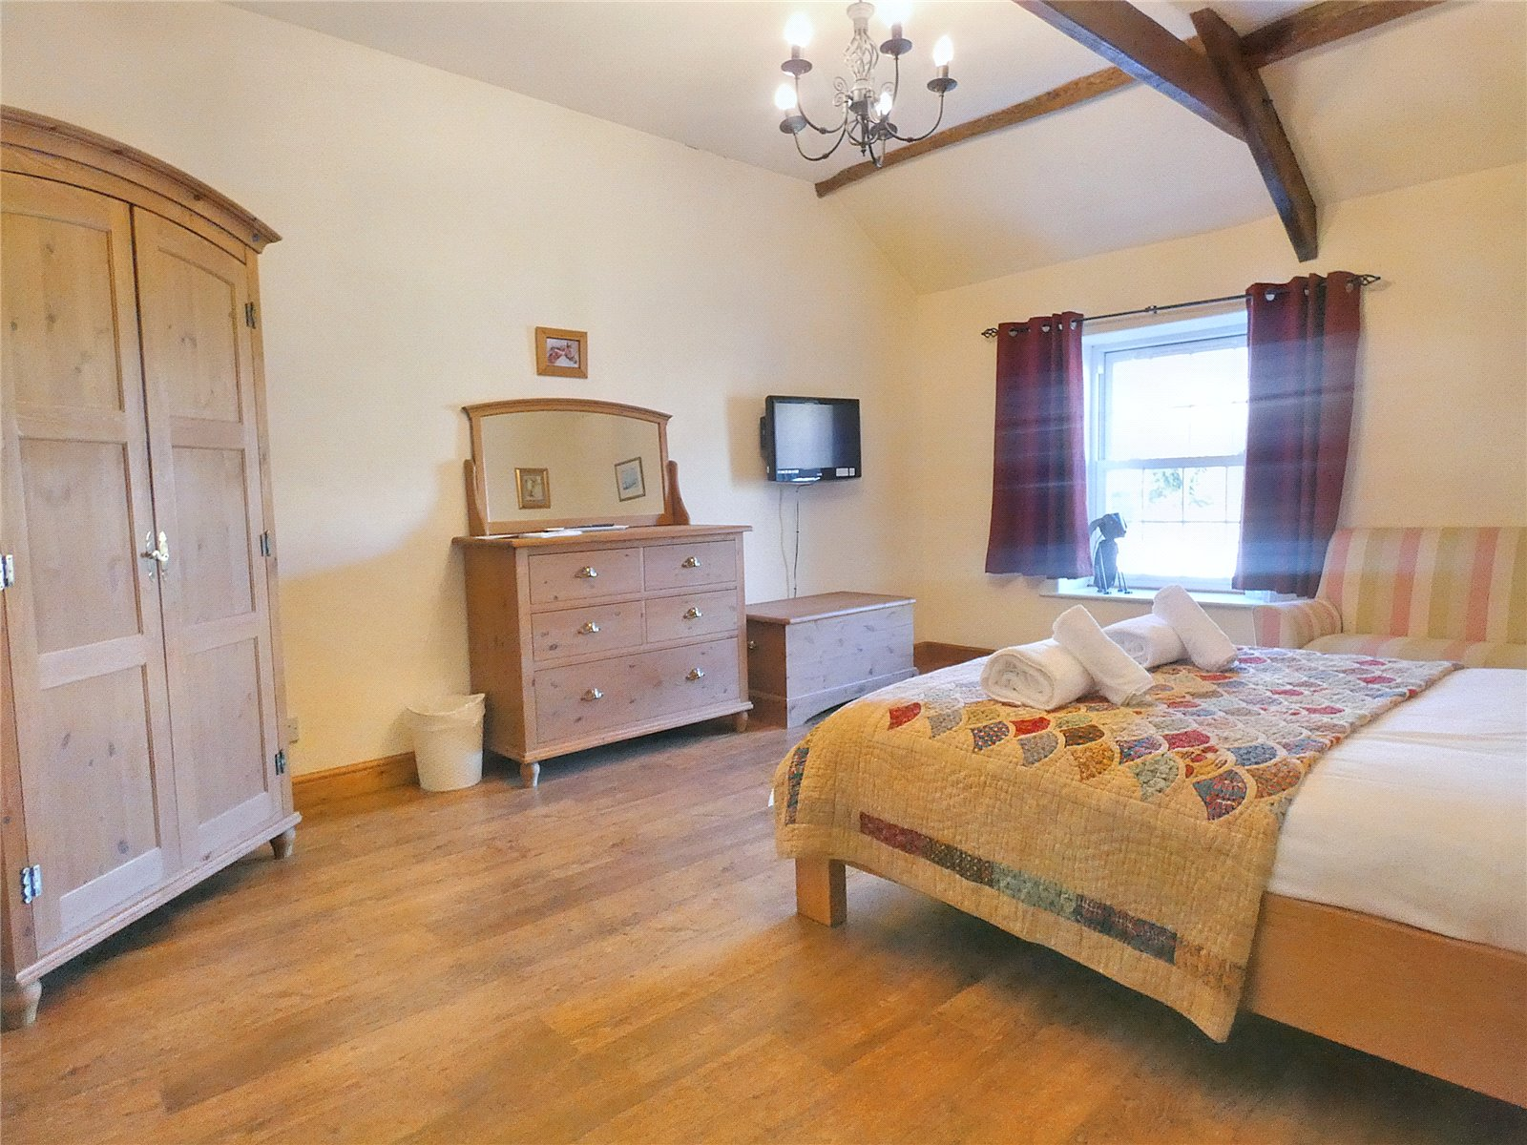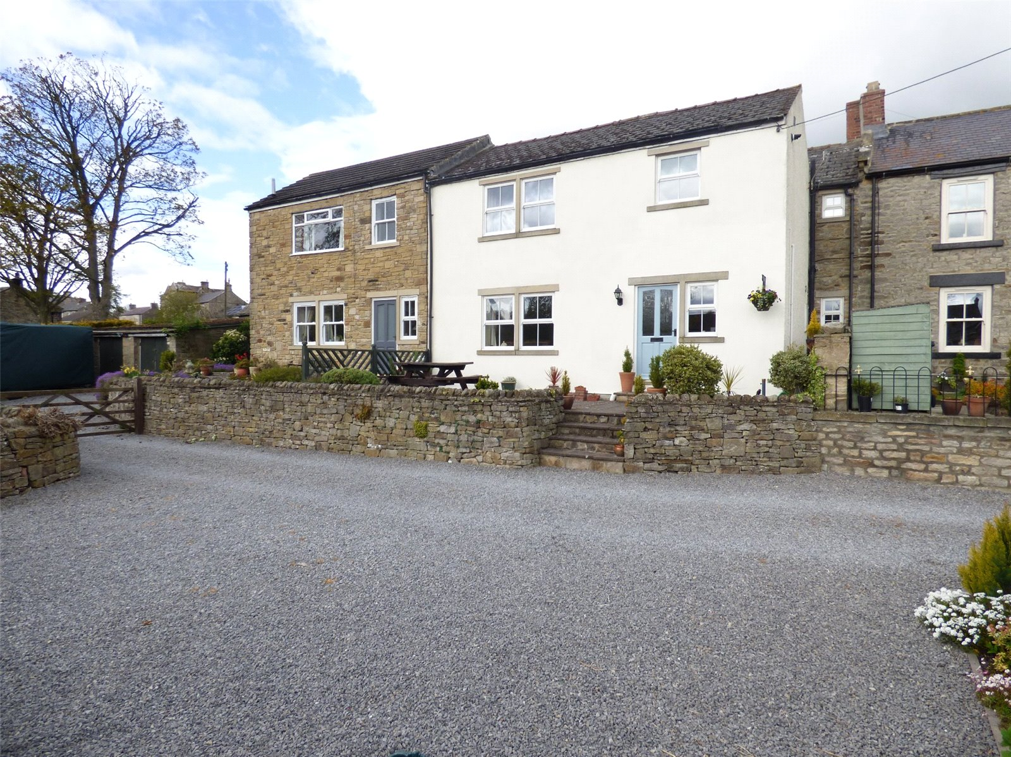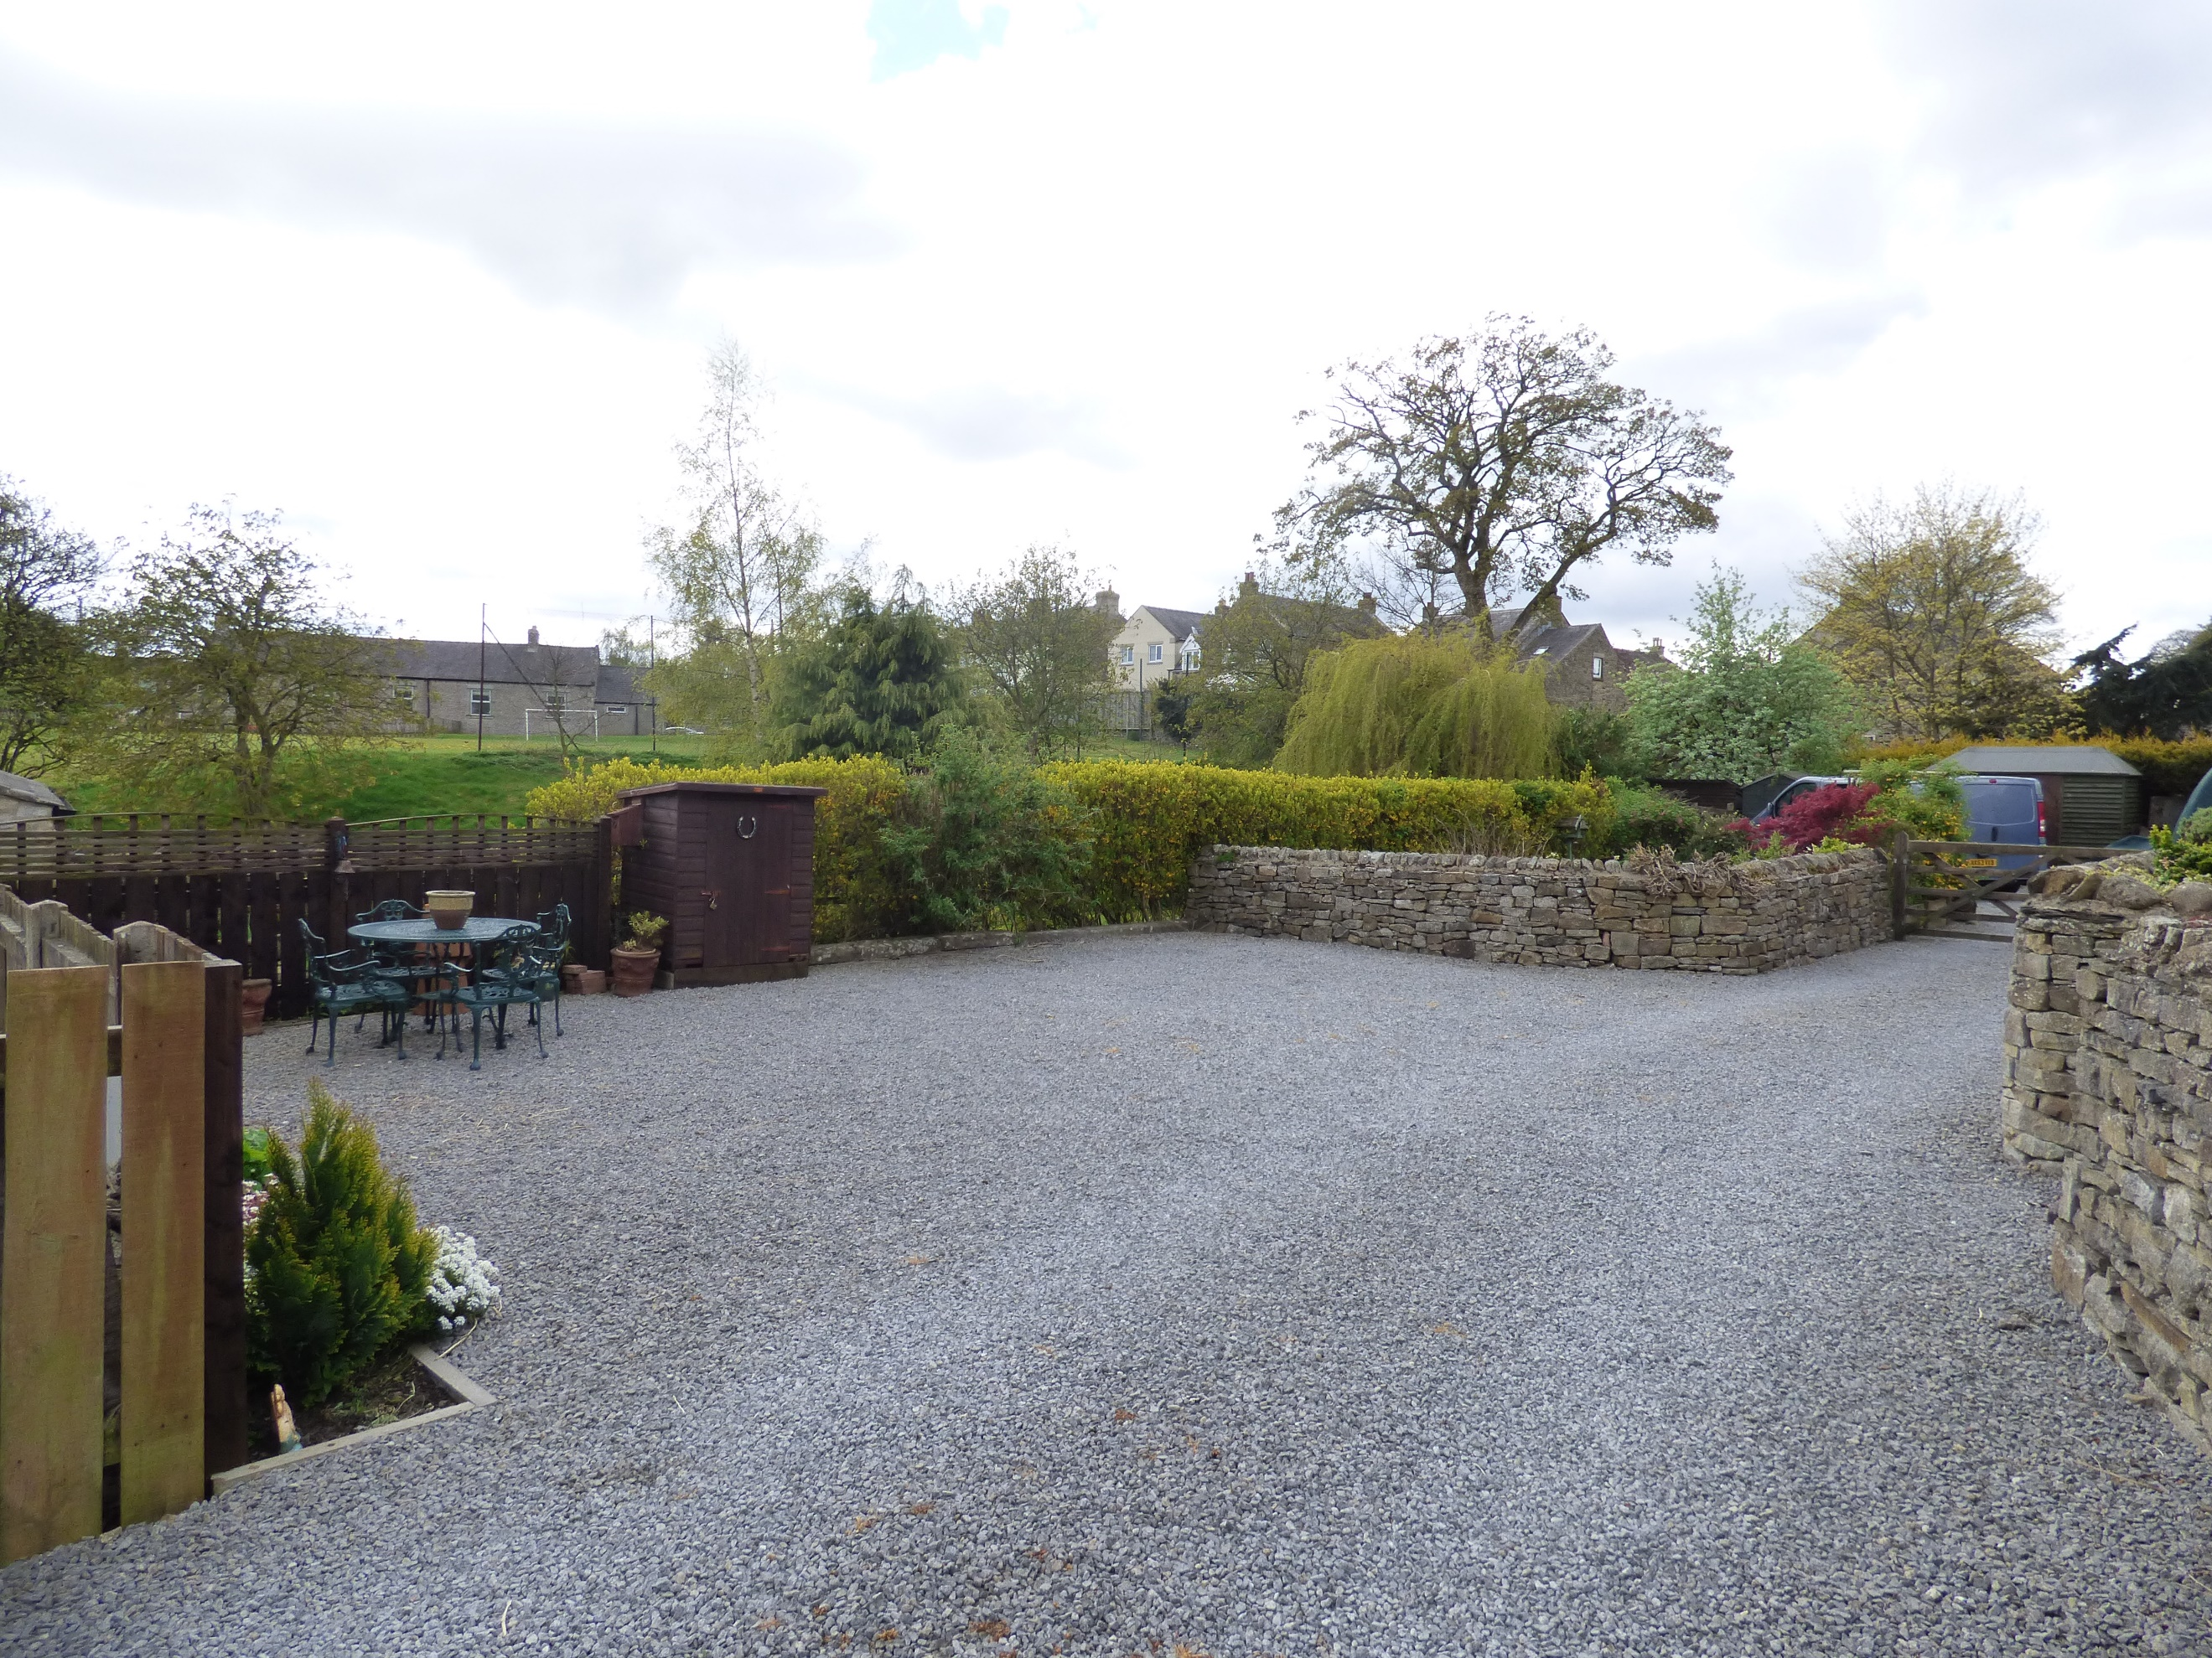
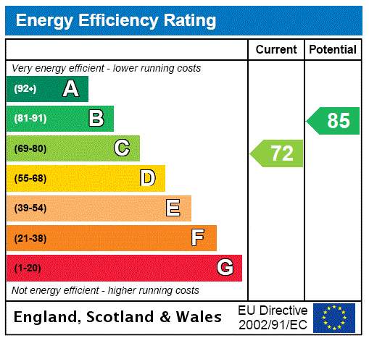
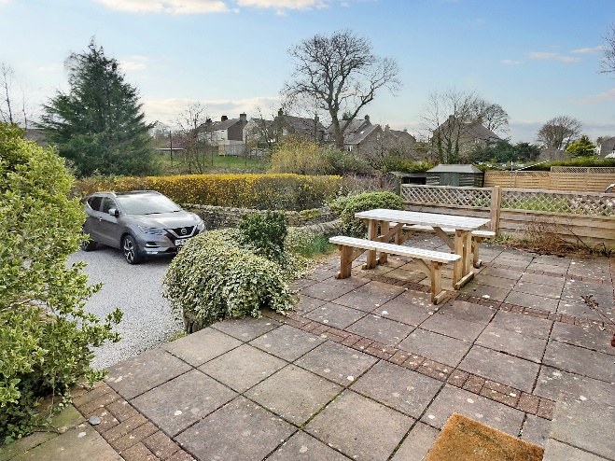
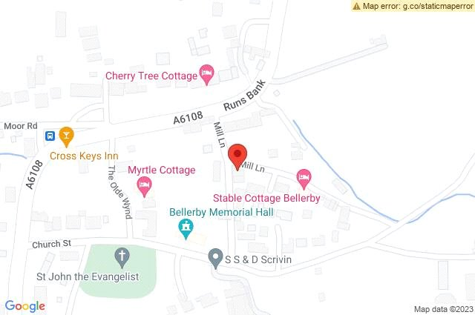
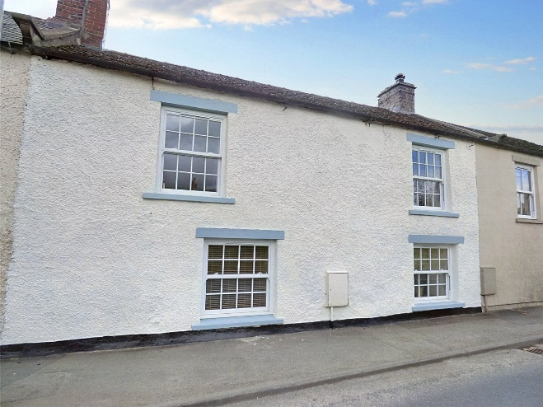
Items in these photographs and tours may not be included in the sale • J. R. Hopper & Co. has not tested services, fixtures, fittings, central heating, gas, and electrical systems. If in doubt, purchasers should seek professional advice • J. R. Hopper & Co, as Agents in the sale of the property will formally check the identification of prospective Purchasers. In addition, the Purchaser will be required to provide information regarding the source of funding as part of our offer handling procedure • Viewings by appointment only.

