
• Quietly Positioned Ground Floor Apartment
• Surprisingly Generous Living Space
• Stylishly Appointed Kitchen
• Contemporary Bathroom Suite
• Private Rear Garden – Perfect for Outdoor Enjoyment
• Ample On-Street Parking Available
• An Excellent First-Time Purchase or Investment Opportunity
Postcode: DL8 3RP

Tenure: Leasehold

Council Tax Band: A

Energy Efficiency Band: E

Local & Planning Authority:
North Yorkshire Council
Guide Price: £100,000 - £120,000
25 Little Ings, Gayle
J. R. Hopper & Co. is a trading name for J. R. Hopper & Co. (Property Services) Ltd. Registered: England No. 3438347.
Registered Office: Hall House, Woodhall, DL8 3LB. Directors: L. B. Carlisle, E. J. Carlisle
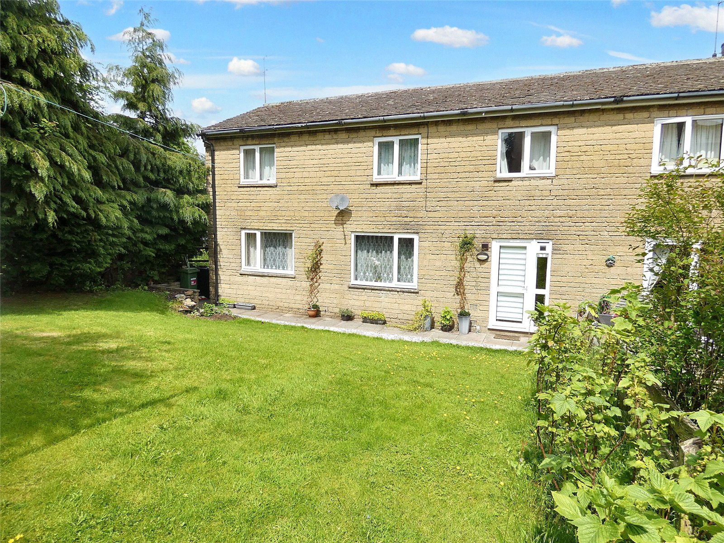
“For Sales In The Dales”
EST. 1886
Central Chambers
Market Place
Leyburn
North Yorkshire
DL8 5BD
Leyburn
Hawes
Settle
Kirkby Stephen
01969 622936
01969 667744
01729 825311
01768 258002
& Co.
www.jrhopper.com enquiries@jrhopper.com
J.R. HOPPER
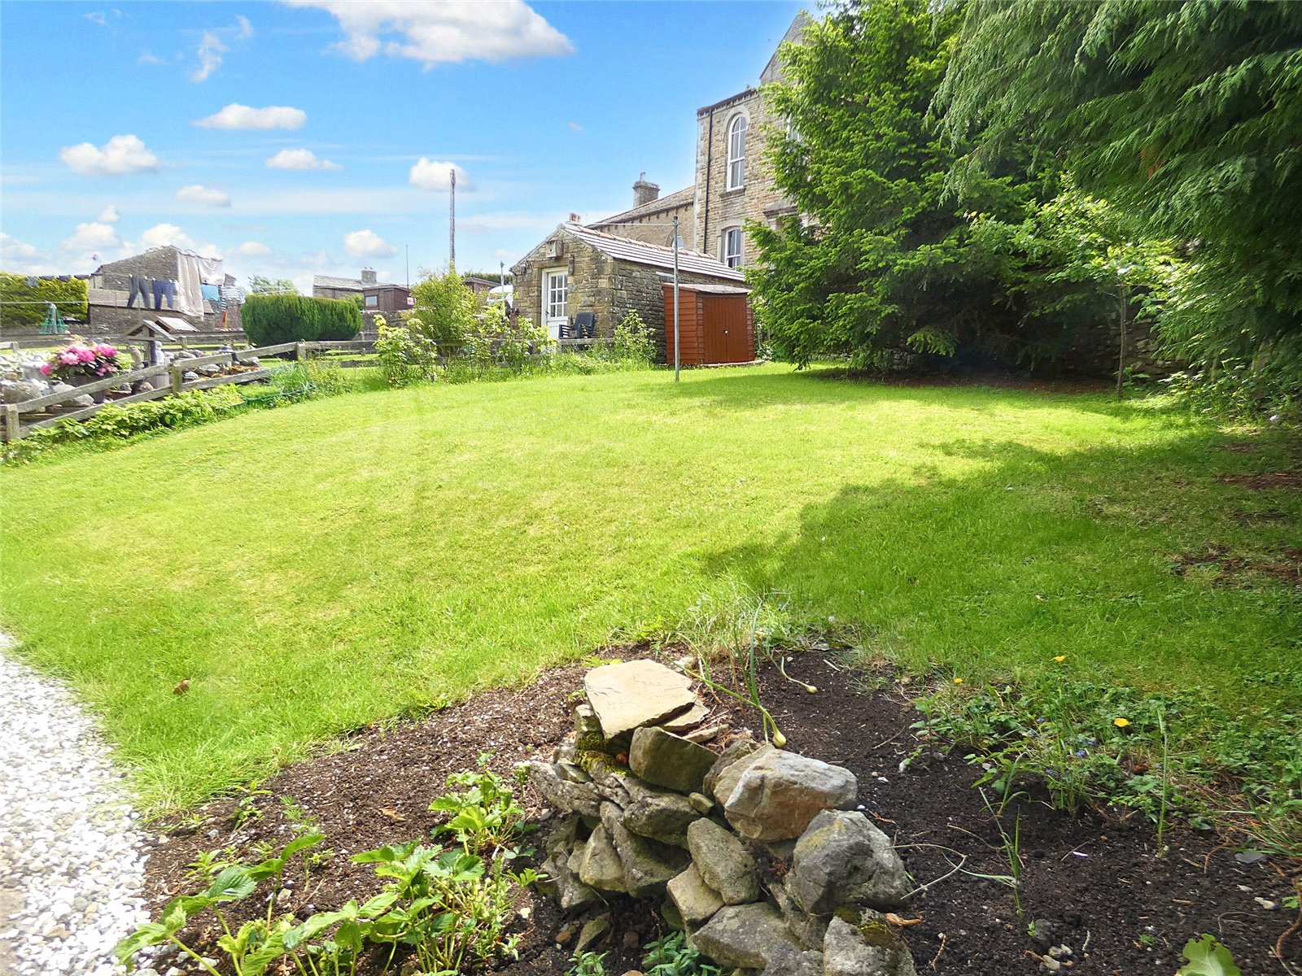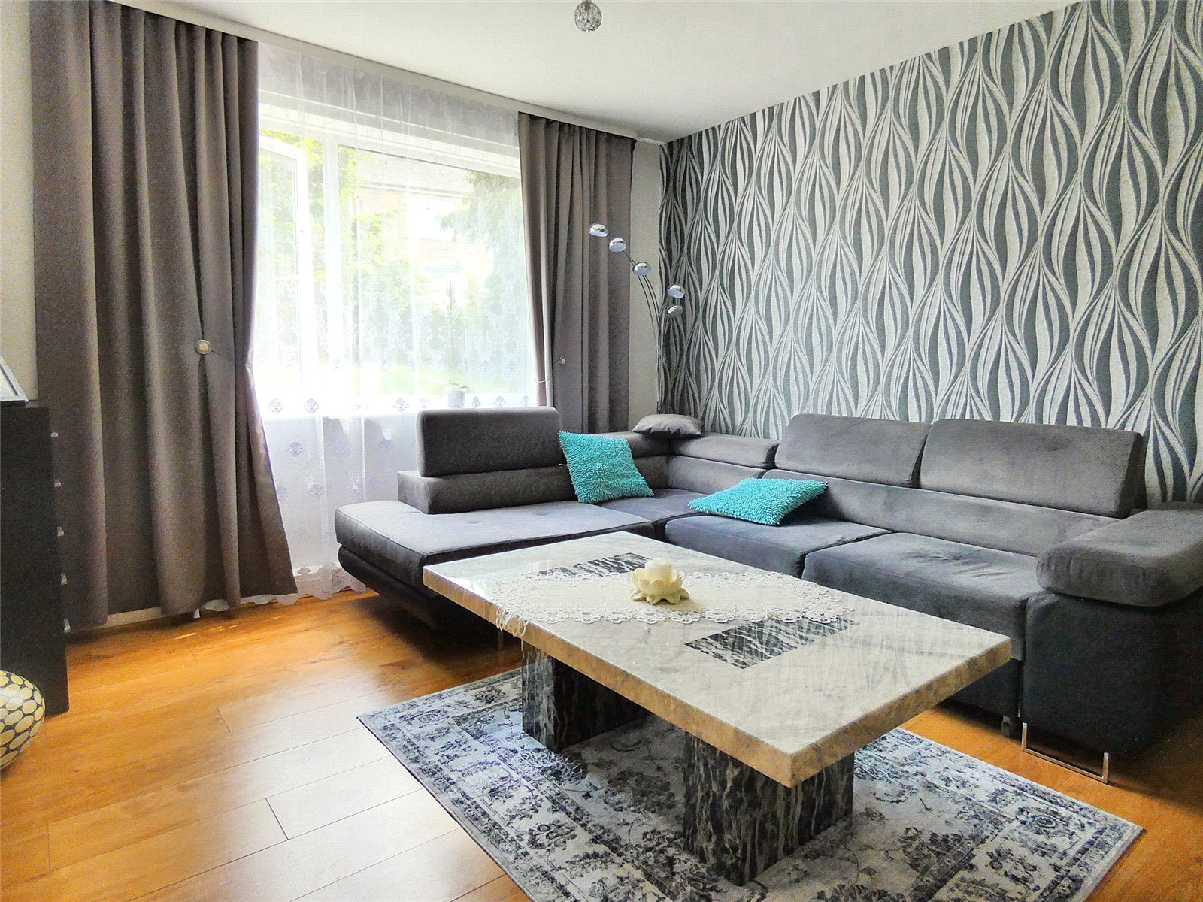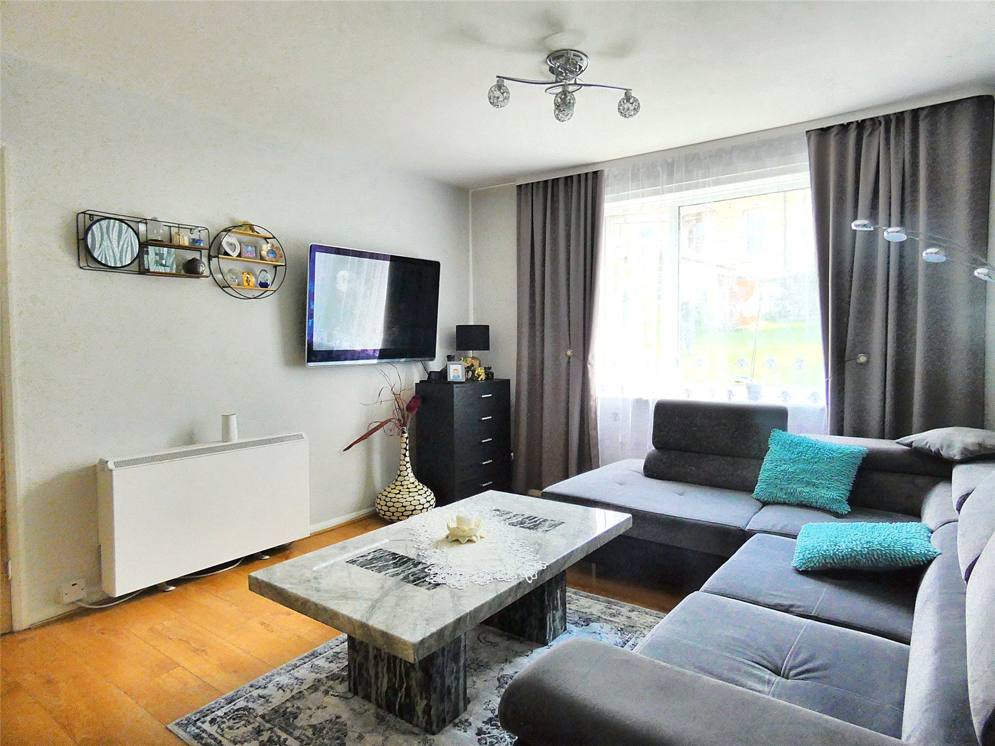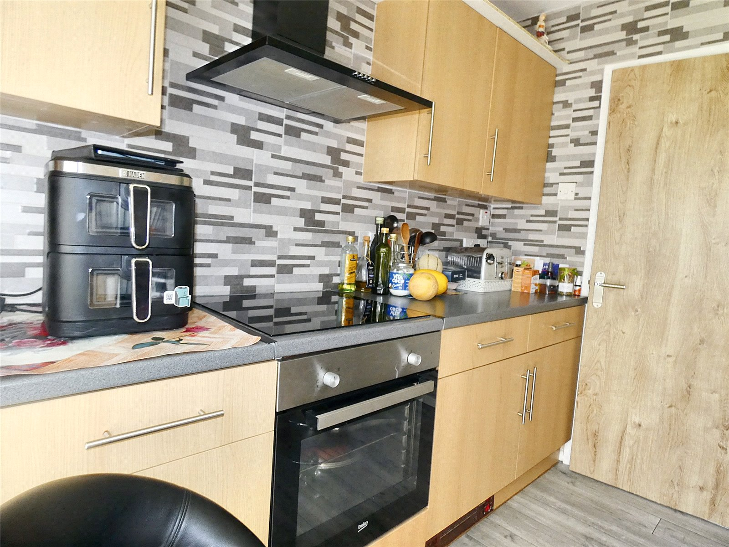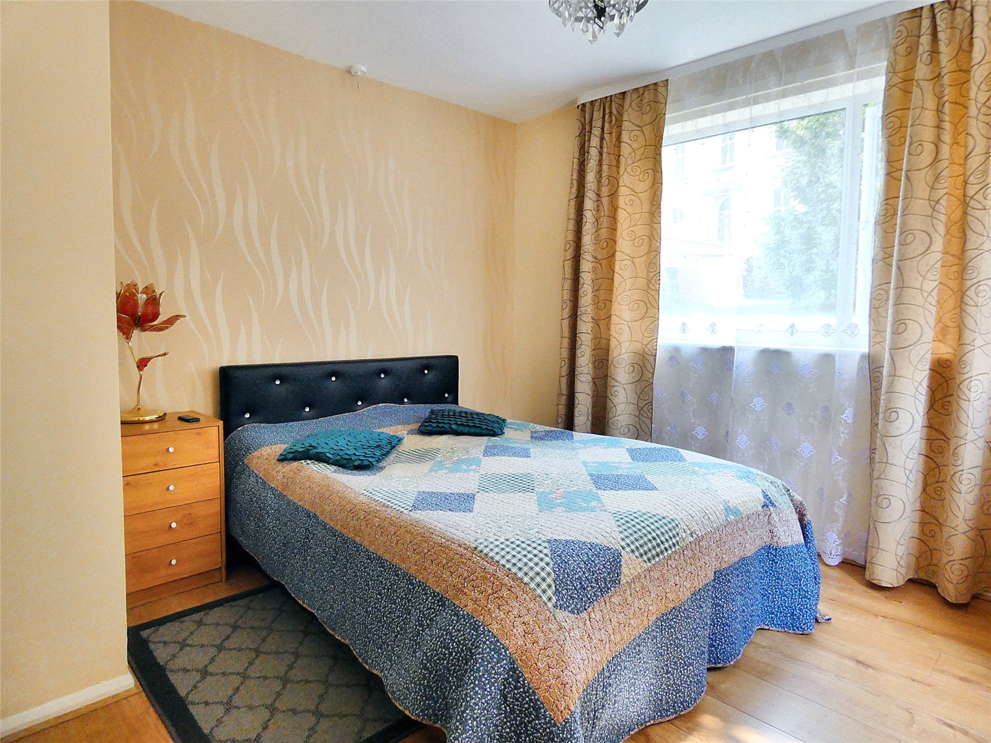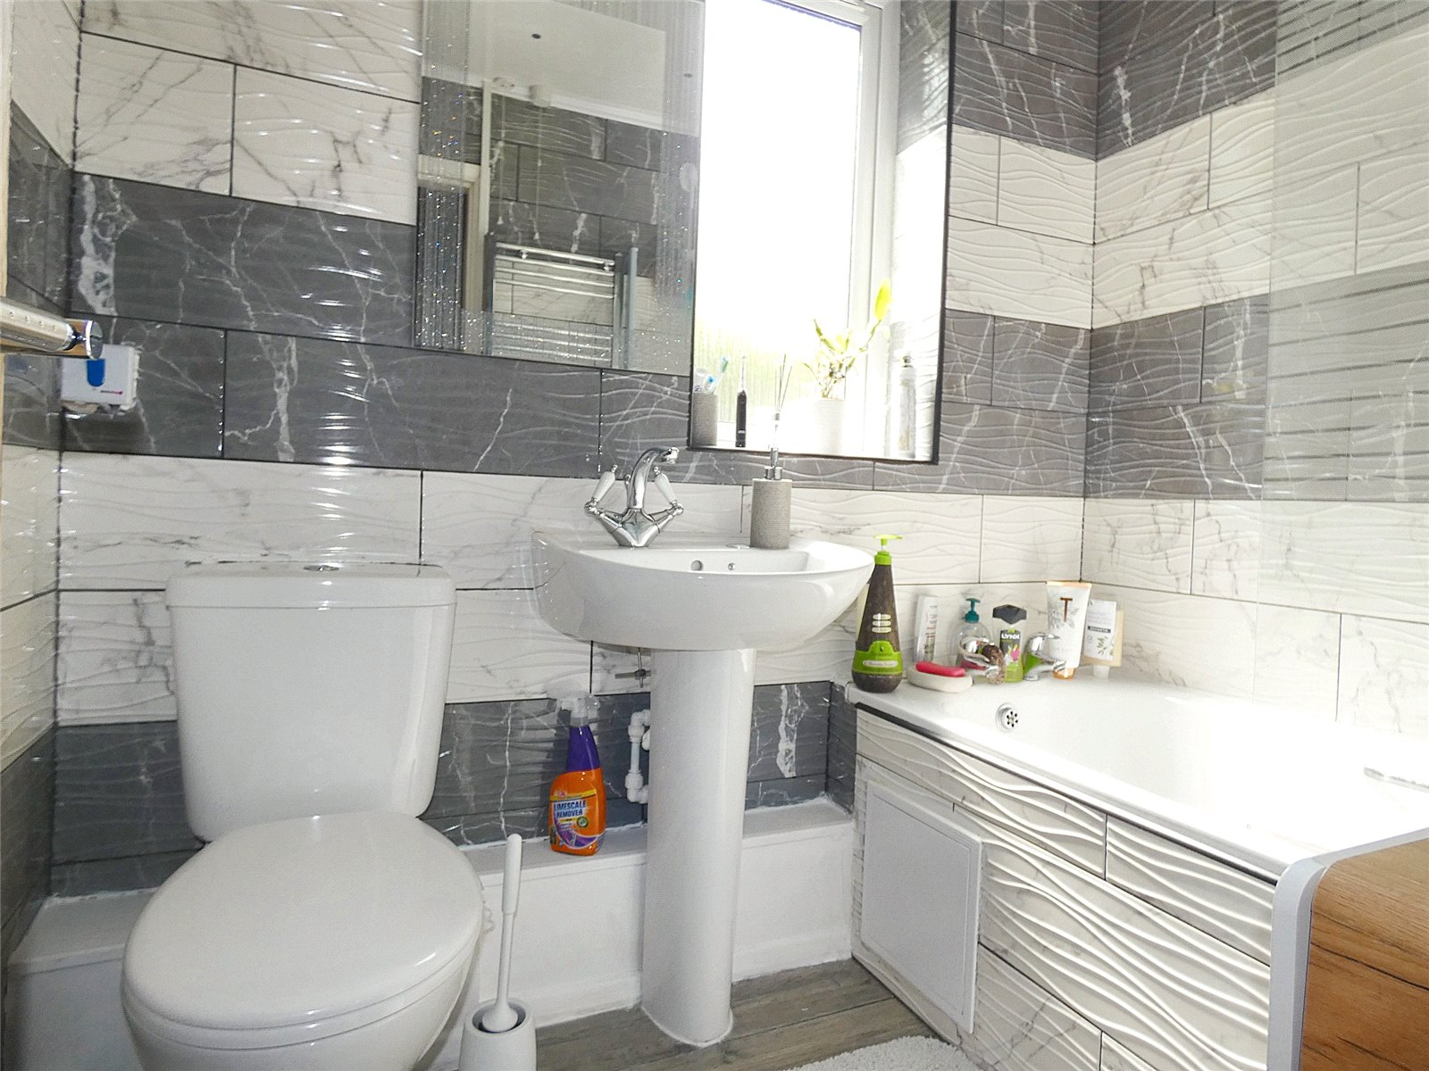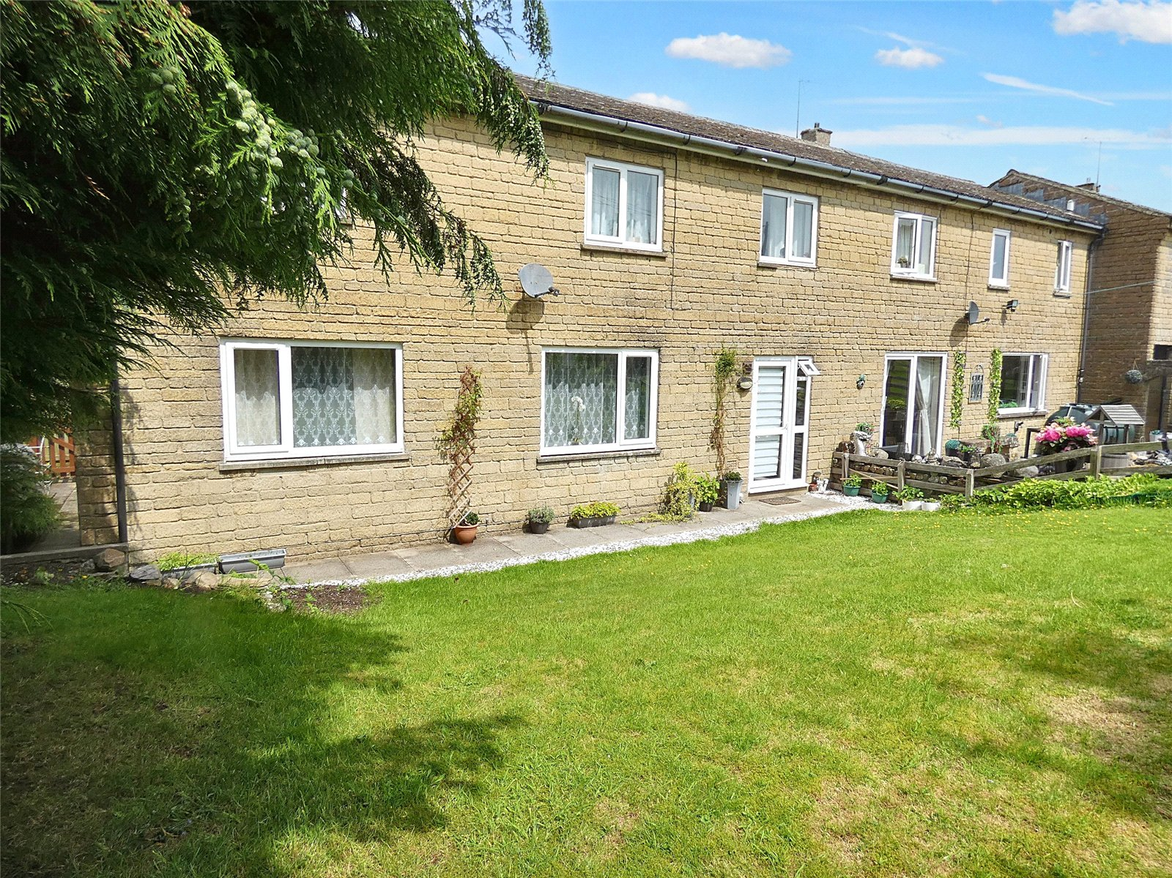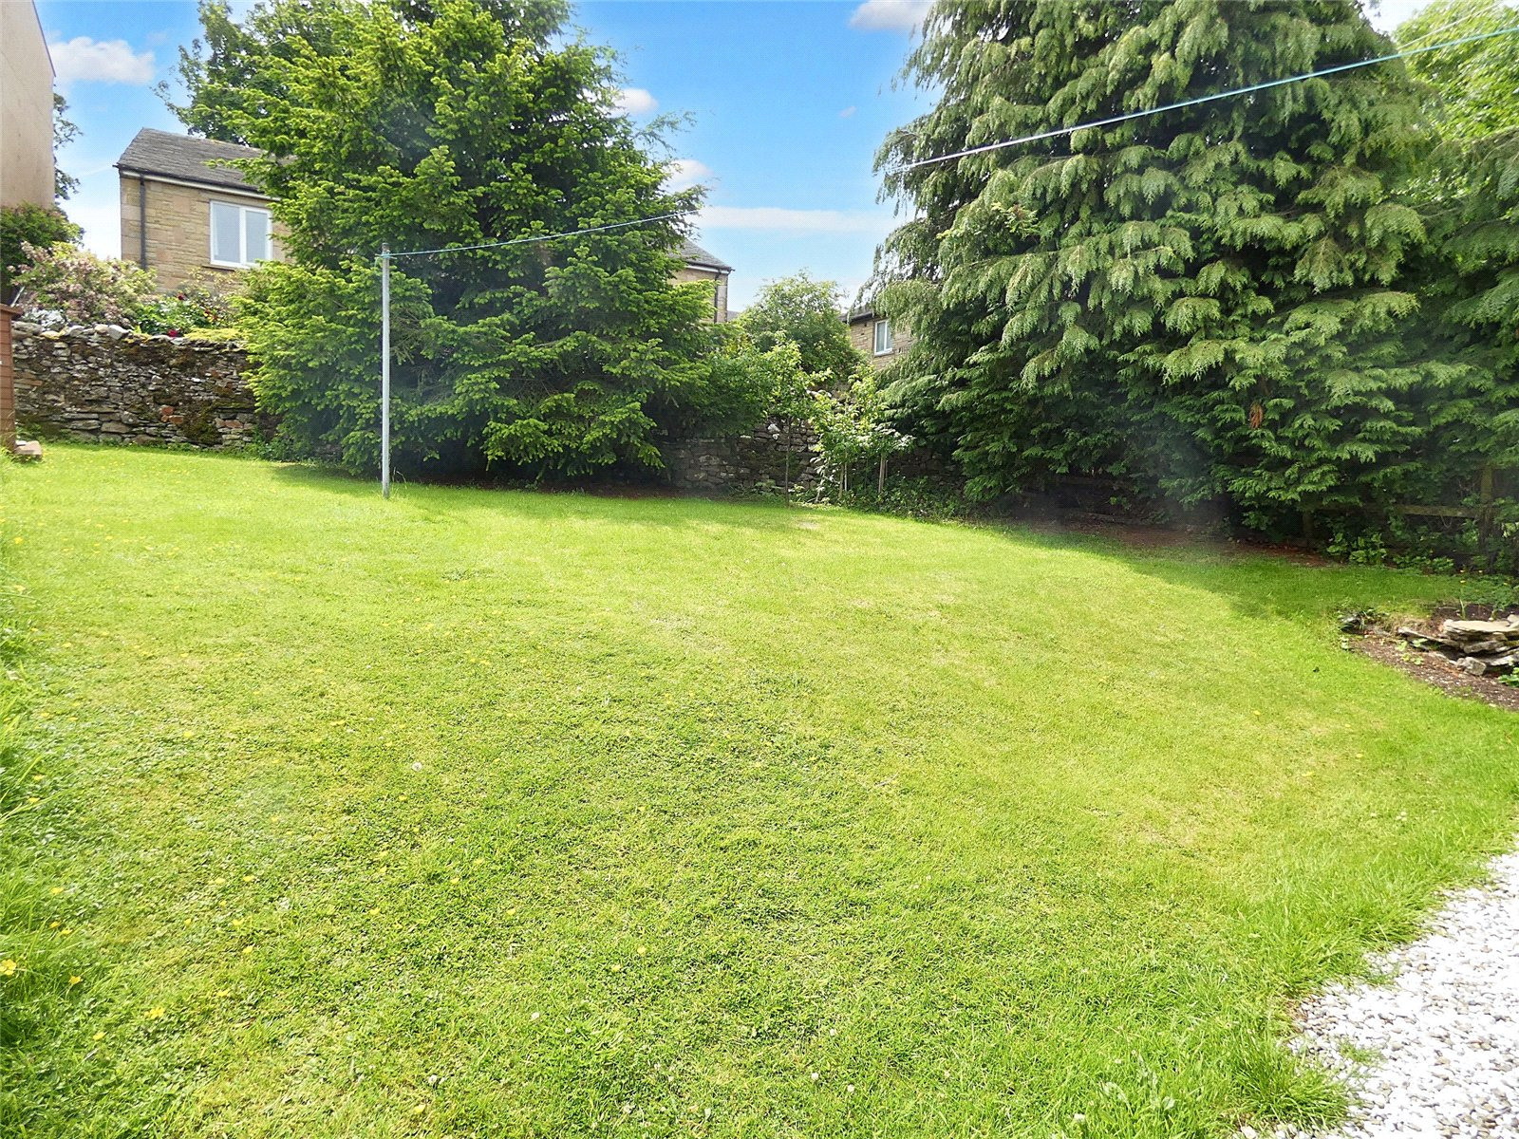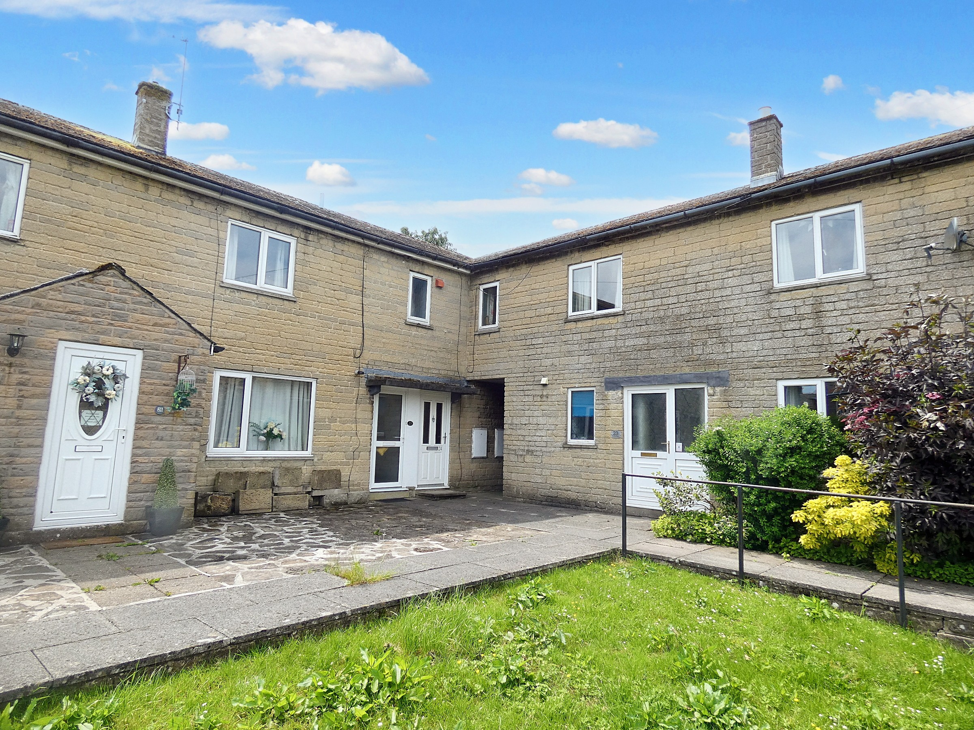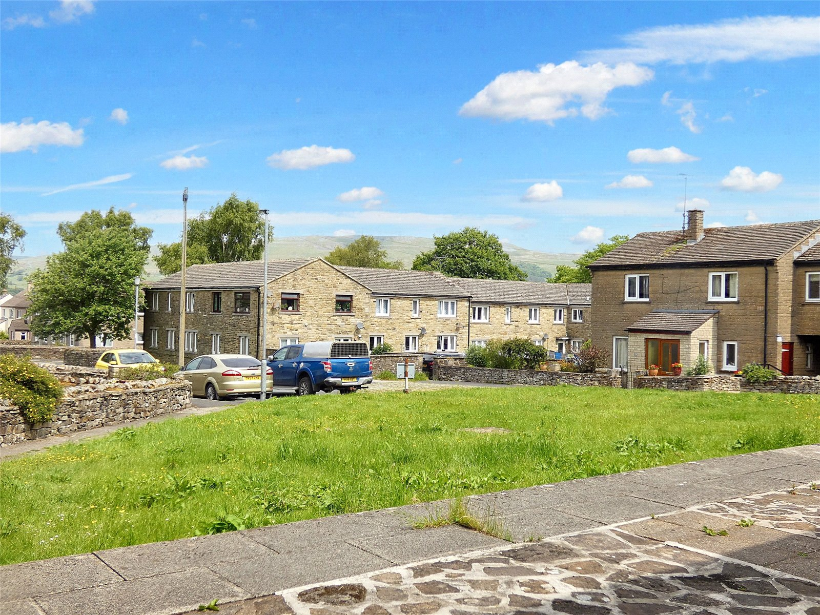

Located in the picturesque village of Gayle, just a short walk from the bustling market town of Hawes, 25 Little Ings is a ground-floor flat offering comfortable living in a desirable Yorkshire Dales setting.

Hawes is celebrated for its rich cultural heritage, most notably its renowned cheese-making traditions, breathtaking countryside, and vibrant farming community. The town features a weekly outdoor market, a range of independent shops, welcoming pubs, and restaurants. Key amenities include a church, chapel, doctor's surgery, and a primary school. While popular with visitors, Hawes retains a warm, close-knit community spirit, making it a wonderful place to live.

The property itself comprises a generously sized living room, a well-appointed kitchen, a double bedroom, and a family bathroom. Ample built-in storage cupboards throughout the flat provide practical and convenient living space.

Externally, the property enjoys access to communal front areas and a private, spacious rear garden, perfect for outdoor enjoyment. An external storage shed is also included.

This is an excellent opportunity for first-time buyers or those seeking a buy-to-let investment in a sought-after Dales location.

Entrance Hall Laminate flooring. Space for coats and shoes. Electric radiator. UPVC external door.

Kitchen Tiled flooring. Good range of wall and base units with complimentary worktops. Integrated electric oven, hob and extractor hood. Stainless steel sink. Plumbing for washing machine. Glazed external UPVC door to the rear garden.

Living Room Laminate flooring. TV point. Built in storage cupboards. Electric radiator. Large window overlooking the garden.

Hallway Laminate flooring. Large storage cupboard and boiler cupboard.

Bedroom Laminate flooring. TV point. Electric radiator. Two windows over dual aspects bringing in lots of natural light.

Bathroom Tiled flooring. Downlights. Extractor fan. Fully tiled walls. W/C. Wash basin. Bath with electric shower over. Heated towel rail. Frosted window to the side.

OUTSIDE

Large, private rear garden with wooden shed. Path to the front of property with space for bins.

Storage shed to the front.

Communal area to the front shared with neighbouring properties.

AGENTS NOTES

The property is leasehold with a 119 years remaining.

Double glazing and electric central heating throughout.

Broadband: Basic 17 Mbps
Superfast 61 Mbps

Very low flood risk

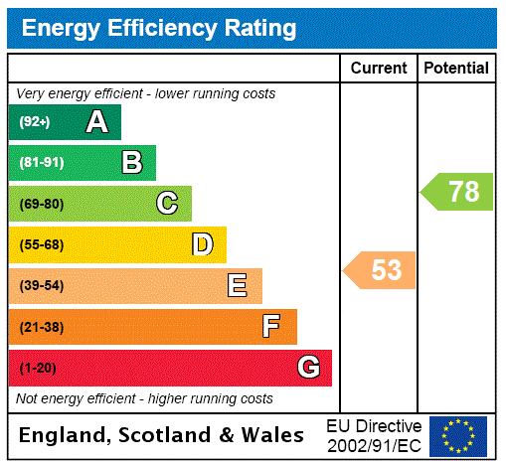
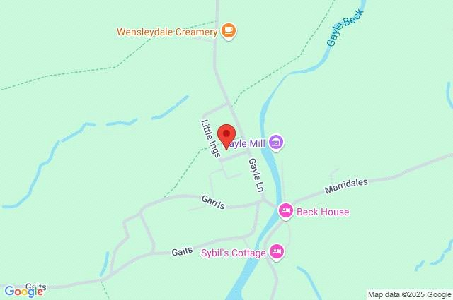
Items in these photographs and tours may not be included in the sale • J. R. Hopper & Co. has not tested services, fixtures, fittings, central heating, gas, and electrical systems. If in doubt, purchasers should seek professional advice • J. R. Hopper & Co, as Agents in the sale of the property will formally check the identification of prospective Purchasers. In addition, the Purchaser will be required to provide information regarding the source of funding as part of our offer handling procedure • Viewings by appointment only.

