
• Beautiful Cottage In Sought After Village Location
• Lovely Coverdale Views
• 3 Good Bedrooms
• Living Room
• Dining Room
• Kitchen & Pantry
• Bathroom & Separate WC
• Front & Rear Gardens
• Private Parking Available
• Chain Free

Postcode: DL8 4AY

Tenure: Freehold

Council Tax Band: D

Energy Efficiency Band: TBC

Local & Planning Authority: North Yorkshire Council

Offers in the region of: £280,000
Beech Cottage, Carlton
J. R. Hopper & Co. is a trading name for J. R. Hopper & Co. (Property Services) Ltd. Registered: England No. 3438347.
Registered Office: Hall House, Woodhall, DL8 3LB. Directors: L. B. Carlisle, E. J. Carlisle
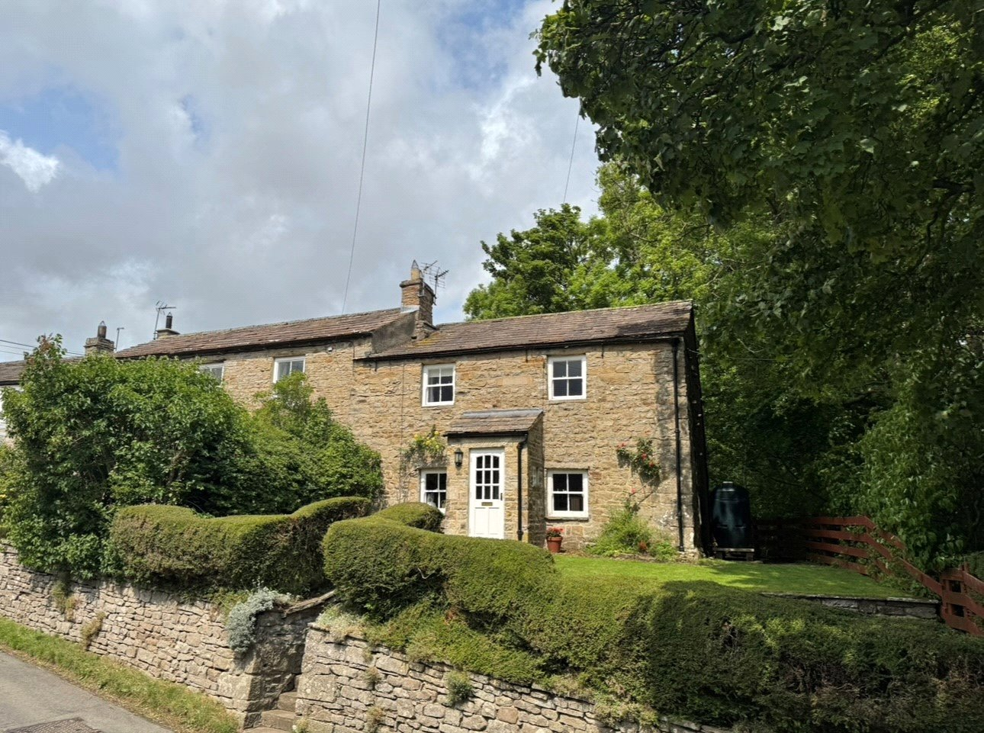
“For Sales In The Dales”
EST. 1886
Central Chambers
Market Place
Leyburn
North Yorkshire
DL8 5BD
Leyburn
Hawes
Settle
Kirkby Stephen
01969 622936
01969 667744
01729 825311
01768 258002
& Co.
www.jrhopper.com enquiries@jrhopper.com
J.R. HOPPER

Beech Cottage is a lovely semi-detached period property in the sought-after village of Carlton, in Coverdale.

The village itself is a popular Dale's village with an active village hall, and a good sense of community spirit, where even the Forester's Arms is owned by the local community. Carlton is approximately 6 miles from the thriving market town of Leyburn with a good range of shops, restaurants and pubs, as well as both primary and secondary schools, church, chapel and doctors.

This beautiful cottage offers the perfect blend of character, comfort, and countryside charm. Enjoy lovely views from this delightful home, which features three spacious bedrooms, a welcoming living room, and a separate dining room ideal for entertaining or family meals. The well-appointed kitchen comes with an adjoining pantry, providing plenty of storage and functionality. A family bathroom and separate WC add convenience. This property benefits from oil central heating.

Outside to the front is a lovely, enclosed, South facing lawned garden with well-established shrubs. There is also a patio seating area to the front and a gate of convenience down to the parking place. To the rear is a low maintenance patio garden and handy storage shed.

Beech Cottage would make a fantastic investment property or family home and is currently run as a holiday cottage.

Ground Floor

Entrance Porch Stone flagged floor. Stone shelf. Window to side. Front door.

Dining Room Fitted carpet. Feature alcove shelves. Built in cupboard. Radiator. Window to front. Feature beams. fireplace housing electric stove.

Living Room Fitted carpet. Radiator. Feature beams. Stone fireplace. Open fire. Feature alcove shelves. Window to front.

Kitchen Laminate wood flooring. Radiator. Wall and base units. Integrated electric oven and hob. Extractor hood. Plumbing for washer. Integrated dishwasher. 1 1/2 bowl stainless steel sink and drainer. Space for fridge. Window to rear.

Pantry Oil fired central heating boiler. Shelves. Storage cupboard. Window to rear.

Rear Hall Laminate wood effect flooring. Space under stairs. Oak staircase. Door to rear patio garden. Window to rear.

Stairs & Landing Fitted carpet. Loft access to boarded and insulated loft.

First Floor

Bedroom 1 Large double bedroom. Fitted carpet. Radiator Window to front with lovely views.

Bedroom 2 Good double bedroom. Fitted carpet. Radiator. Feature alcove shelf and cupboard. Window to front with pleasant views.

Bedroom 3 Good bedroom. Fitted carpet. Radiator. Washbasin. Window to rear.

Bathroom Laminate flooring. Shelves. Washbasin. Bath with shower over. Partially tiled walls. Heated towel rail.

WC Laminate flooring. Radiator. WC. Washbasin. Built in cupboard. Frosted window to rear.

Outside

Front South facing lawned garden. Well established shrubs. Garden path to front door. Steps down to patio seating area. Convenience gate down to parking area. Pleasant views.

Rear Low maintenance patio garden. Handy storage shed. Path leading down the side of the property to the front garden.

Parking Space for 1 vehicle. Rented from parish council currently for £50 per year. (Bid for annually)

Services
Private water supply managed by a parish council sub committee.
Mains sewerage and drains.
Mains electric.
Oil central heating.

No history of flooding.

Broadband
Basic 17 Mbps. Superfast 80 Mbps.

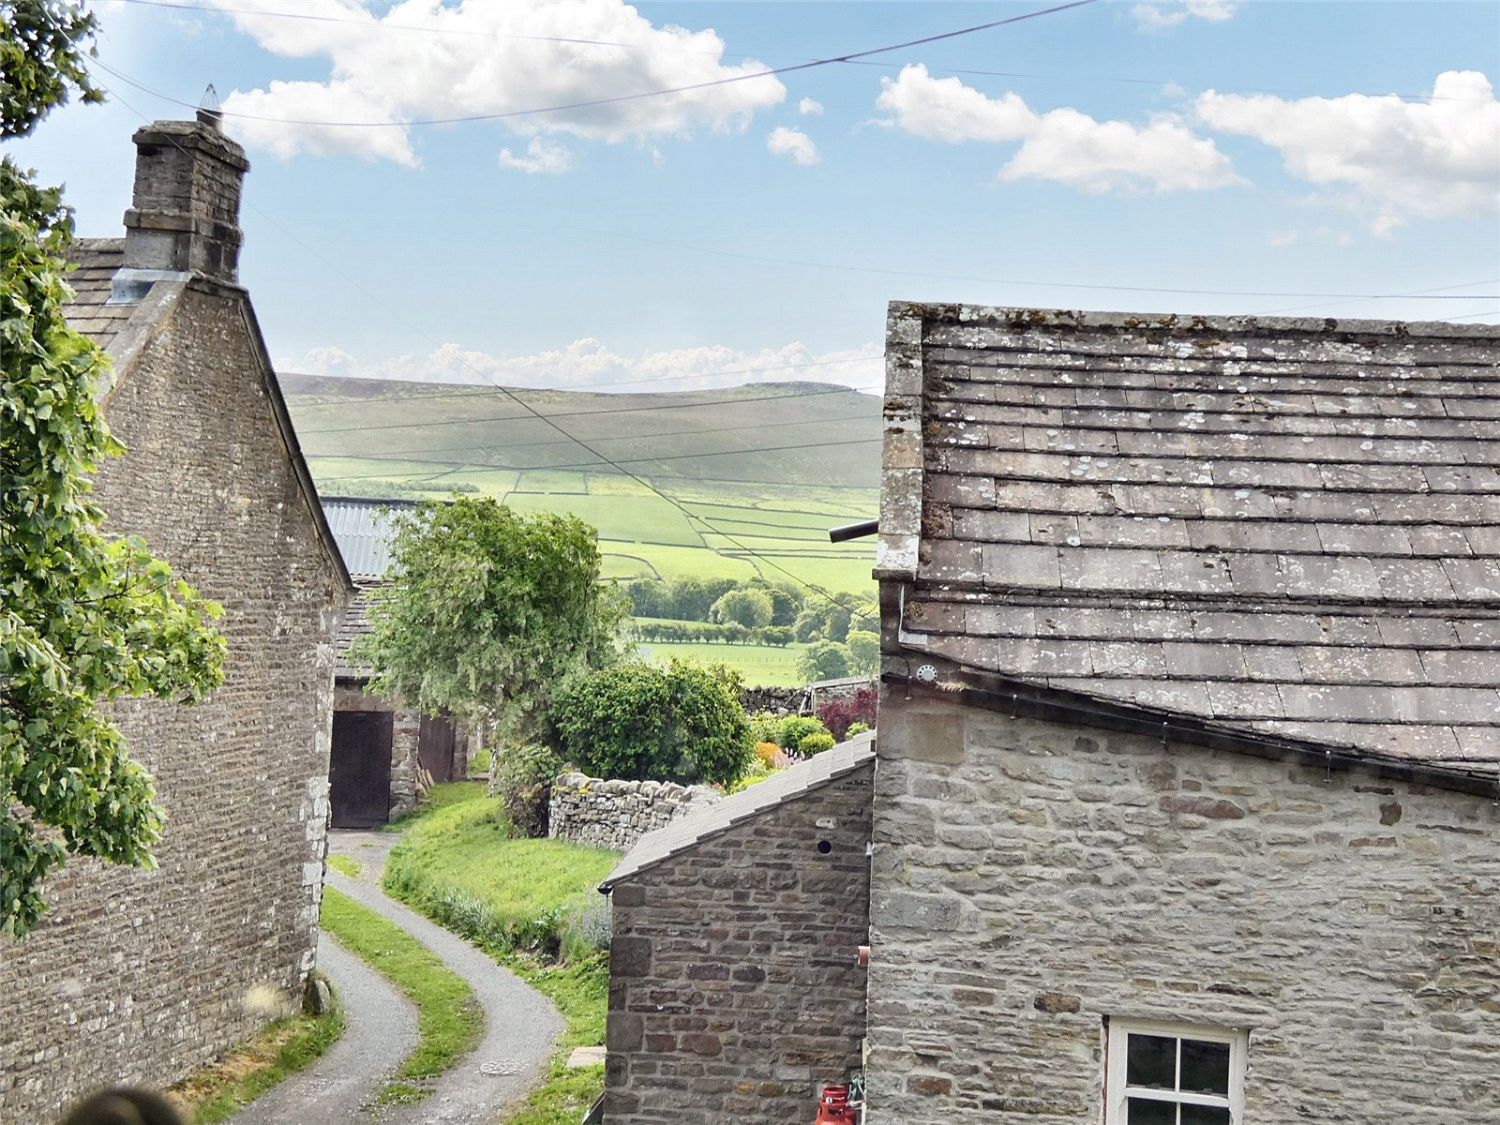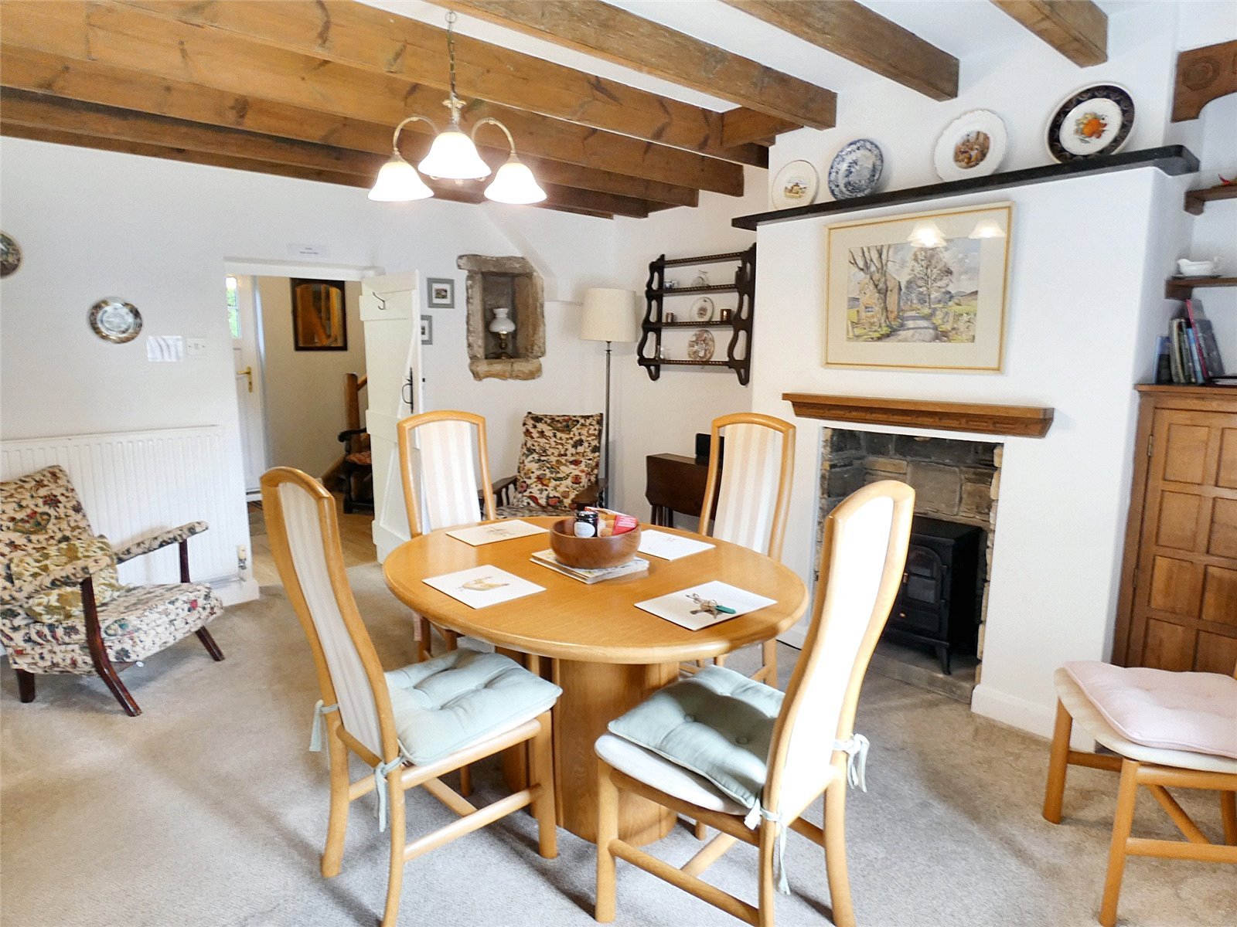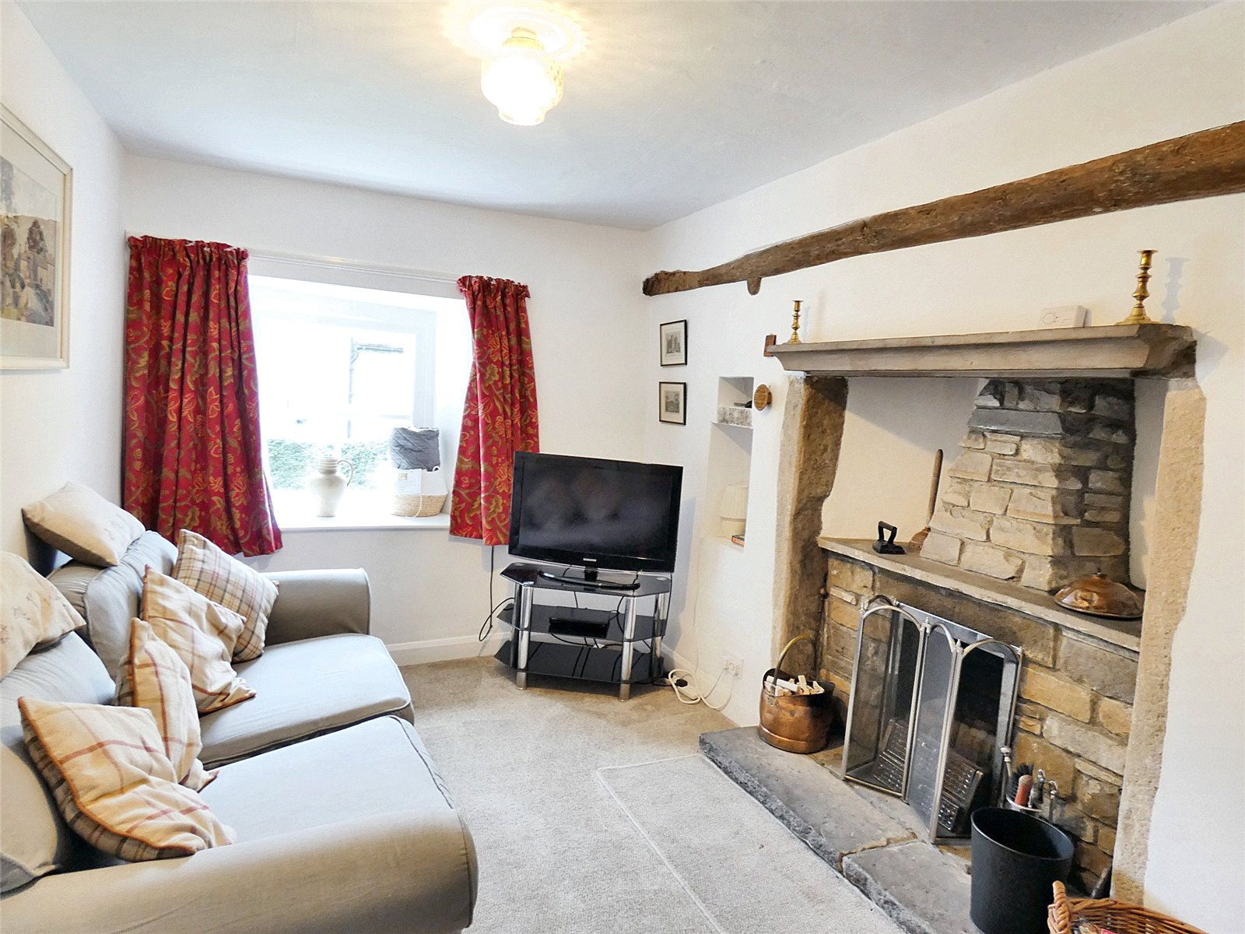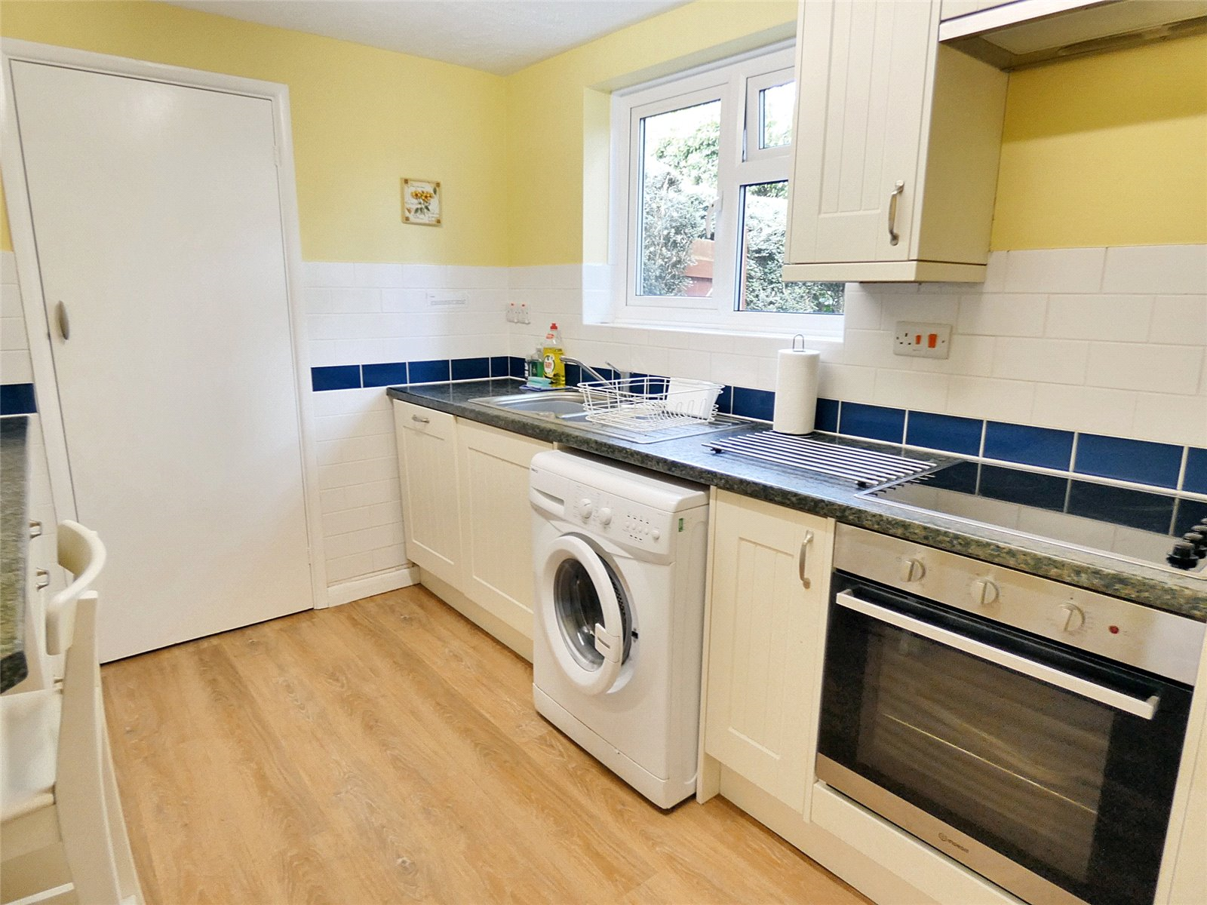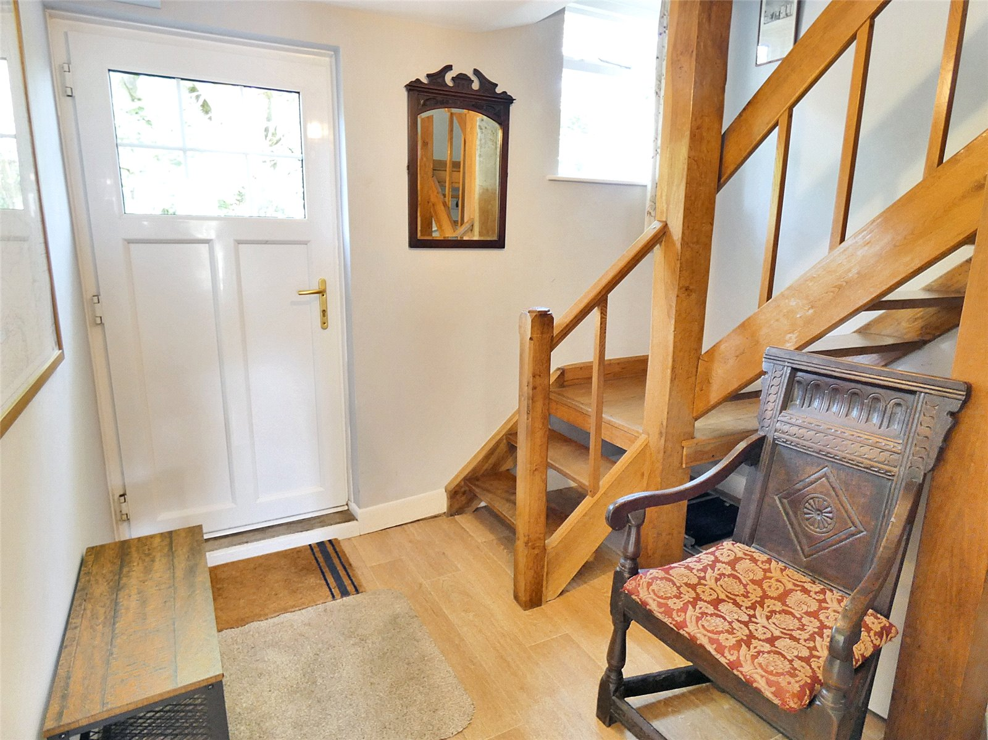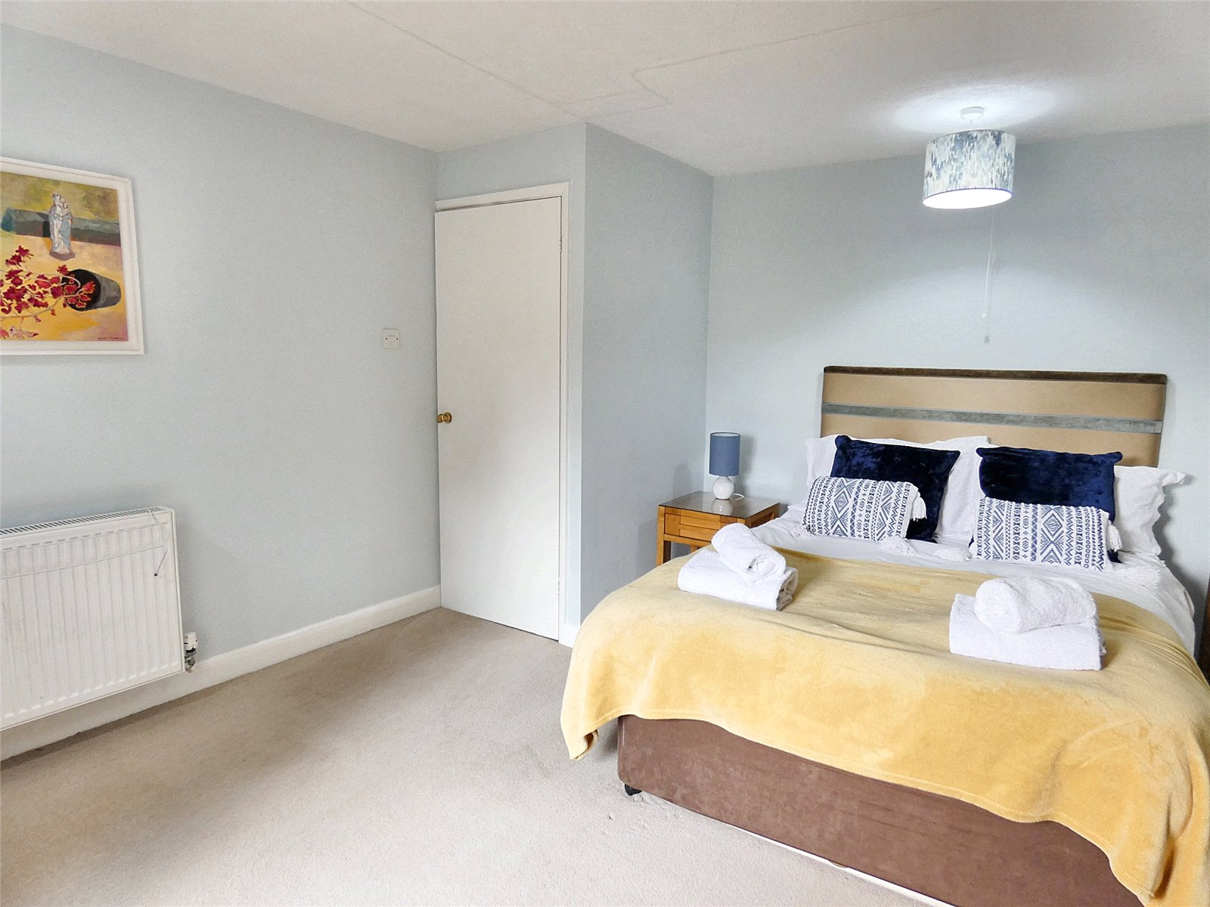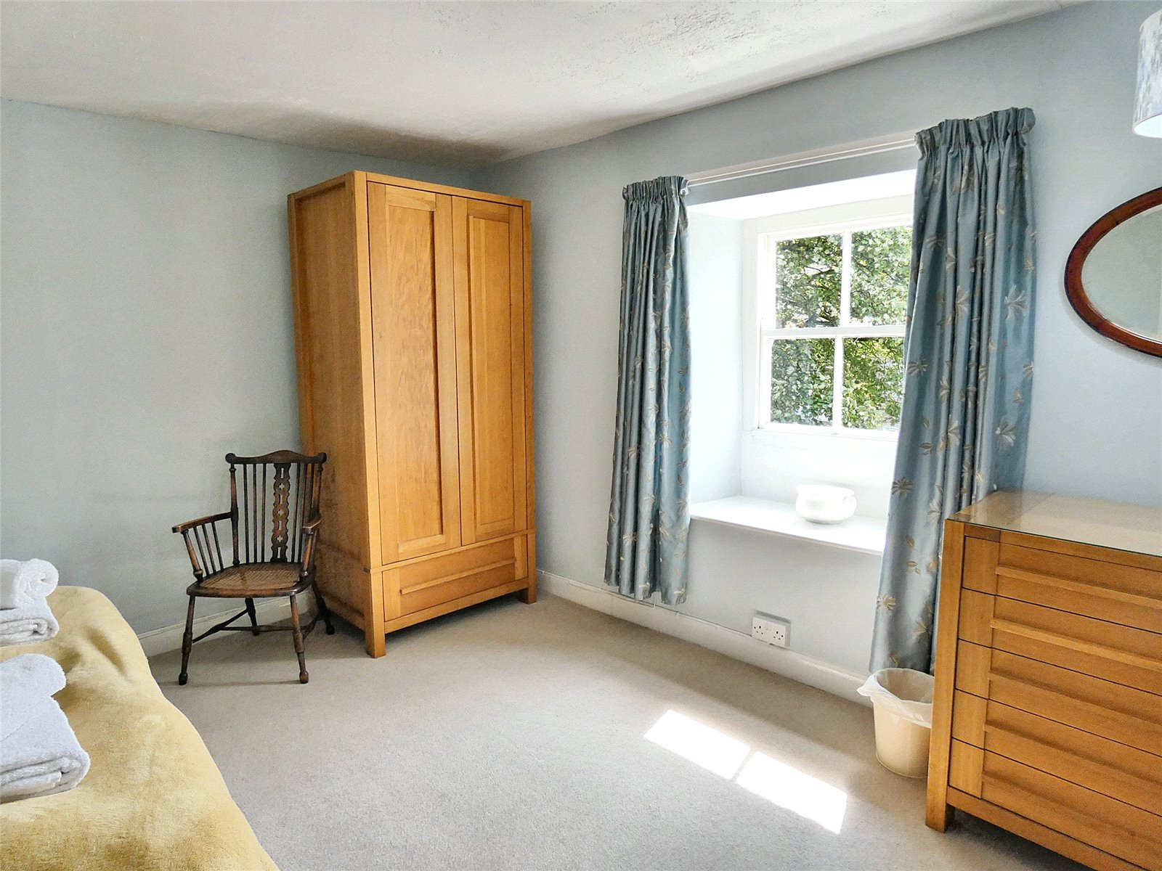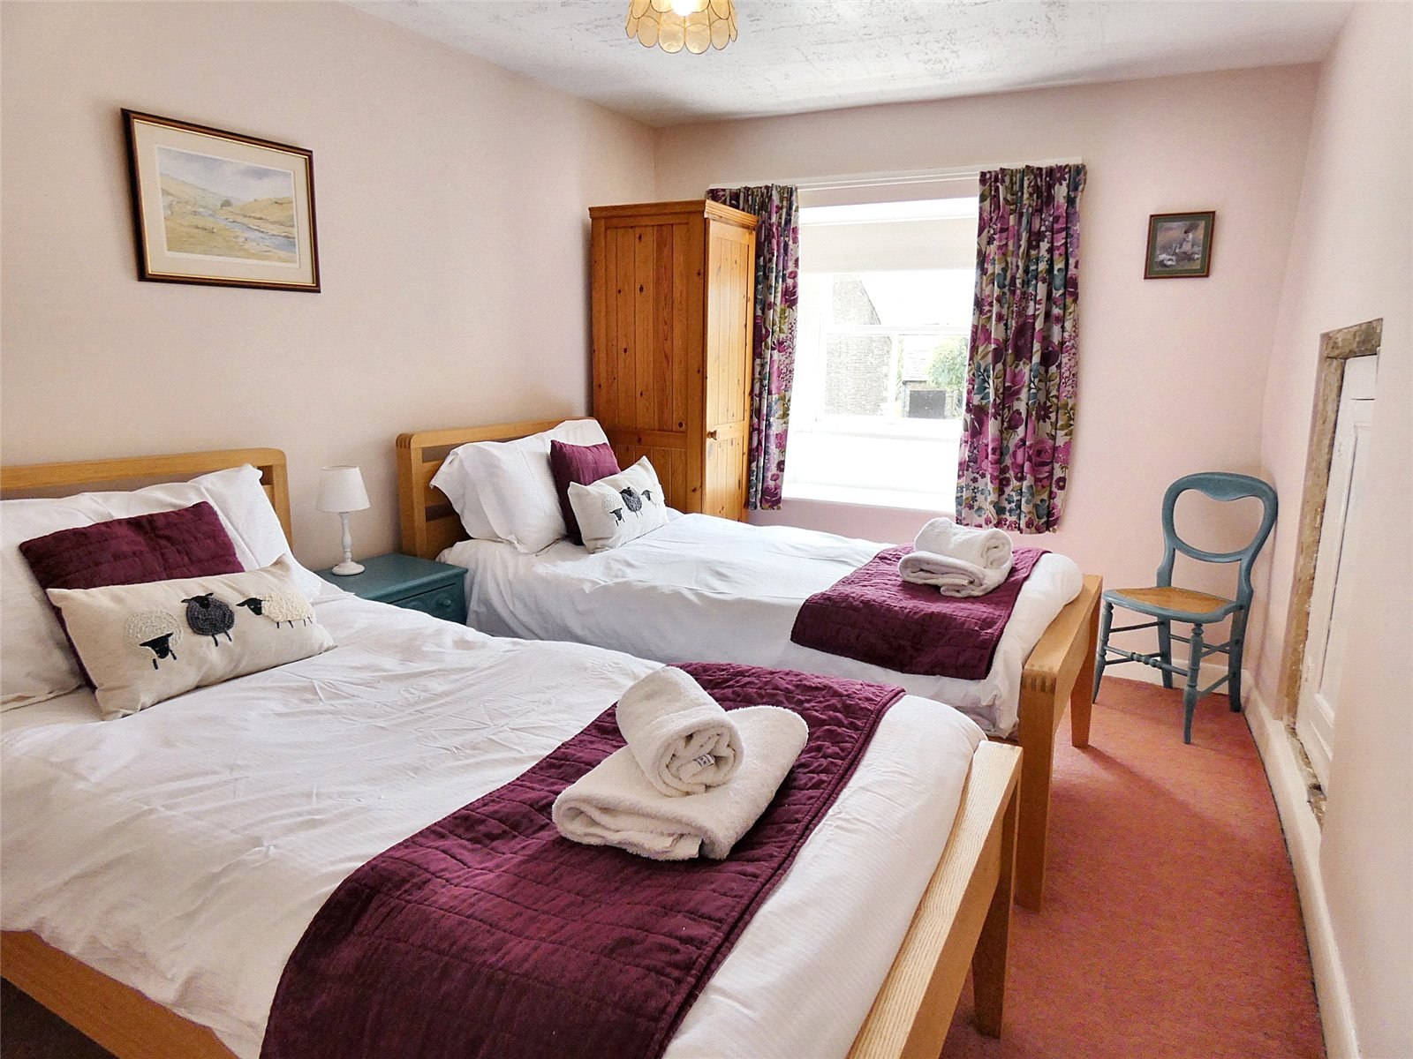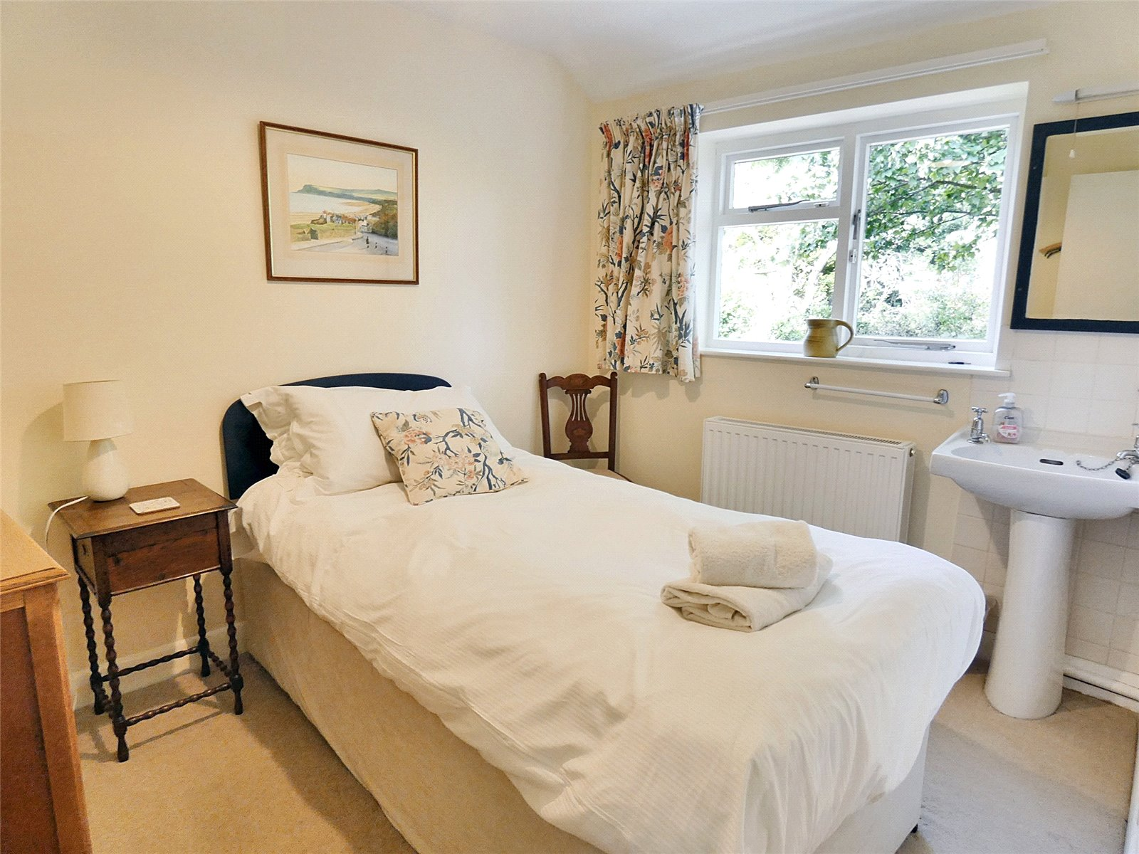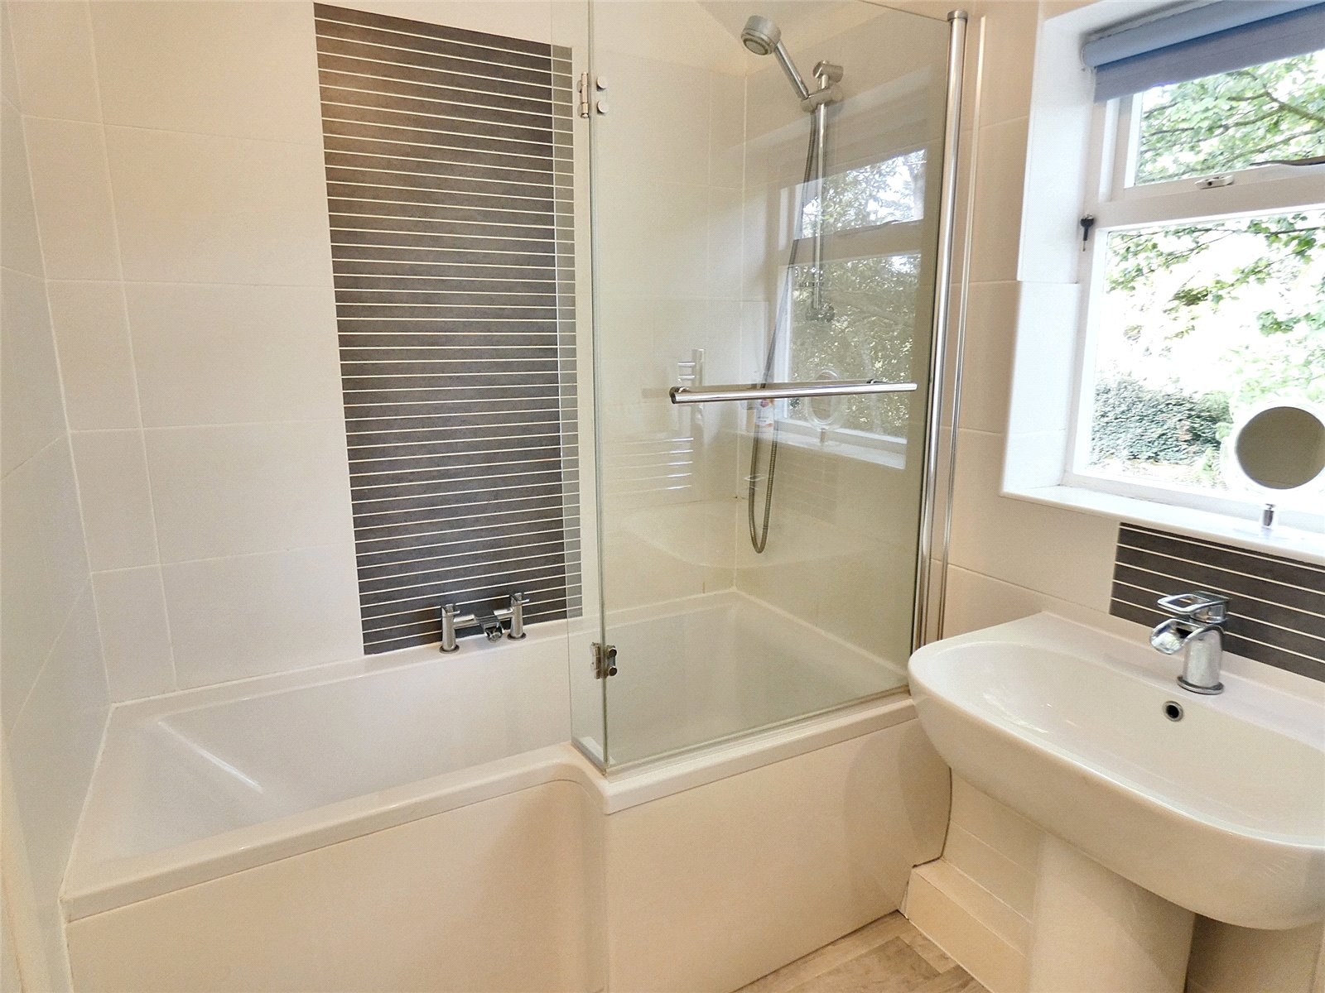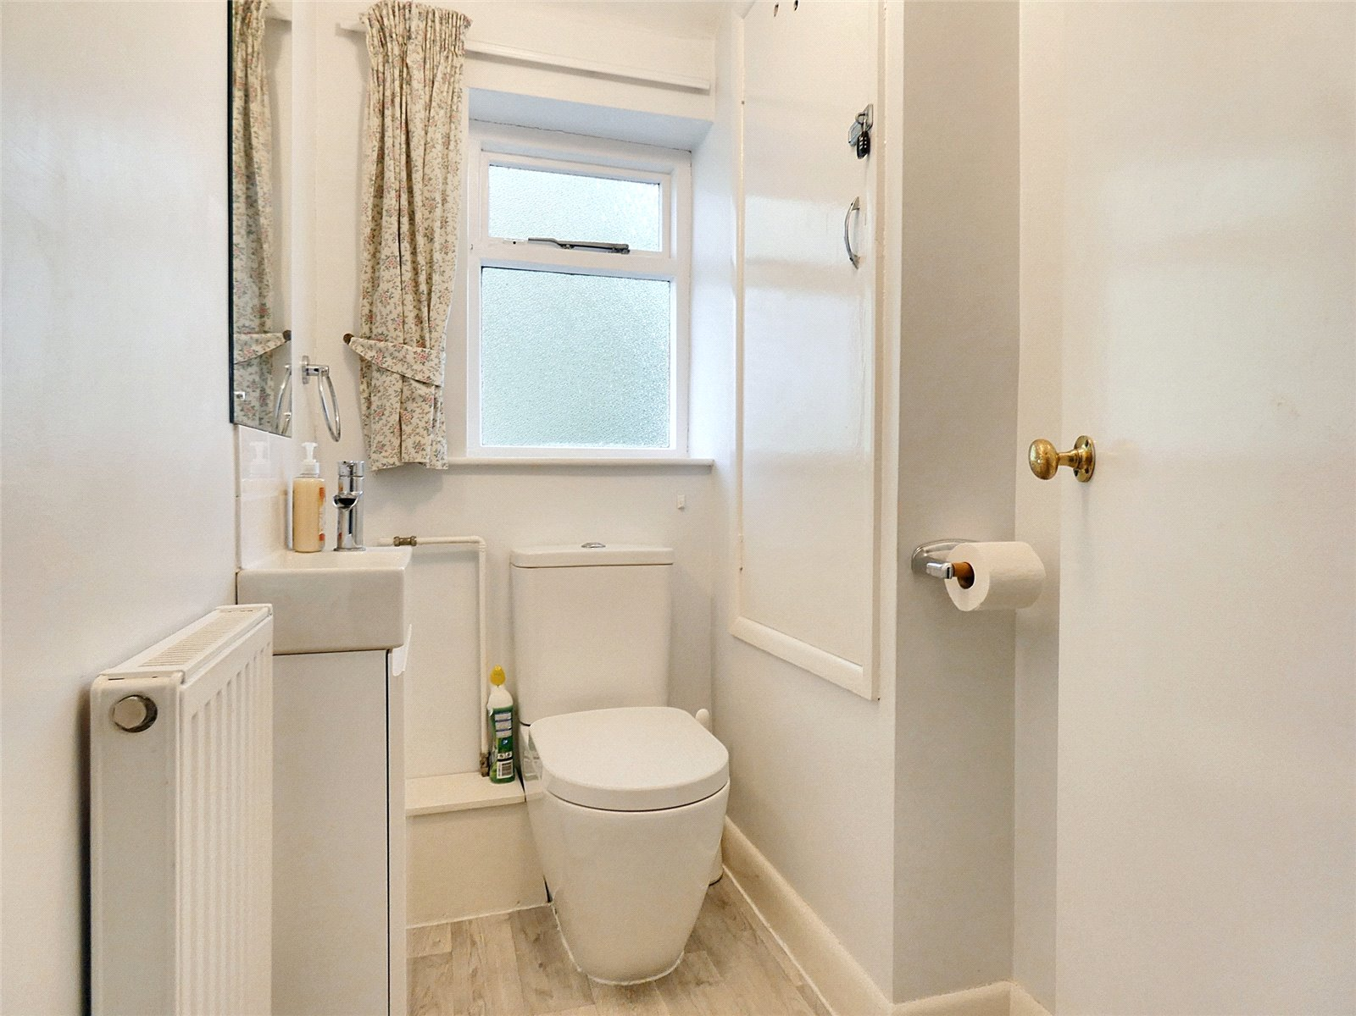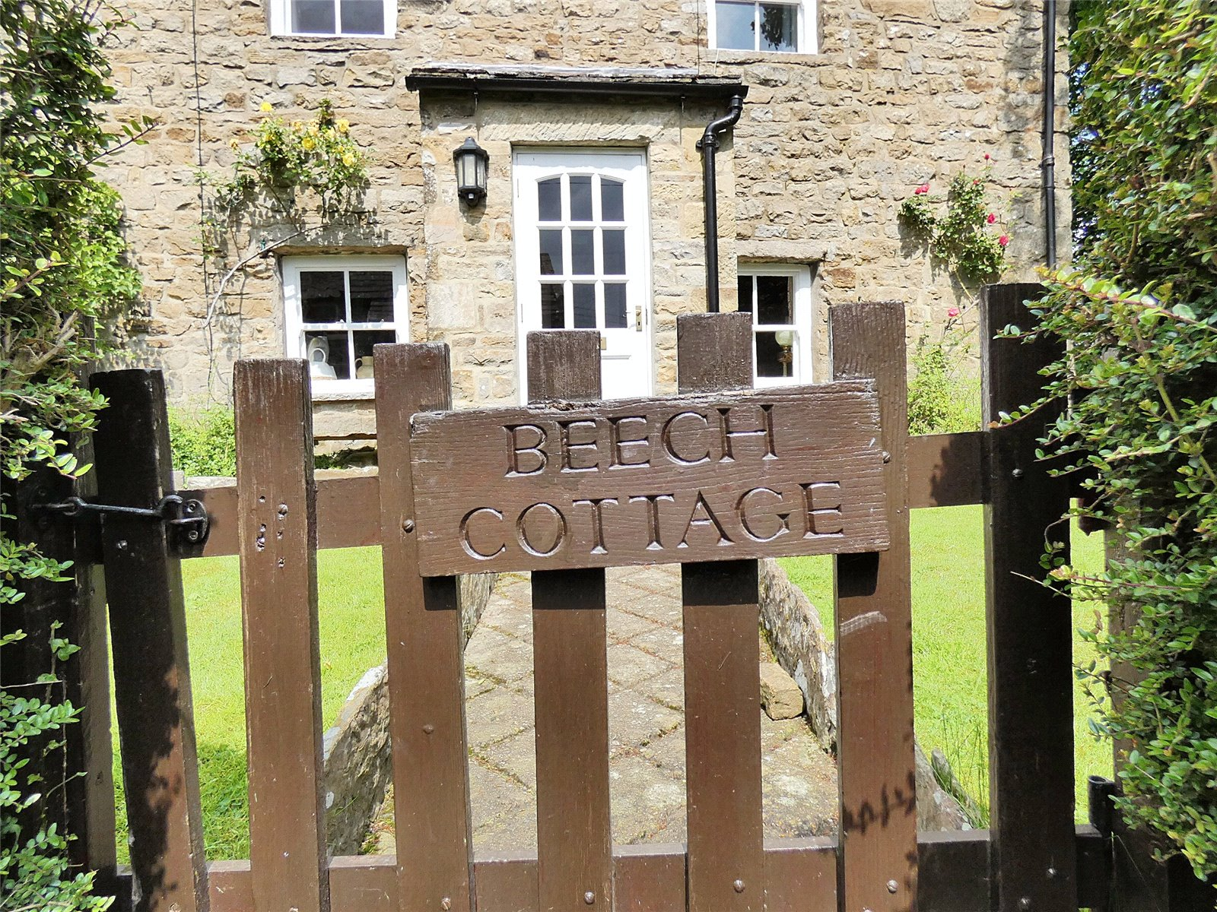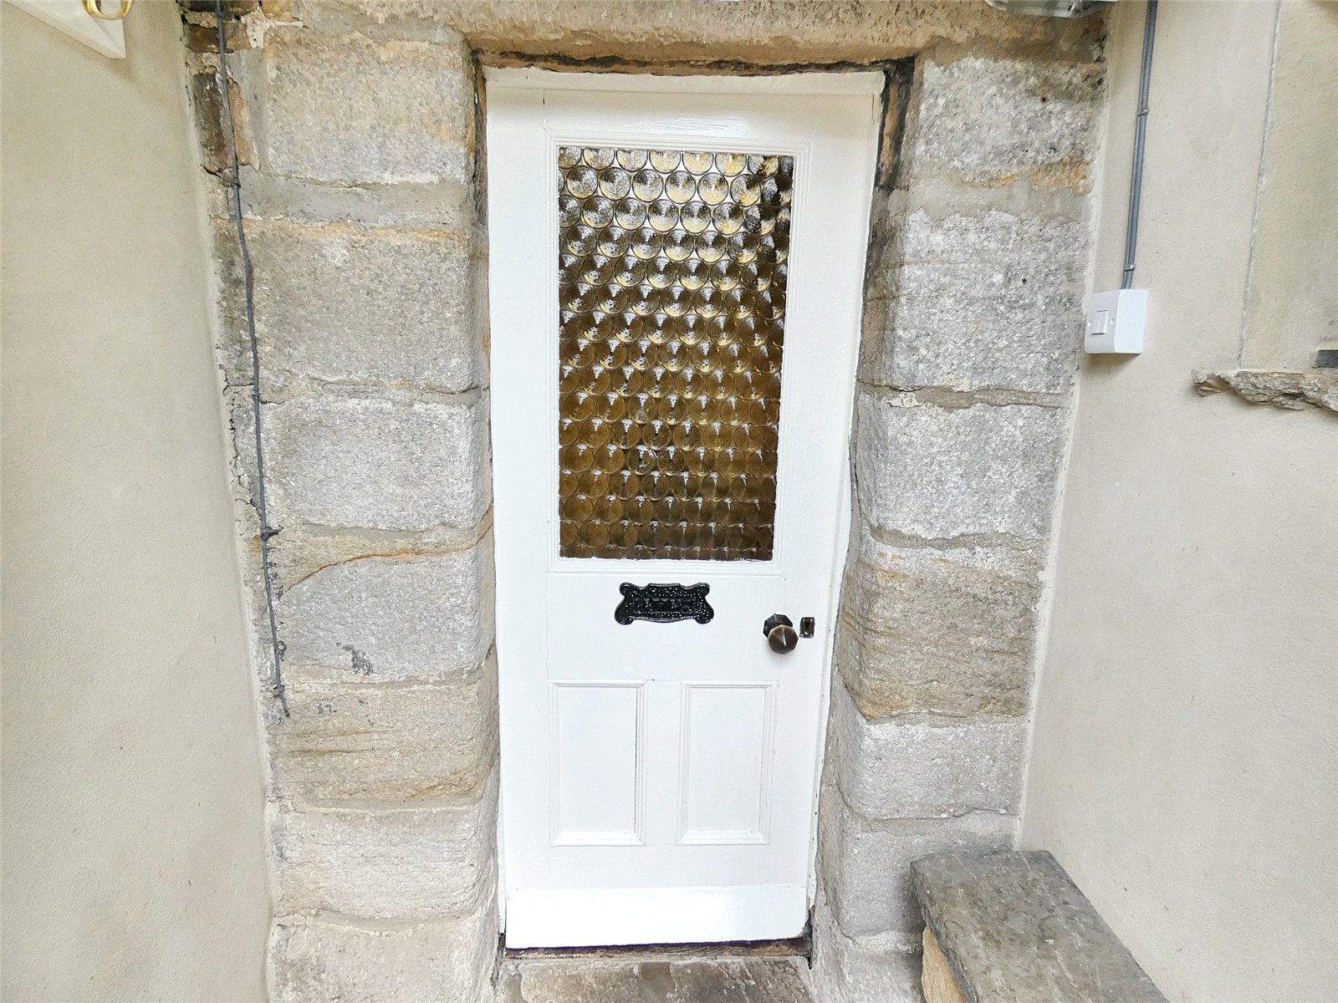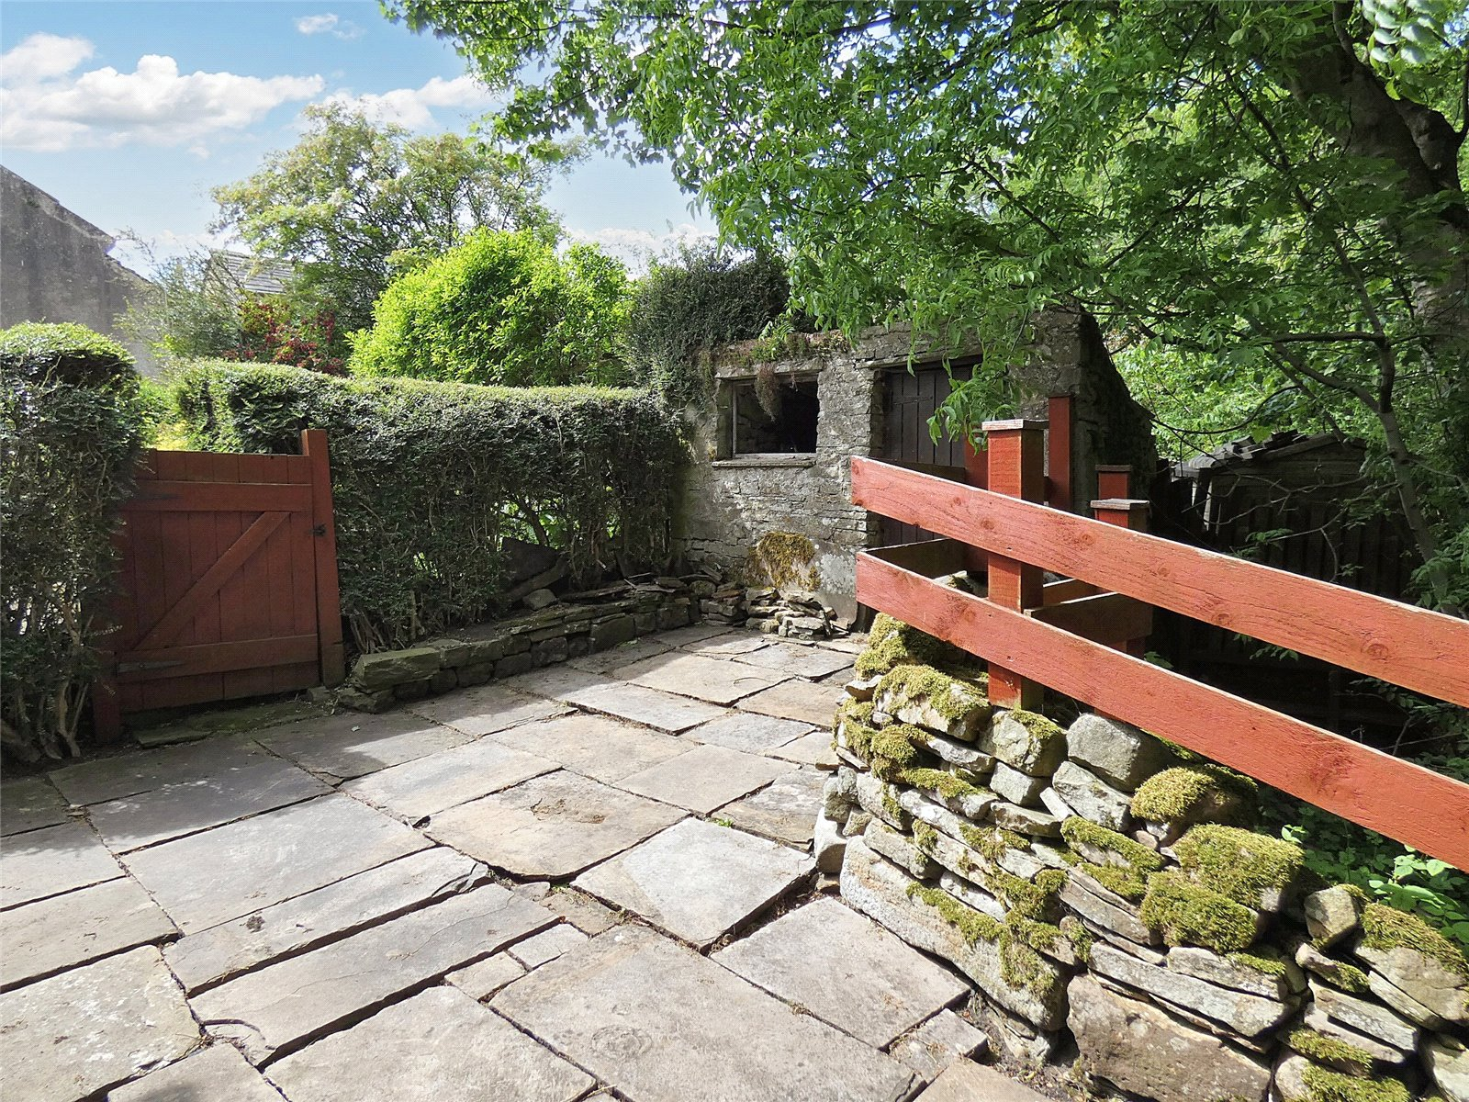

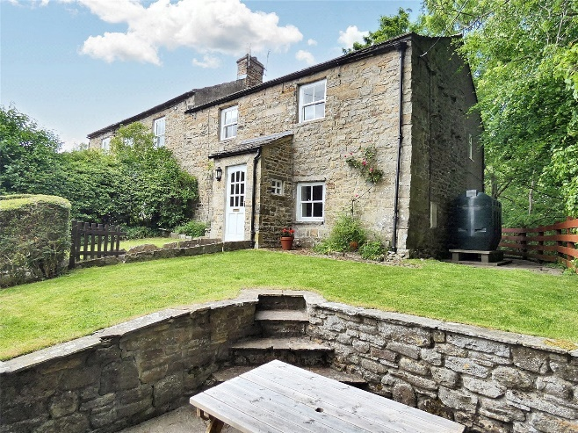
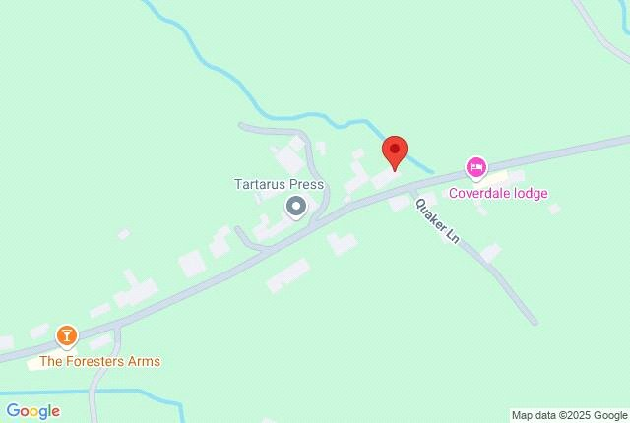
Items in these photographs and tours may not be included in the sale • J. R. Hopper & Co. has not tested services, fixtures, fittings, central heating, gas, and electrical systems. If in doubt, purchasers should seek professional advice • J. R. Hopper & Co, as Agents in the sale of the property will formally check the identification of prospective Purchasers. In addition, the Purchaser will be required to provide information regarding the source of funding as part of our offer handling procedure • Viewings by appointment only.

