
• Superb Detached Dormer Bungalow 2112 Sq Ft
• Quiet Cul-De-Sac Location, Positioned On A Generous Plot
• 3 Double Bedrooms
• Spacious Storage Loft & 4th Bedroom
• Large Living Room • Garden Room
• Well-Appointed Kitchen • Dining Room
• Scope For Modernisation
• Integral Double Garage & Ample Parking
• Well-Maintained Front And Rear Gardens
Postcode: DL8 4PZ

Tenure: Freehold

Council Tax Band: G

Energy Efficiency Band: D

Local & Planning Authority:
North Yorkshire Council
Guide Price: £625,000 - £650,000
Furlongs, Kingsley Drive, Middleham
J. R. Hopper & Co. is a trading name for J. R. Hopper & Co. (Property Services) Ltd. Registered: England No. 3438347.
Registered Office: Hall House, Woodhall, DL8 3LB. Directors: L. B. Carlisle, E. J. Carlisle
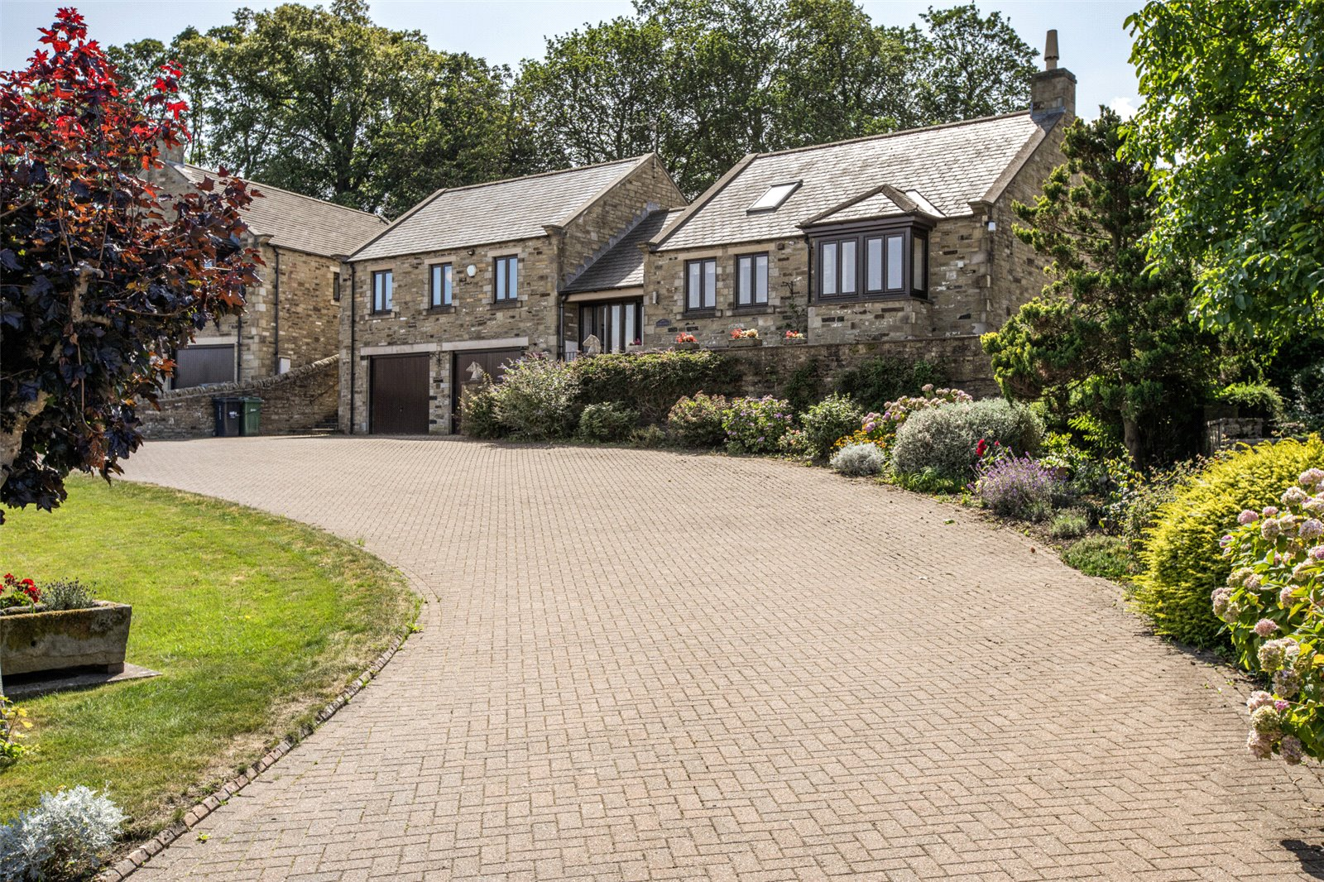
“For Sales In The Dales”
EST. 1886
Central Chambers
Market Place
Leyburn
North Yorkshire
DL8 5BD
Leyburn
Hawes
Settle
Kirkby Stephen
01969 622936
01969 667744
01729 825311
01768 258002
& Co.
www.jrhopper.com enquiries@jrhopper.com
J.R. HOPPER

Furlongs is a superb and spacious well-presented detached dormer bungalow, quietly positioned on a desirable cul-de-sac in Kingsley Drive, within the town of Middleham.

Nestled in the heart of the Yorkshire Dales, Middleham is renowned for its historic castle and strong equestrian heritage. The town offers a range of local amenities including traditional pubs, independent shops, restaurants, a church, primary school, and an active community centre. Located just 2 miles south of Leyburn, Middleham enjoys a picturesque setting surrounded by outstanding countryside.

The accommodation on offer is generous and provides flexible living space throughout. It is accessed via a few external stone steps, into a lovely welcoming entrance hall which leads to a spacious living room, a well-appointed kitchen, formal dining room, and a bright garden room. There are 3 double bedrooms, including a master bedroom with en-suite bathroom, along with a separate shower room.

The first floor offers a versatile study or potential 4th bedroom, alongside a large loft storage room.

The integral double garage is located on the lower ground floor, providing additional storage and secure parking.

Externally, the property offers generous grounds. The front features a block paved driveway with parking for several vehicles, a lawned garden, and mature shrubs and flower beds. To the rear is a low-maintenance patio area which leads to a stone-built storage shed, greenhouse, and steps up to an expansive lawned suntrap garden.

Furlongs presents an excellent opportunity as a permanent family residence, multi-generational living, a holiday retreat, or an investment property in a highly desirable Dale’s location.

Ground Floor

Entrance Hall Tiled flooring and fitted carpet. Pitched panelled ceiling. Radiator. Velux window. External wooden glazed door to front with 4 floor to ceiling windows.

Rear Hall Tiled flooring. Loft access. Coved ceiling. Radiator. Internal frosted glazed door to hall. External wooden frosted glazed door to rear.

W/C Tiled flooring. Coved ceiling. Extractor fan. Part tiled walls. Dado rail. W/C. Wash basin. Frosted window to rear.

Living Room Spacious living room. Fitted carpet. Coved ceiling. TV point. Fireplace housing gas fire. Four radiators. Large bay window to the front. Double patio doors to the rear.

Dining Room Fitted carpet. Coved ceiling. TV point. Two radiators. Double French doors into Garden Room.

Stairs & Hallway Fitted carpet. Coved ceiling.

Kitchen Tiled flooring. Coved ceiling. Downlights. Part tiled walls. Good range of wall and base units. Integrated electric oven and separate grill. Gas hob and extractor hood. Stainless steel one and a half bowl sink. TV/Telephone points. Plumbing for dishwasher. Breakfast bar. Radiator. Two windows to the front.

Garden Room Fitted carpet. Panelled ceiling. Downlights. Two radiators. Fully glazed on three aspects with UPVC external door to garden.

Stairs & Landing Fitted carpet. Coved ceiling. Loft access. Built in display unit with glazed doors and lighting.

Master Bedroom 1 Large front double. Fitted carpet. Coved ceiling. TV point. Built in wardrobes. Fitted bedroom furniture. Radiator. Two windows to the front.
En-Suite Bathroom
Nonslip flooring. Extractor fan. Fully tiled walls. W/C. Wash basin. Bath with shower over. Radiator. Frosted window to side.

Shower Room Jack & Jill shower room can be accessed from the landing and bedroom two. Vinyl flooring. Extractor fan. Fully tiled walls. W/C. Wash basin. Illuminated mirror. Corner shower cubicle. Radiator. Frosted window to the rear.

Bedroom 2 Large rear double. Fitted carpet. Coved ceiling. Built in wardrobes. TV point. Two radiators. Two windows overlooking the garden.

Bedroom 3 Large front single bedroom. Staircase. Fitted carpet. Coved ceiling. Radiator. Window to the front.

First Floor

Study/Potential Bedroom 4 Accessed from the dining room. Fitted carpet. Pitched ceiling with two large Velux windows.

Loft Room Good sized storage room. Could potentially make into one large room with scope for ensuite.

Outside

Front Large enclosed blocked paved driveway leading to double garages with ample parking for multiple vehicles. Lawned area with a mature tree, hedge and bushes. Established shrubs and flower beds. Steps to the side giving access to the rear garden. Steps to front door.

Garage large double garage. Up and over doors. Power and electric.

Rear Large enclosed private rear garden. Low maintenance patio area with established flower beds. Oil tank. Stone storage shed. Greenhouse. Steps up to large lawned area.

Agents Notes Mains electric, water and drainage.

Oil central heating.

Flood Risk: Noted as very low risk with no history of flooding.

Broadband: Basic: 5 Mbps.
Superfast: 61 Mbps.

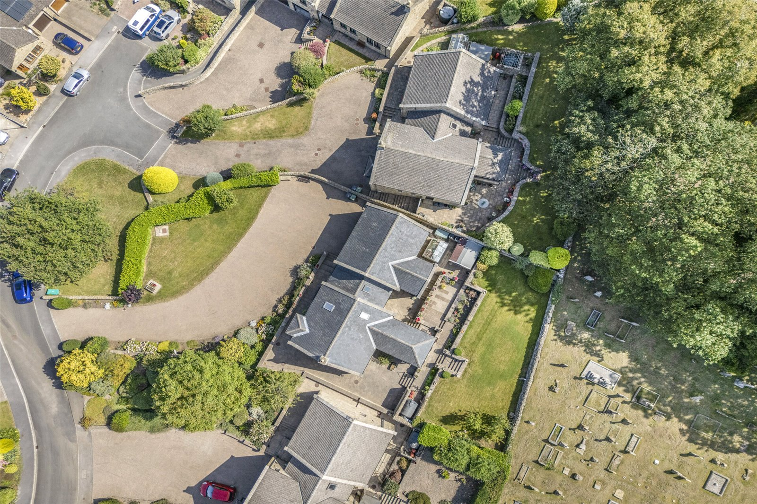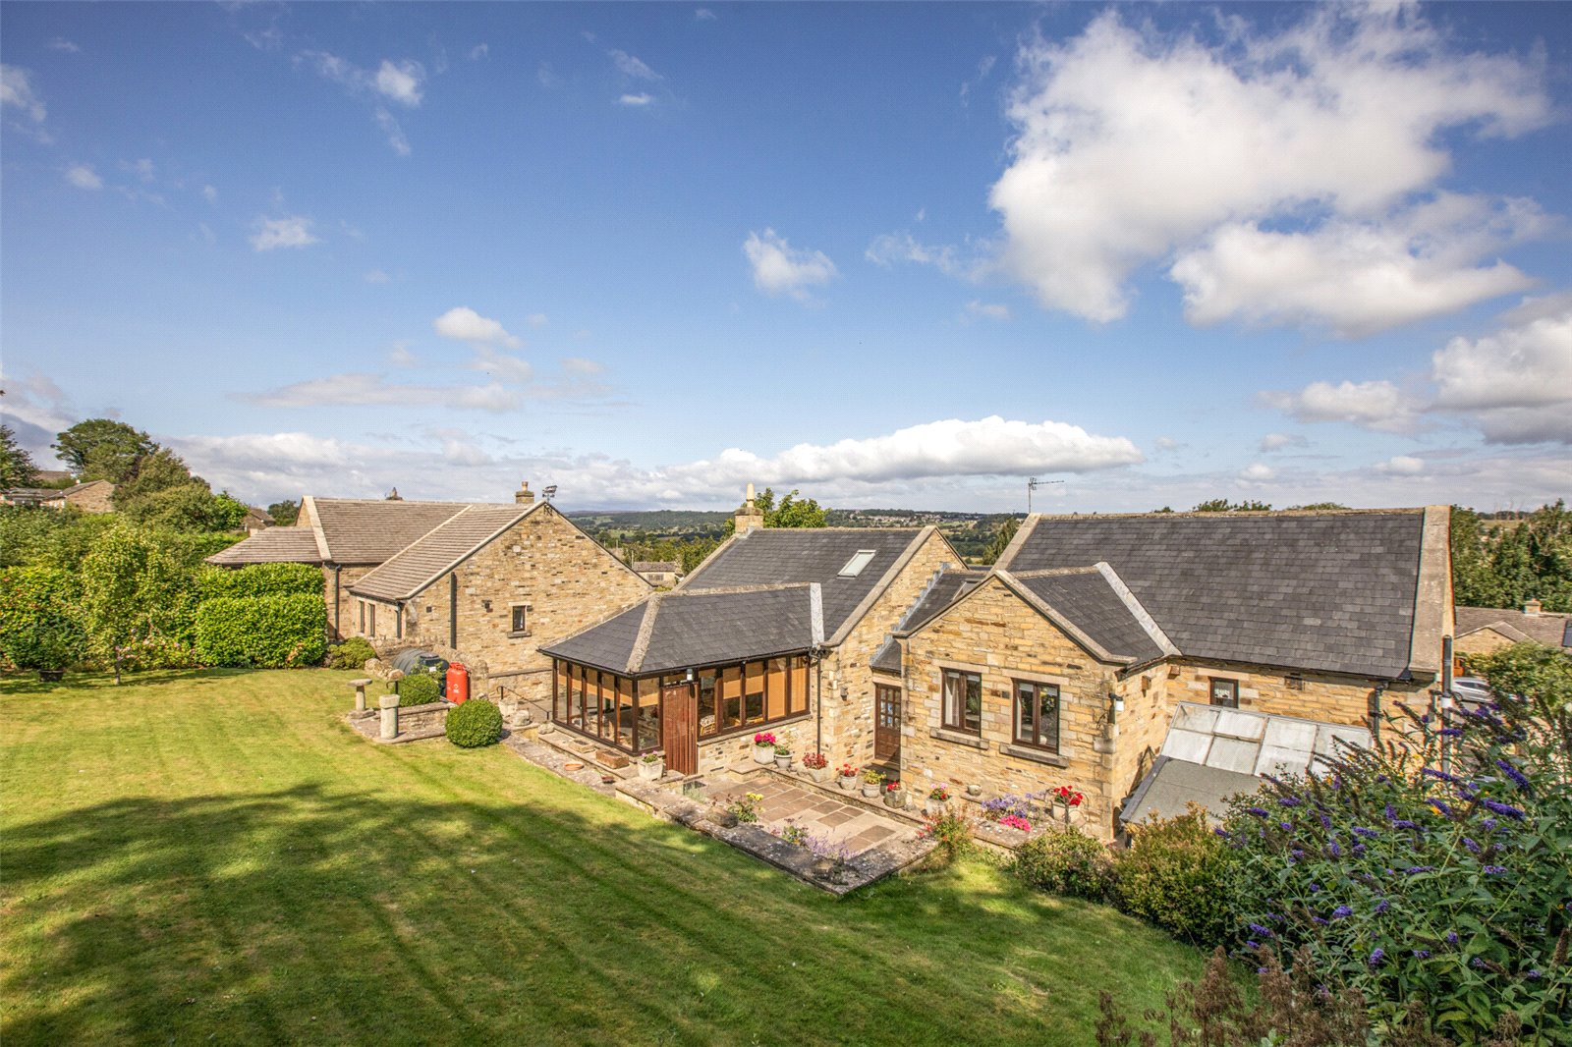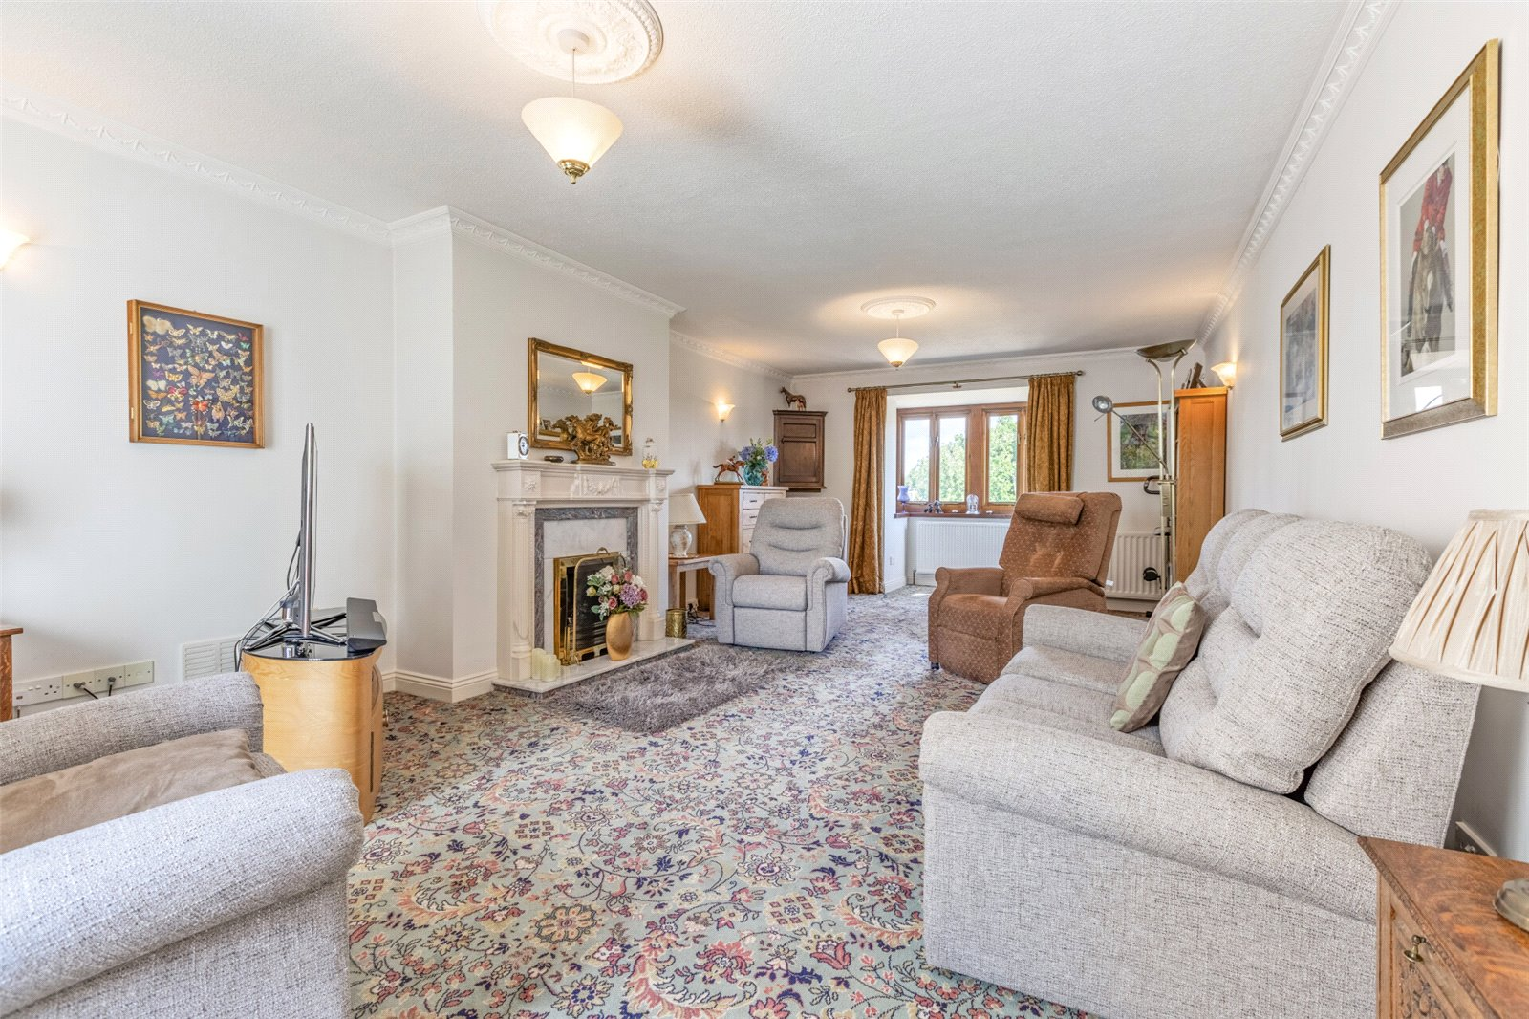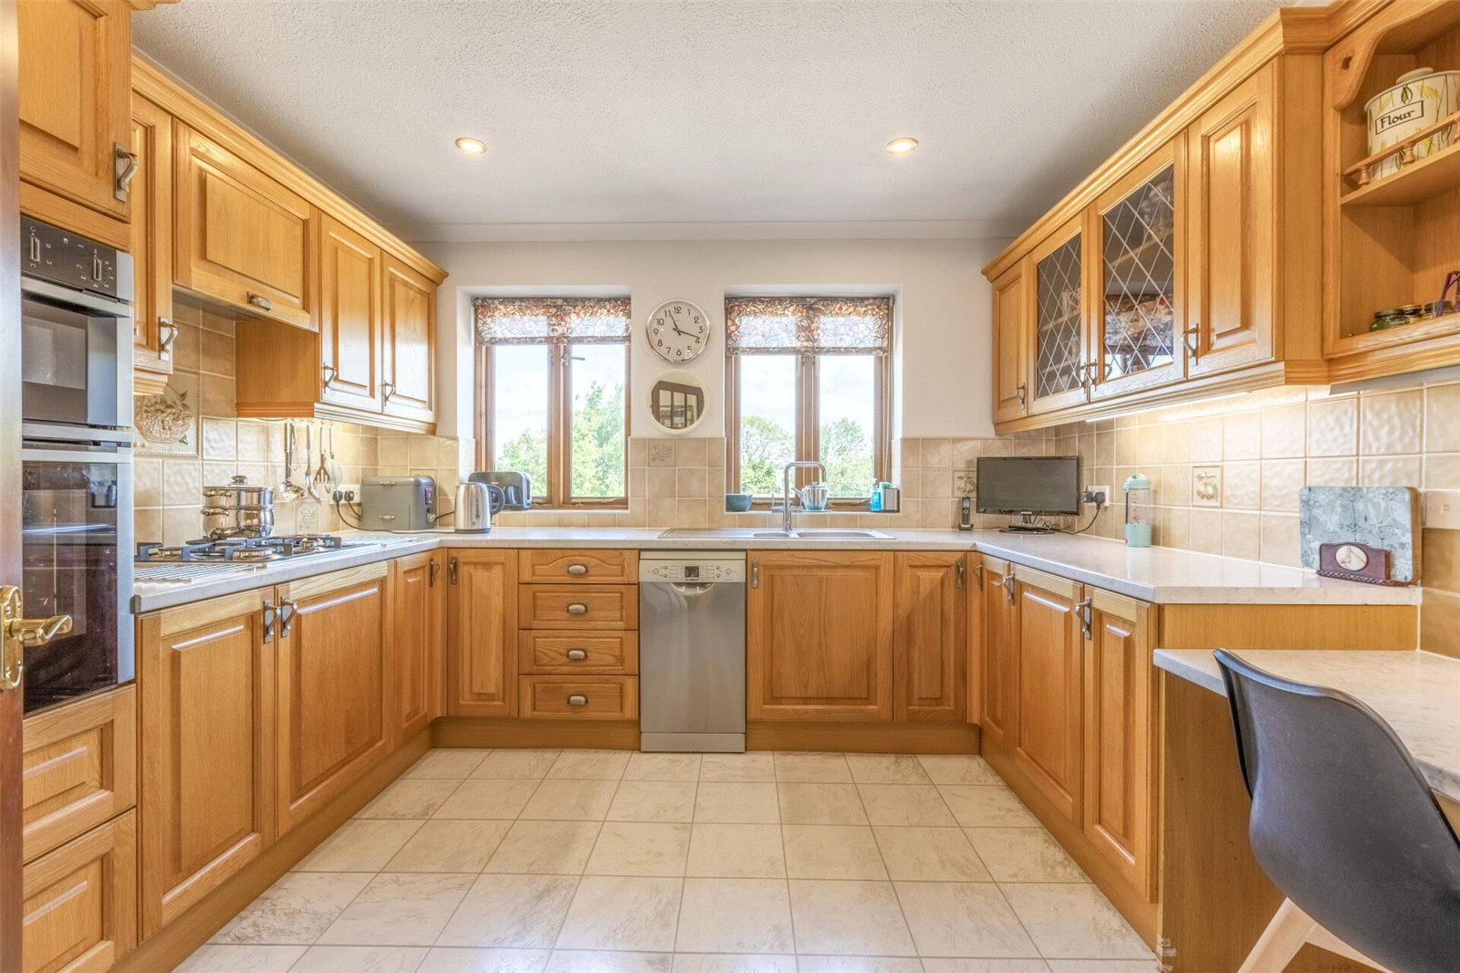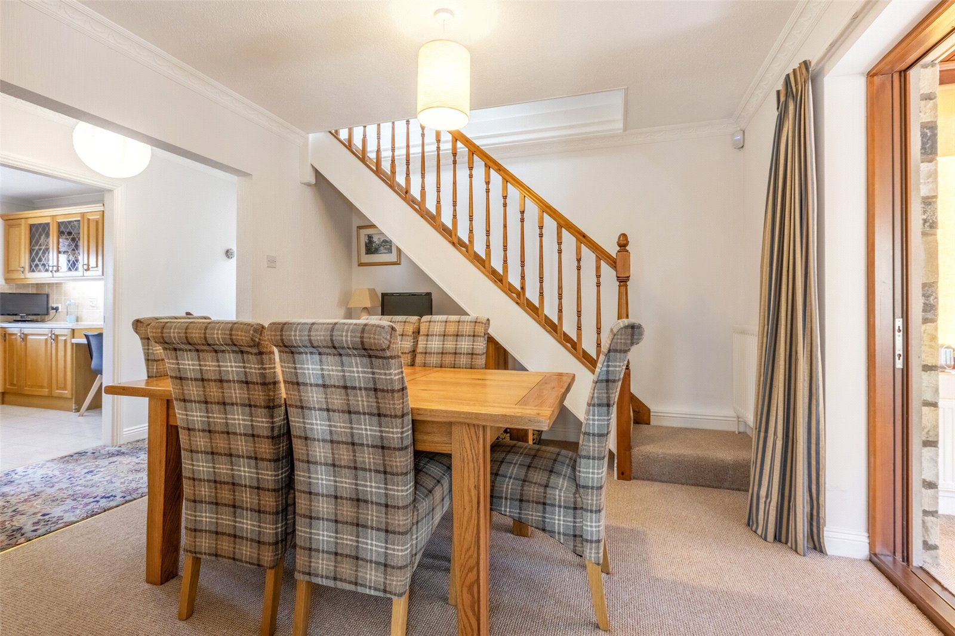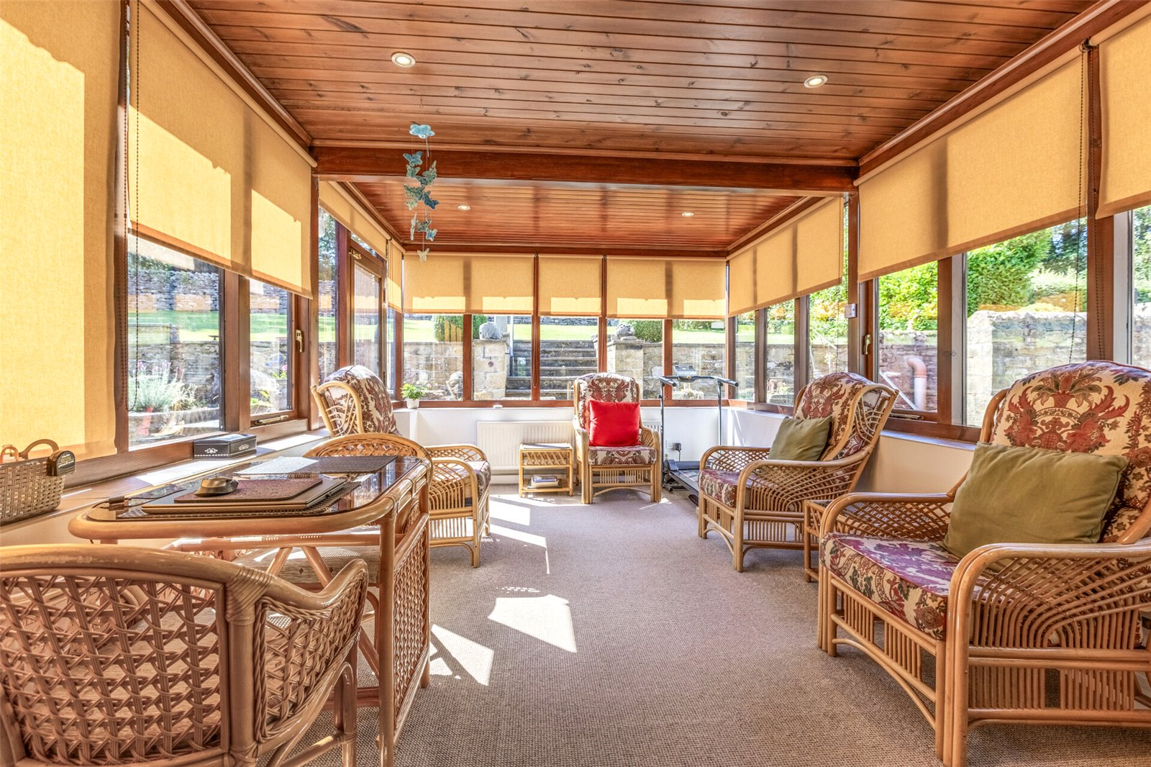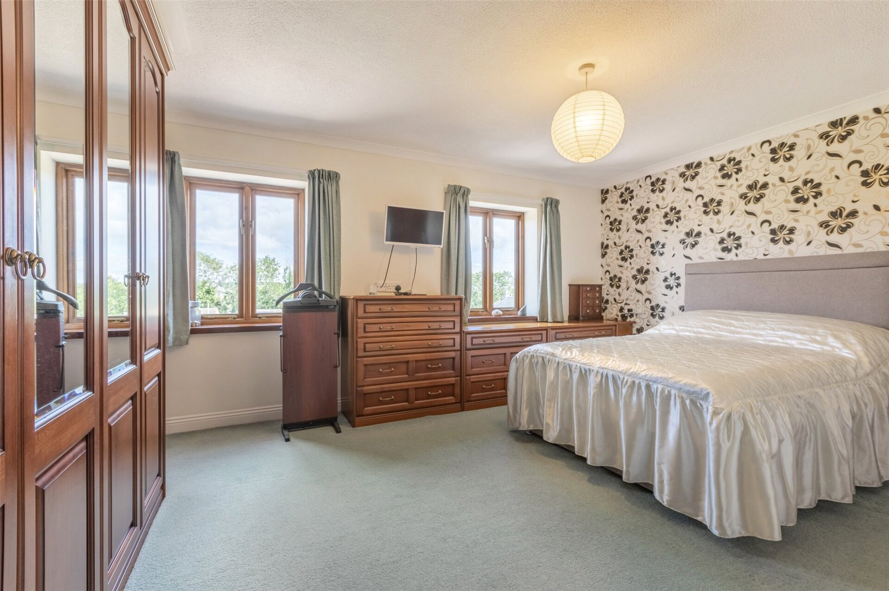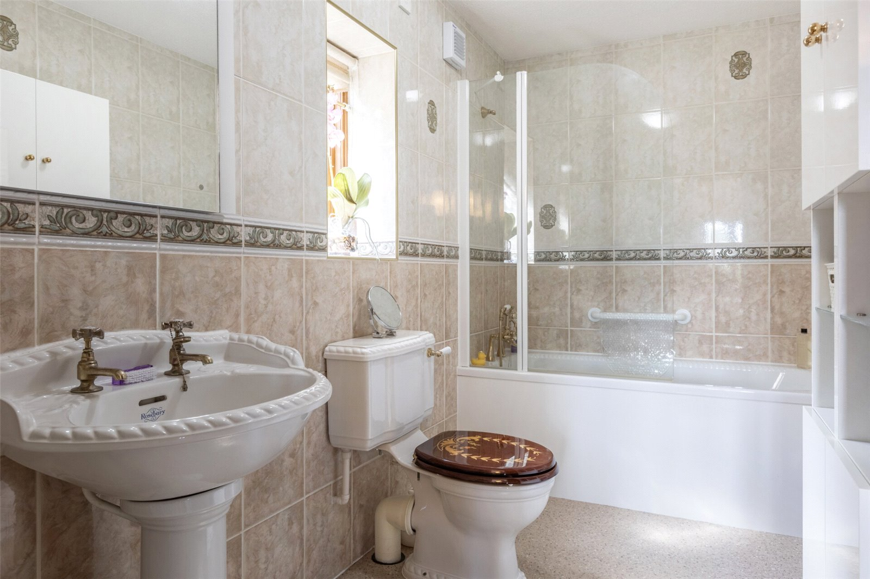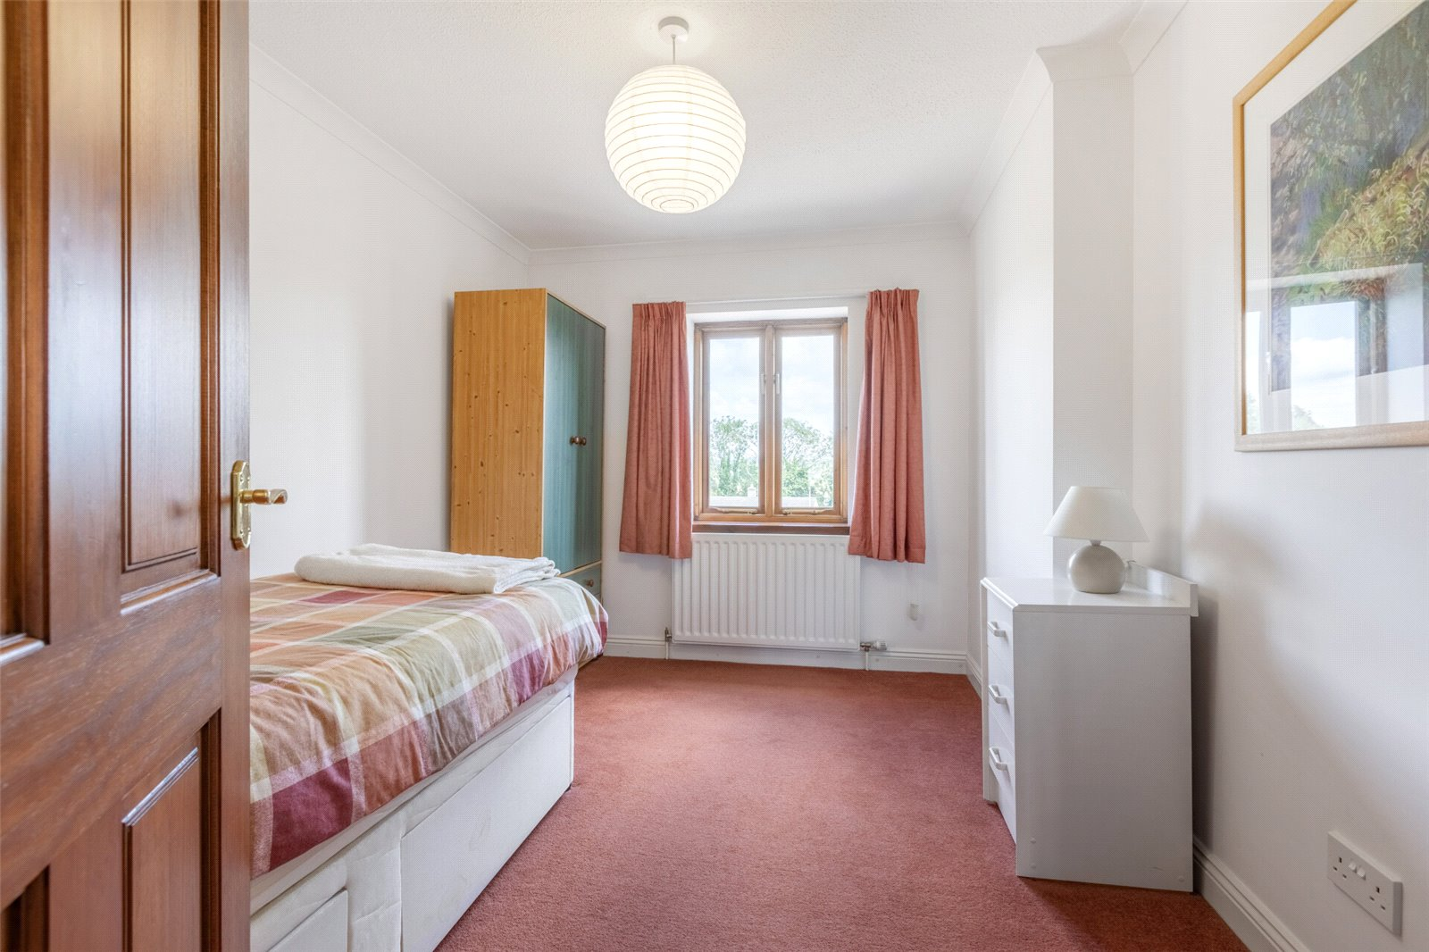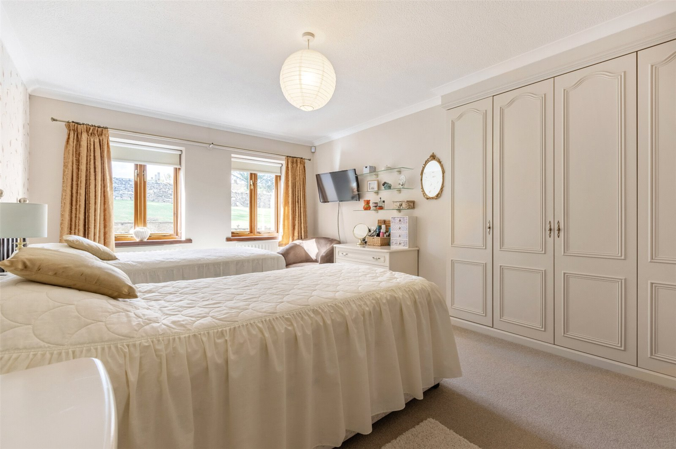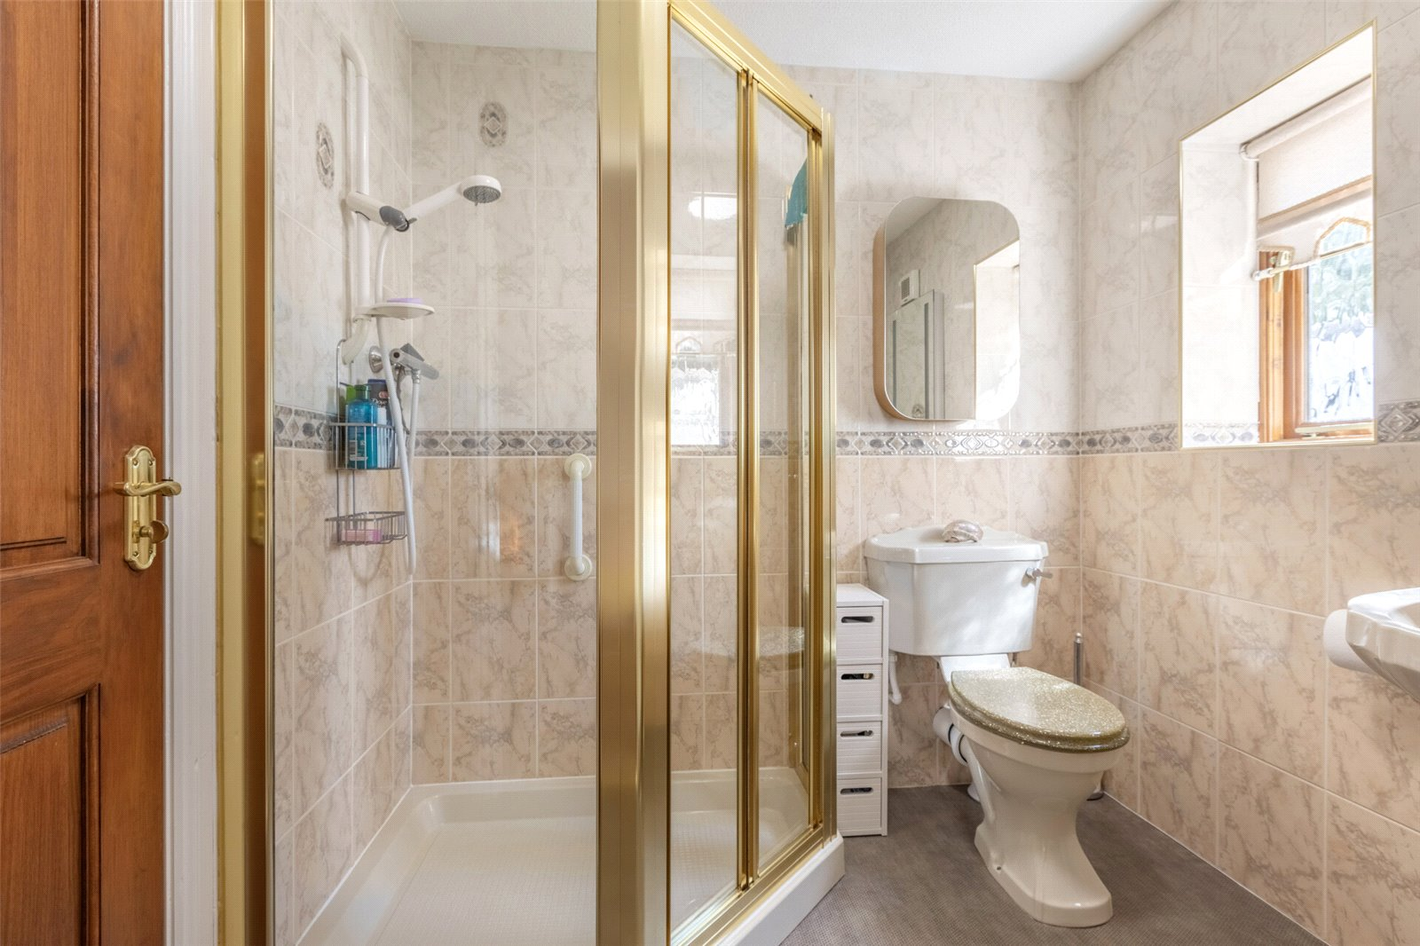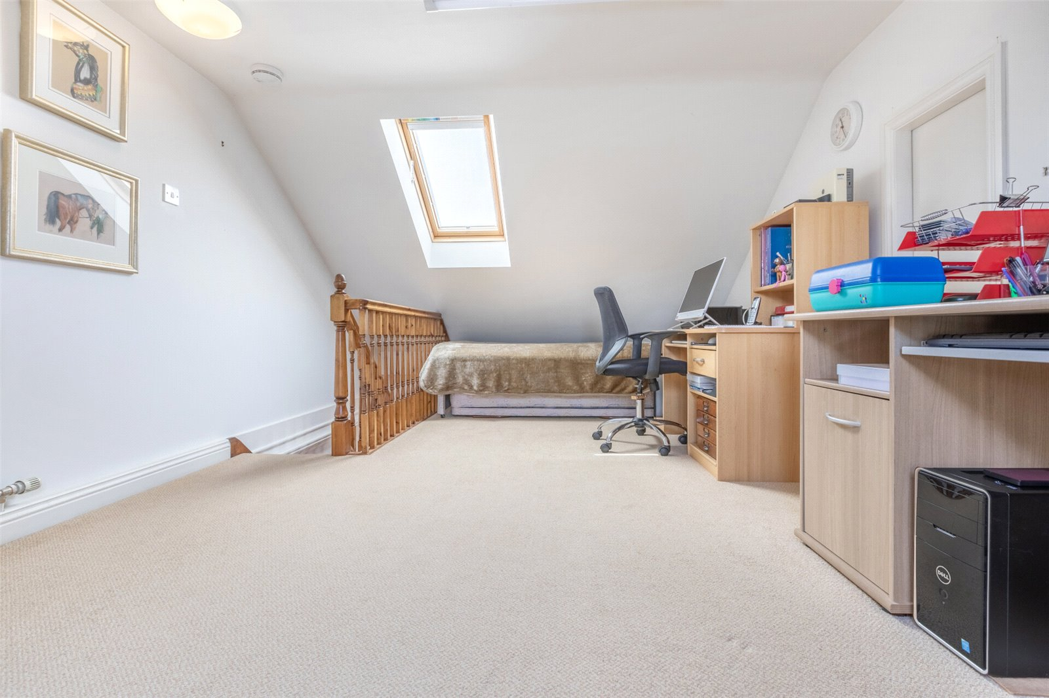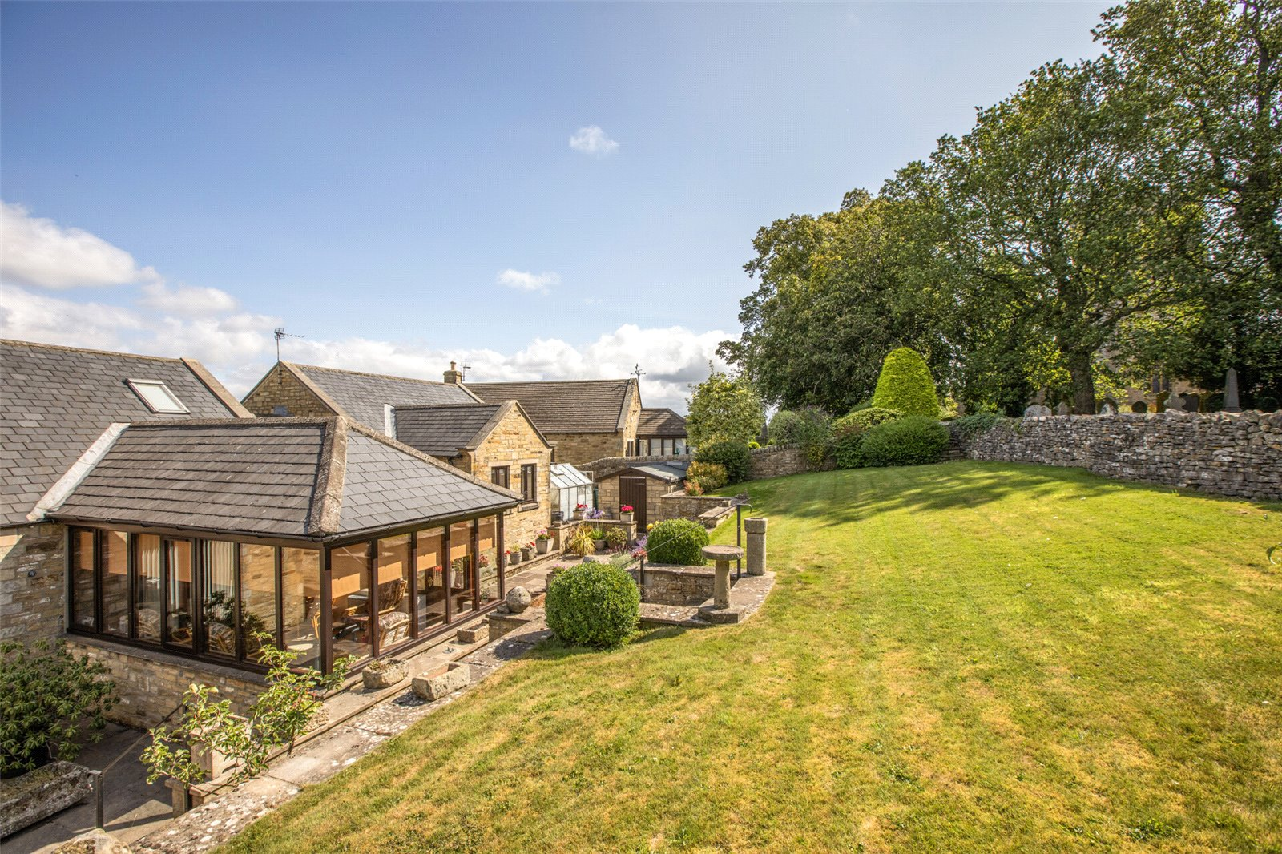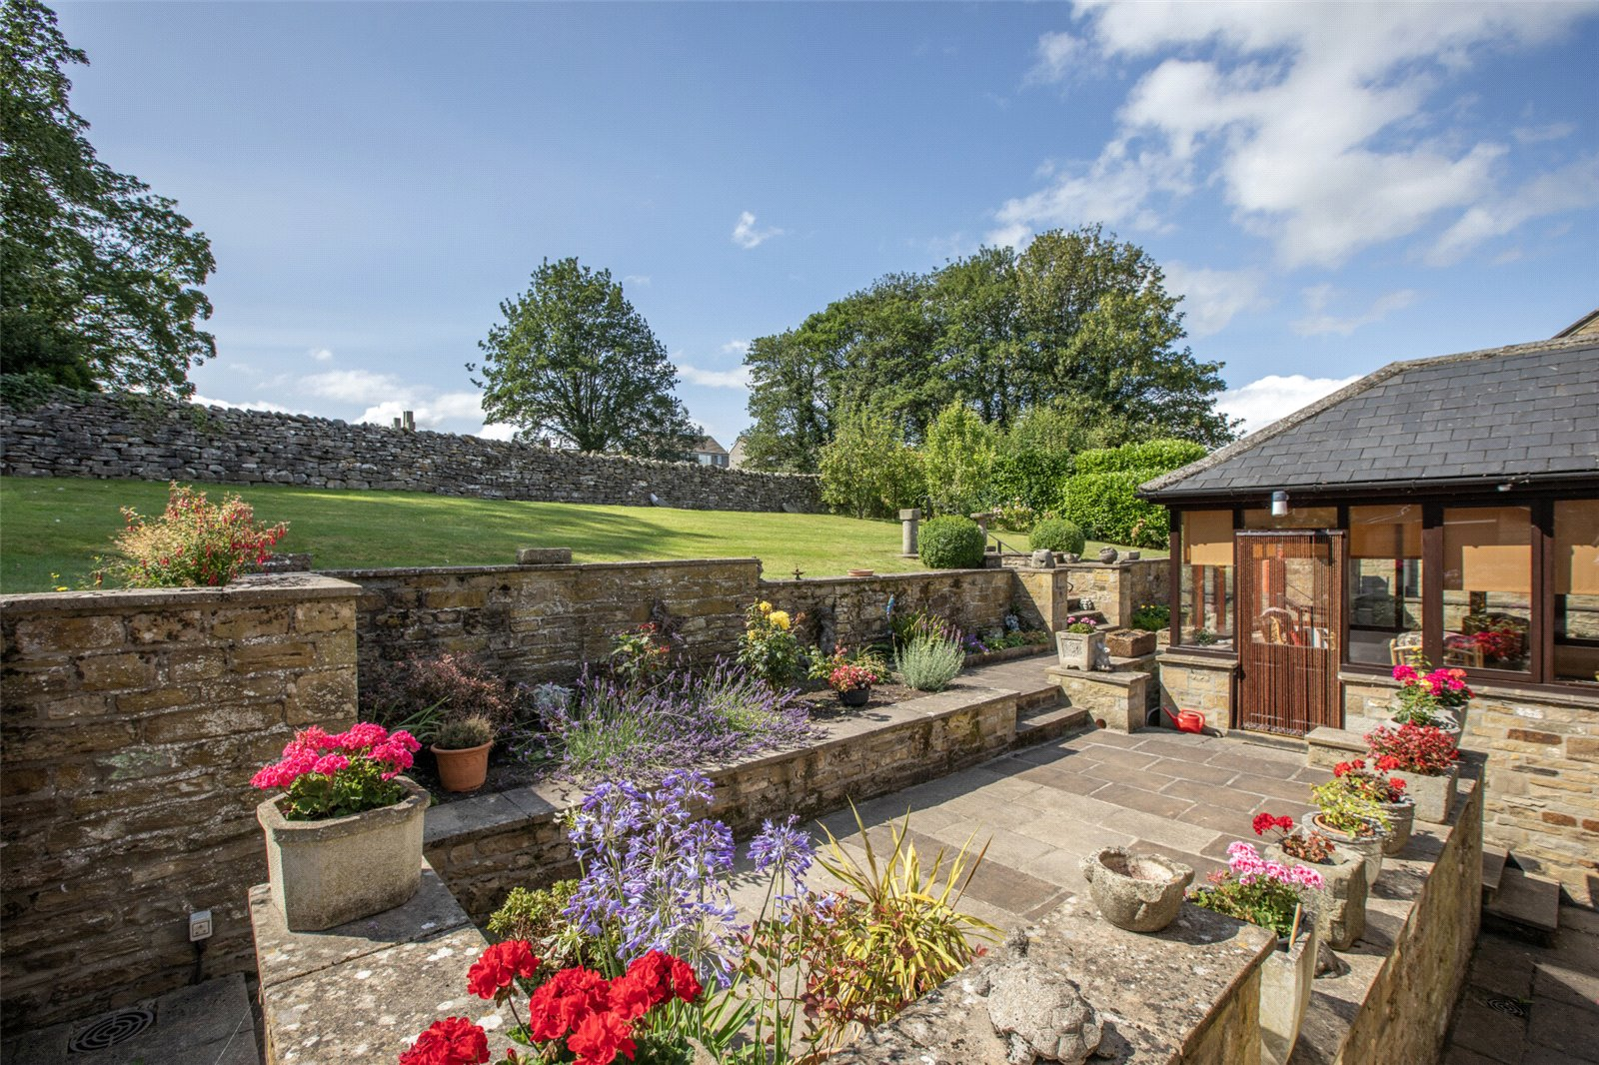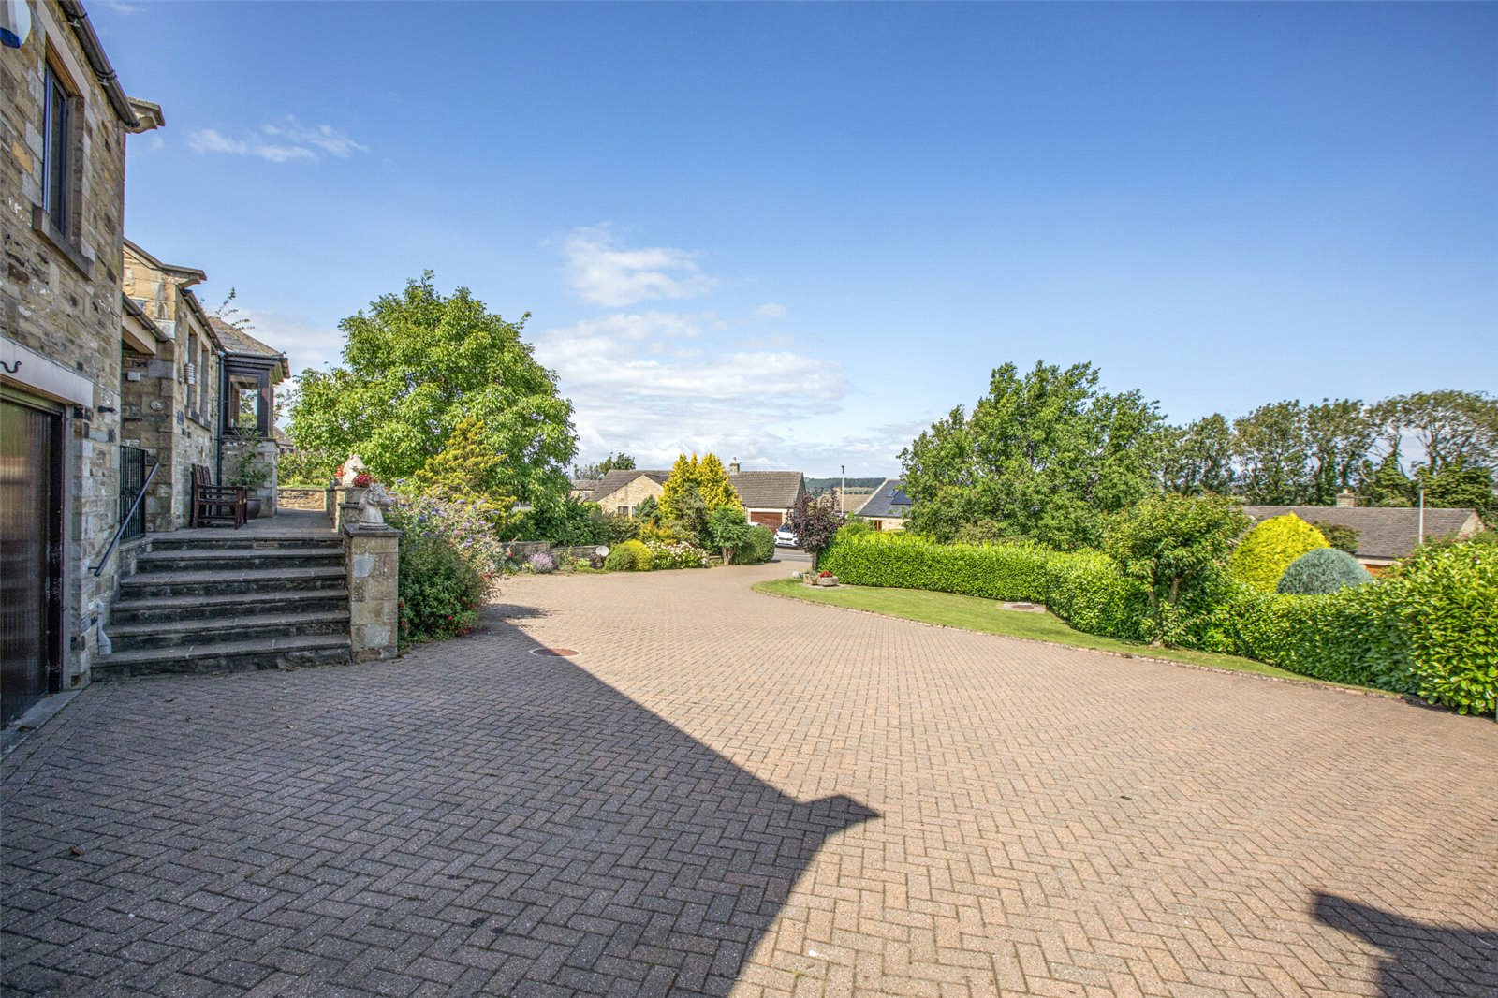

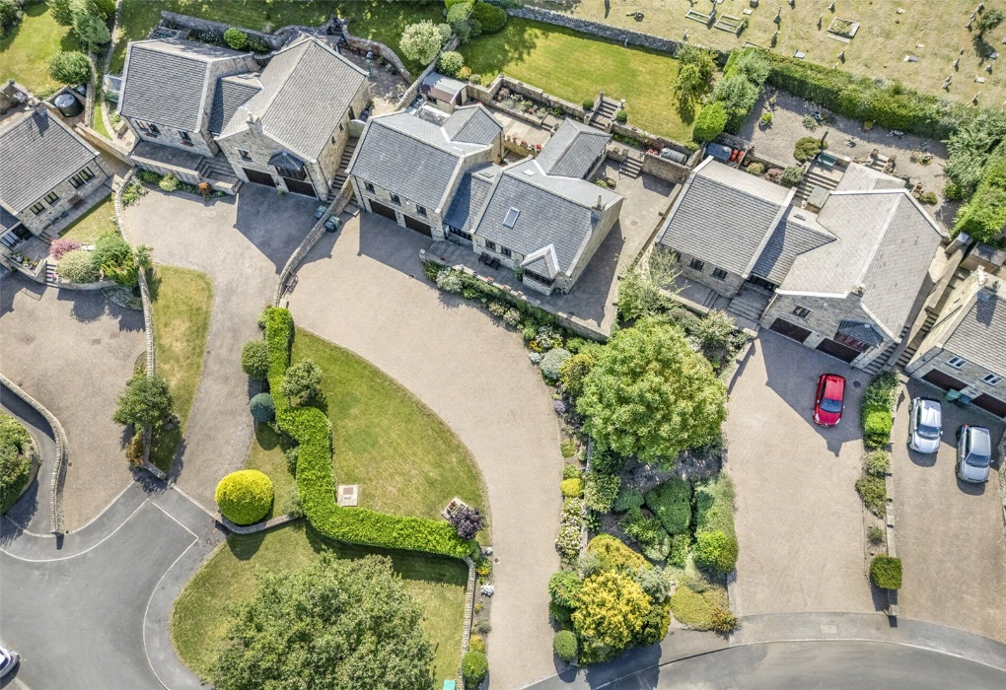
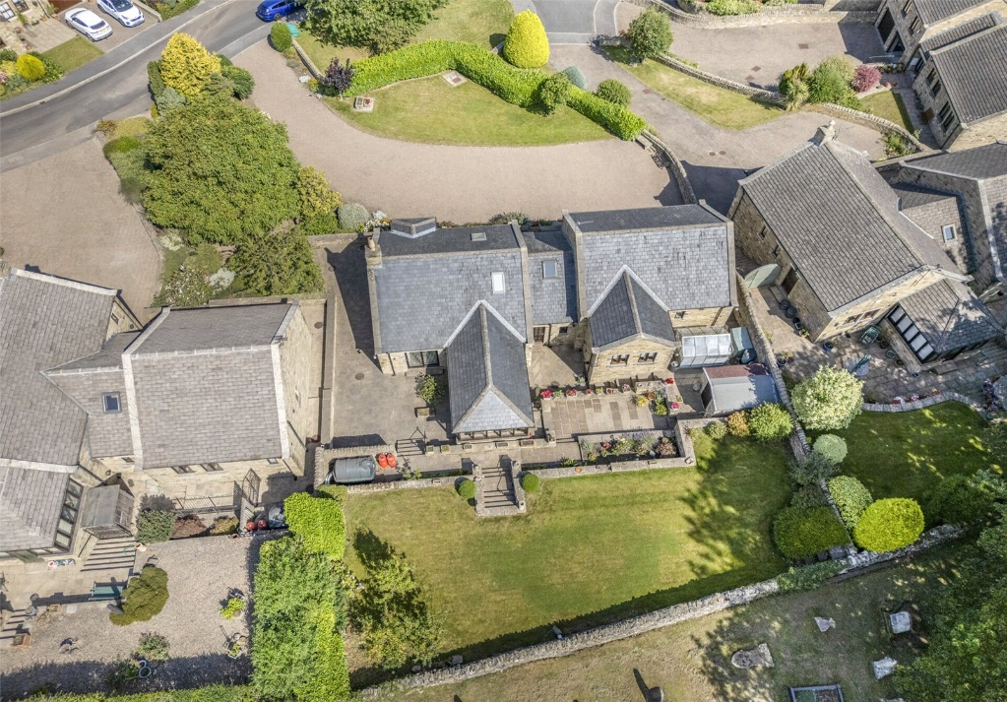
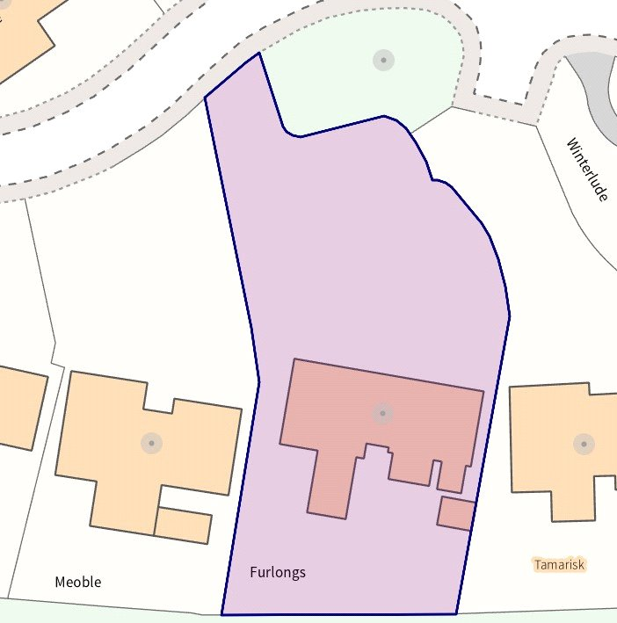
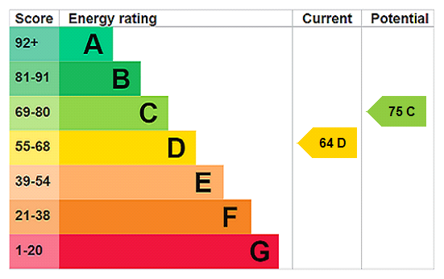
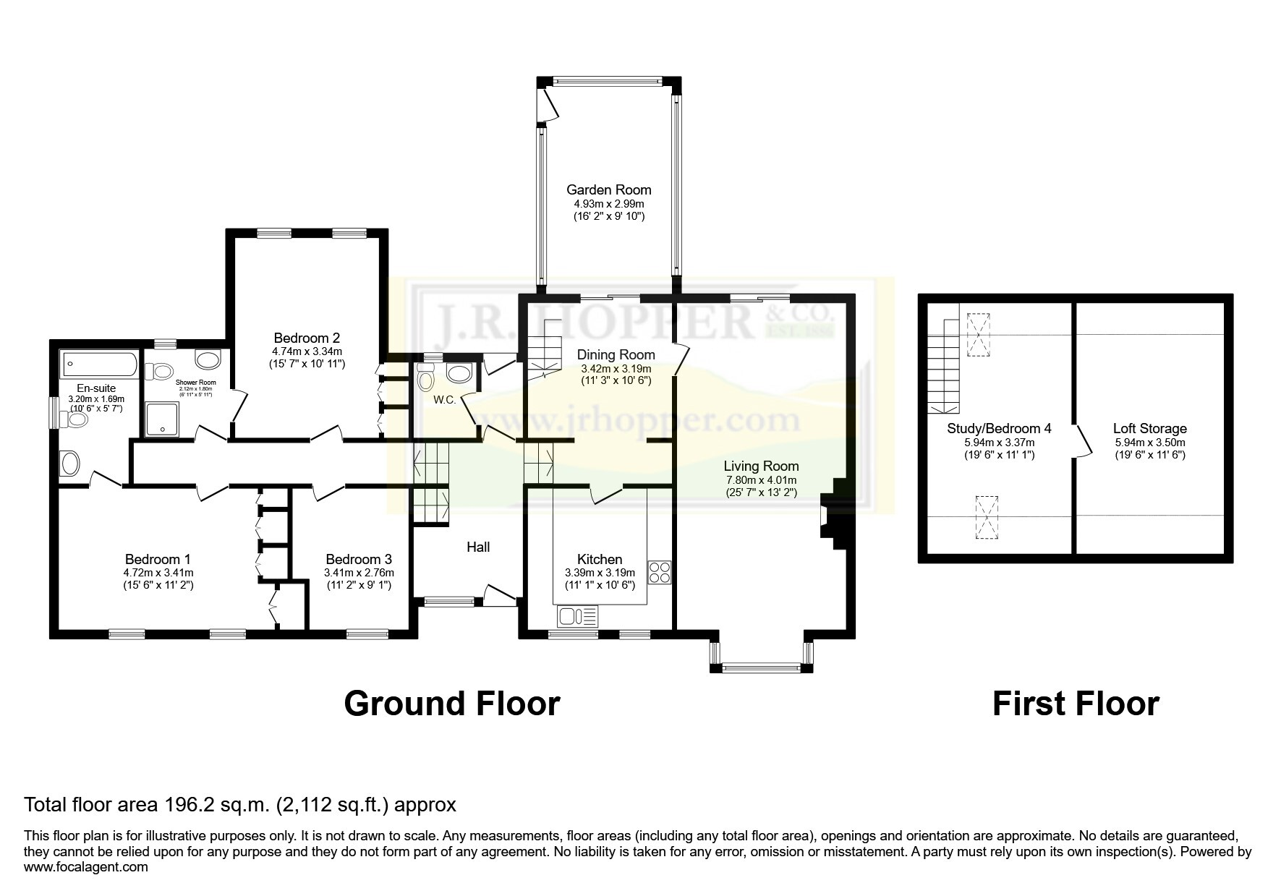
Items in these photographs and tours may not be included in the sale • J. R. Hopper & Co. has not tested services, fixtures, fittings, central heating, gas, and electrical systems. If in doubt, purchasers should seek professional advice • J. R. Hopper & Co, as Agents in the sale of the property will formally check the identification of prospective Purchasers. In addition, the Purchaser will be required to provide information regarding the source of funding as part of our offer handling procedure • Viewings by appointment only.

