
6 The Mount, Leyburn
Rent: £1,200.00 PCM
• Spacious Family Home
• 5 Bedrooms
• Living Room
• Dining Room
• Kitchen
• Utility Room & Ground Floor WC
• Family Bathroom
• Sunroom
• Front & Rear Garden
• Off Road Parking for 1 Small Car
• Gas Central Heating
• Available Now
• Pets Considered
Postcode: DL8 5JA

Deposit: £1,350.00

Council Tax Band: D

Energy Efficiency Band: D

Local & Planning Authority:
North Yorkshire Council

J. R. Hopper & Co. is a trading name for J. R. Hopper & Co. (Property Services) Ltd. Registered: England No. 3438347.
Registered Office: Hall House, Woodhall, DL8 3LB. Directors: L. B. Carlisle, E. J. Carlisle
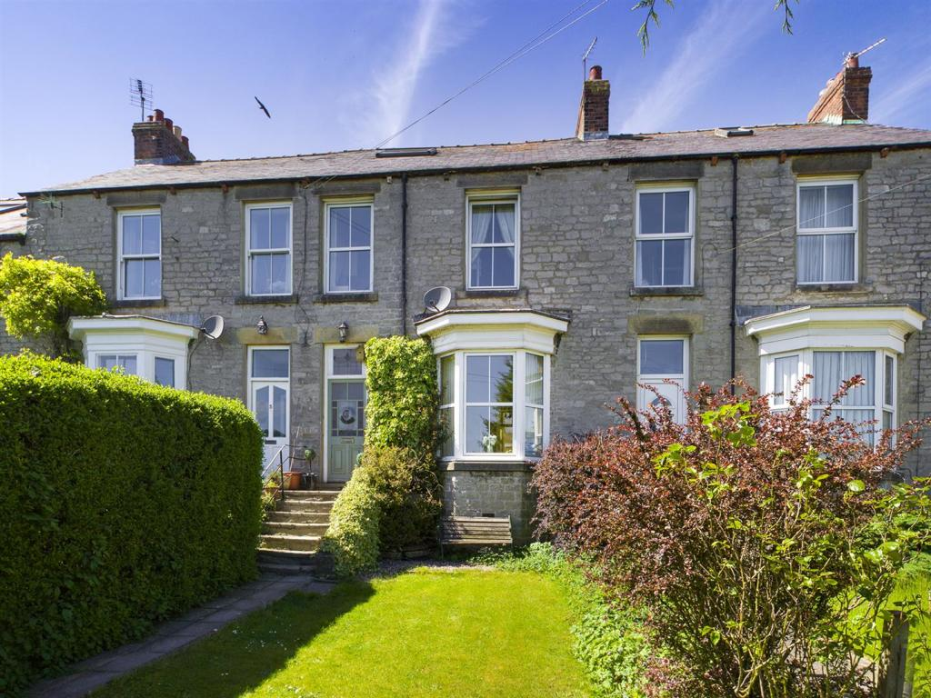
“For Sales In The Dales”
EST. 1886
Central Chambers
Market Place
Leyburn
North Yorkshire
DL8 5BD
Leyburn
Hawes
Settle
Kirkby Stephen
01969 622936
01969 667744
01729 825311
01768 258002
& Co.
www.jrhopper.com enquiries@jrhopper.com
J.R. HOPPER
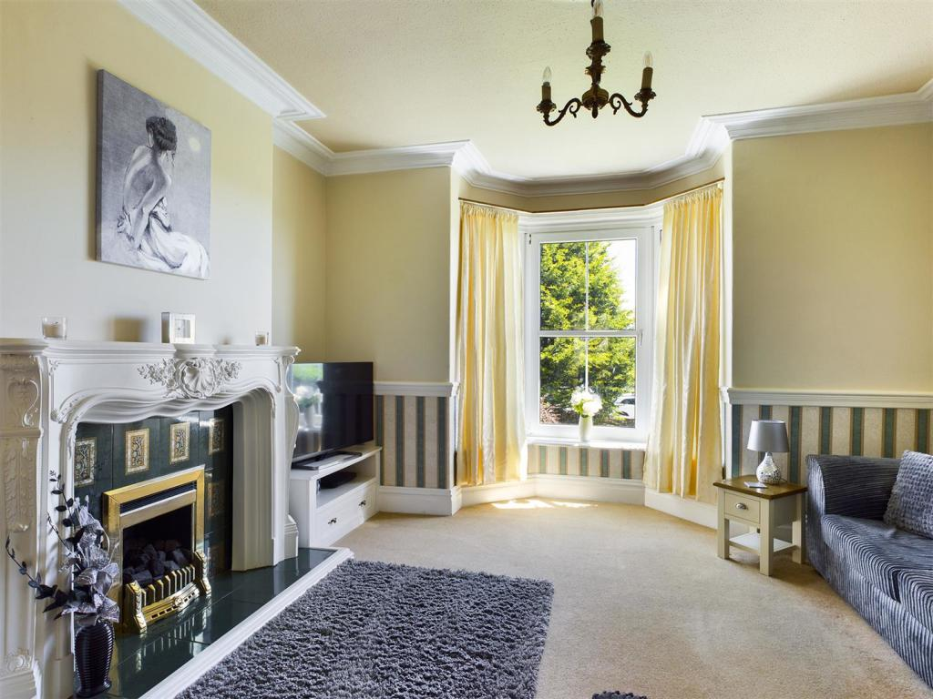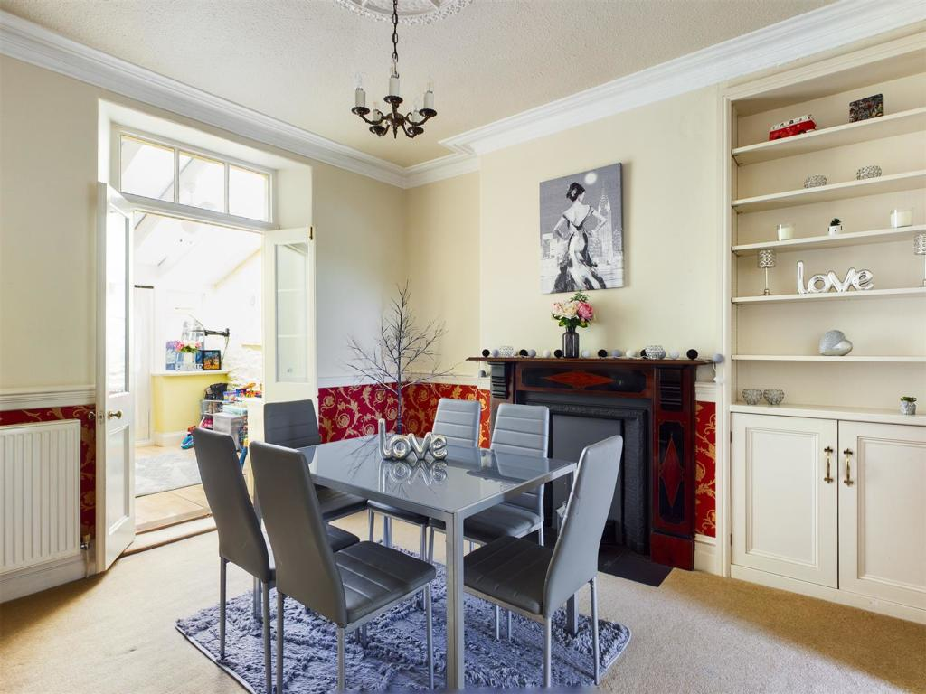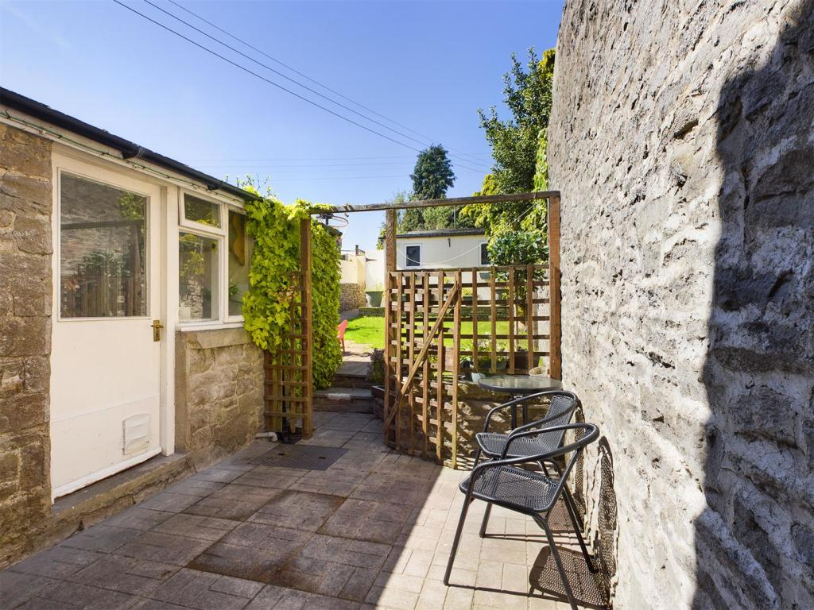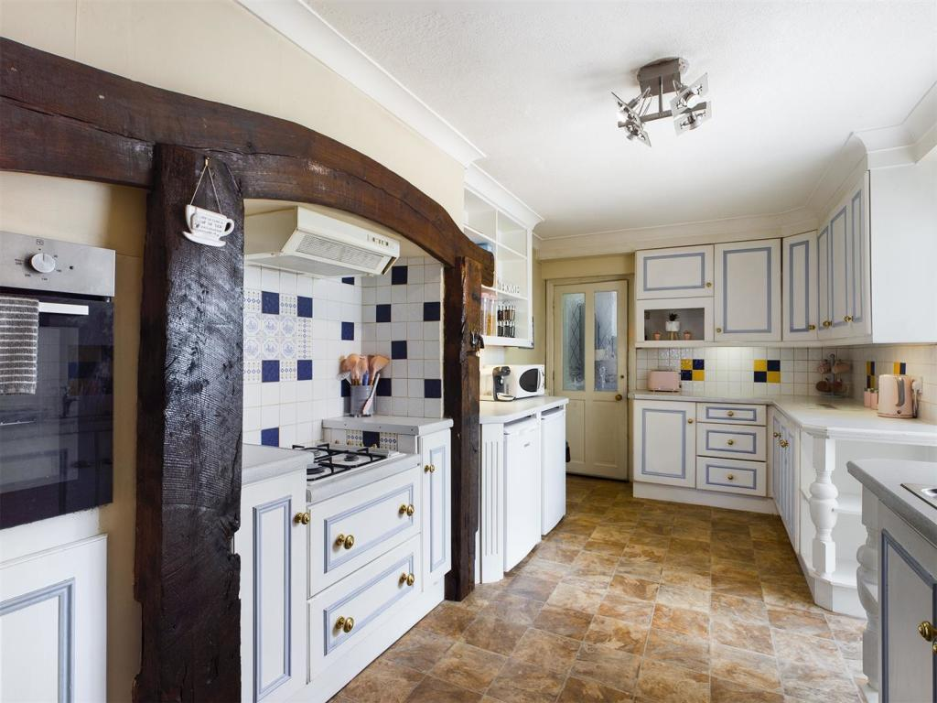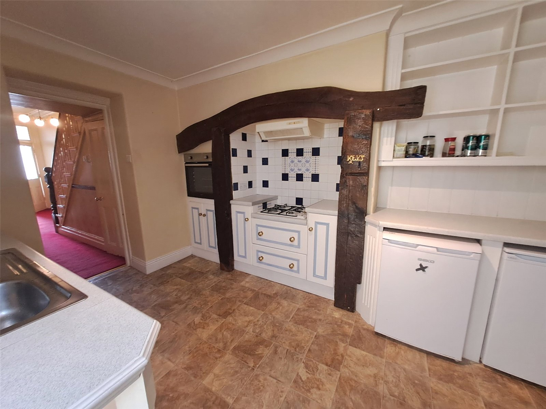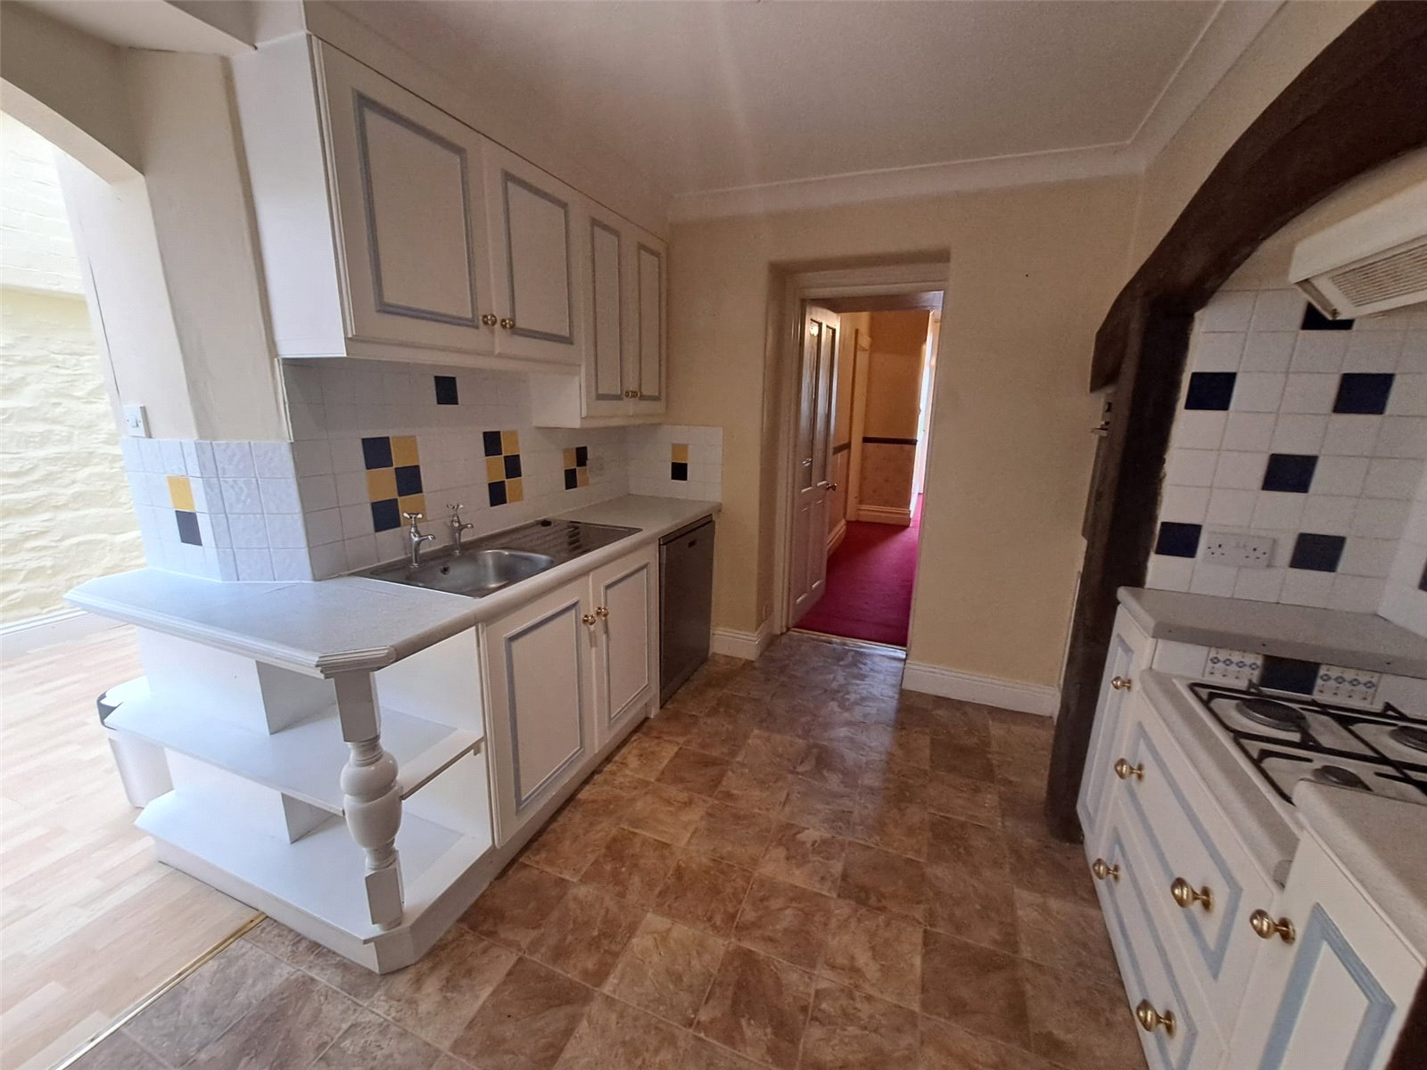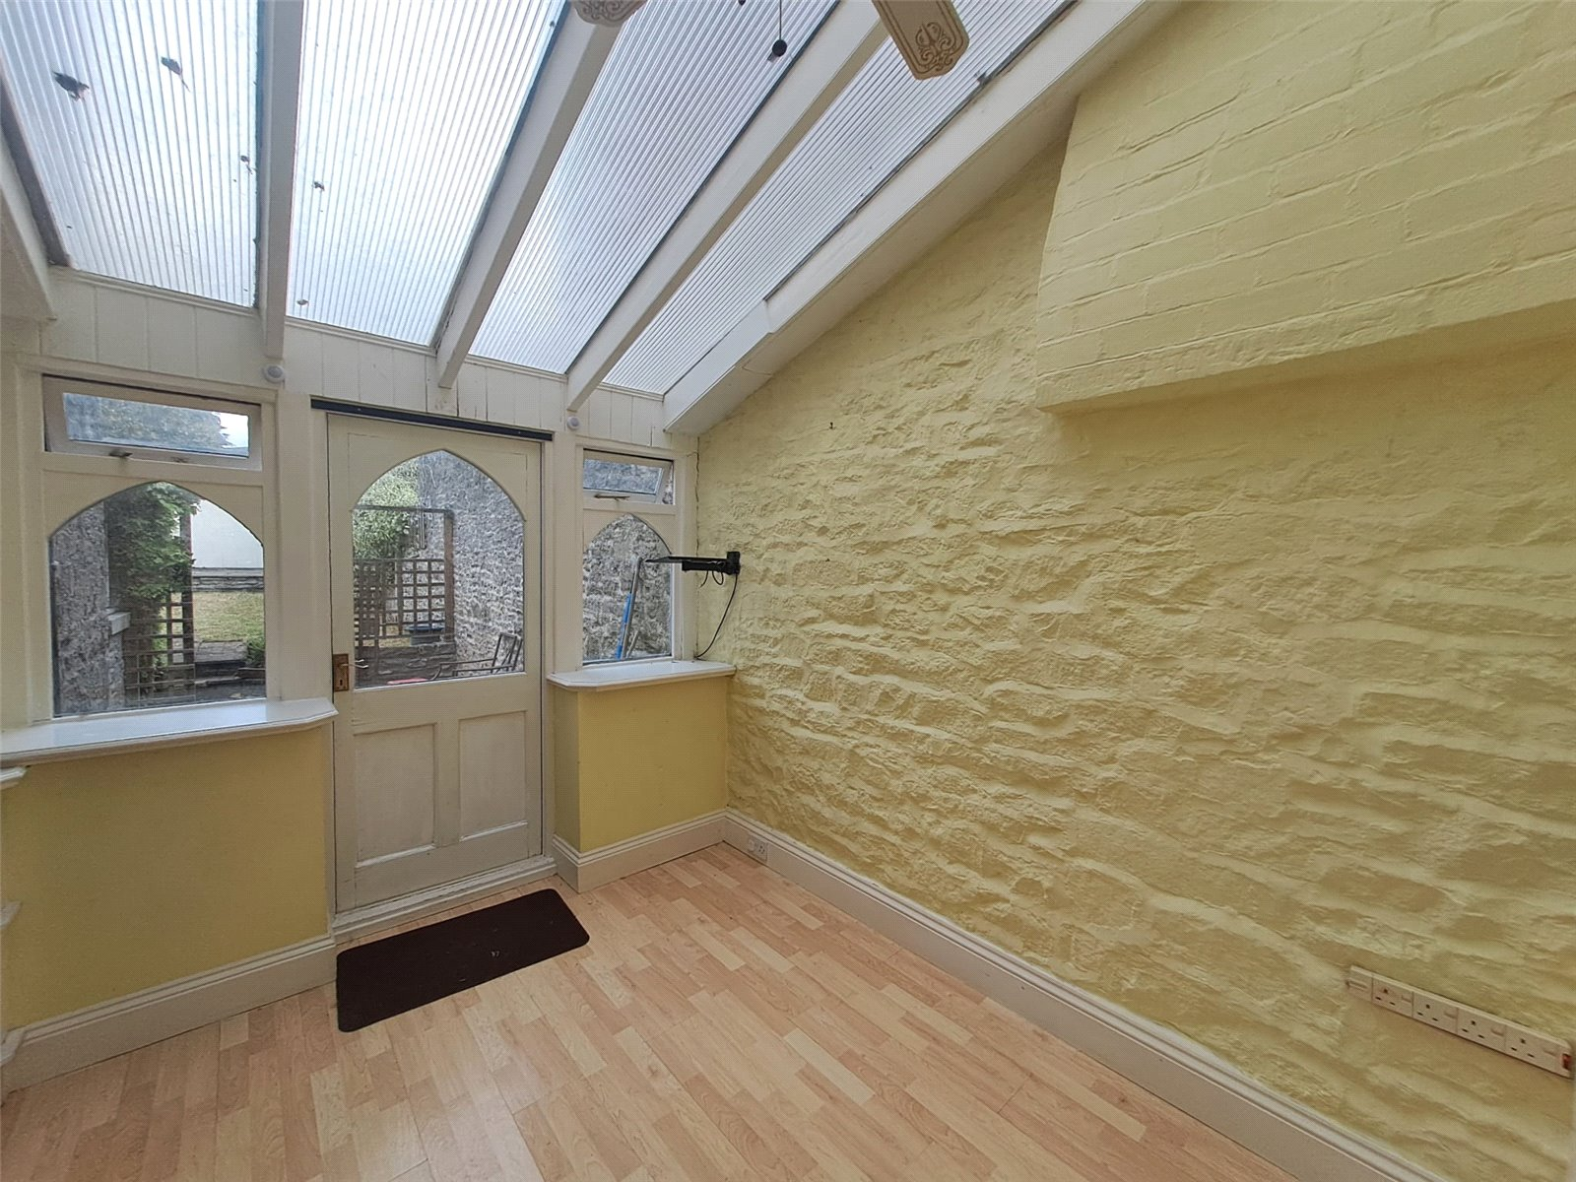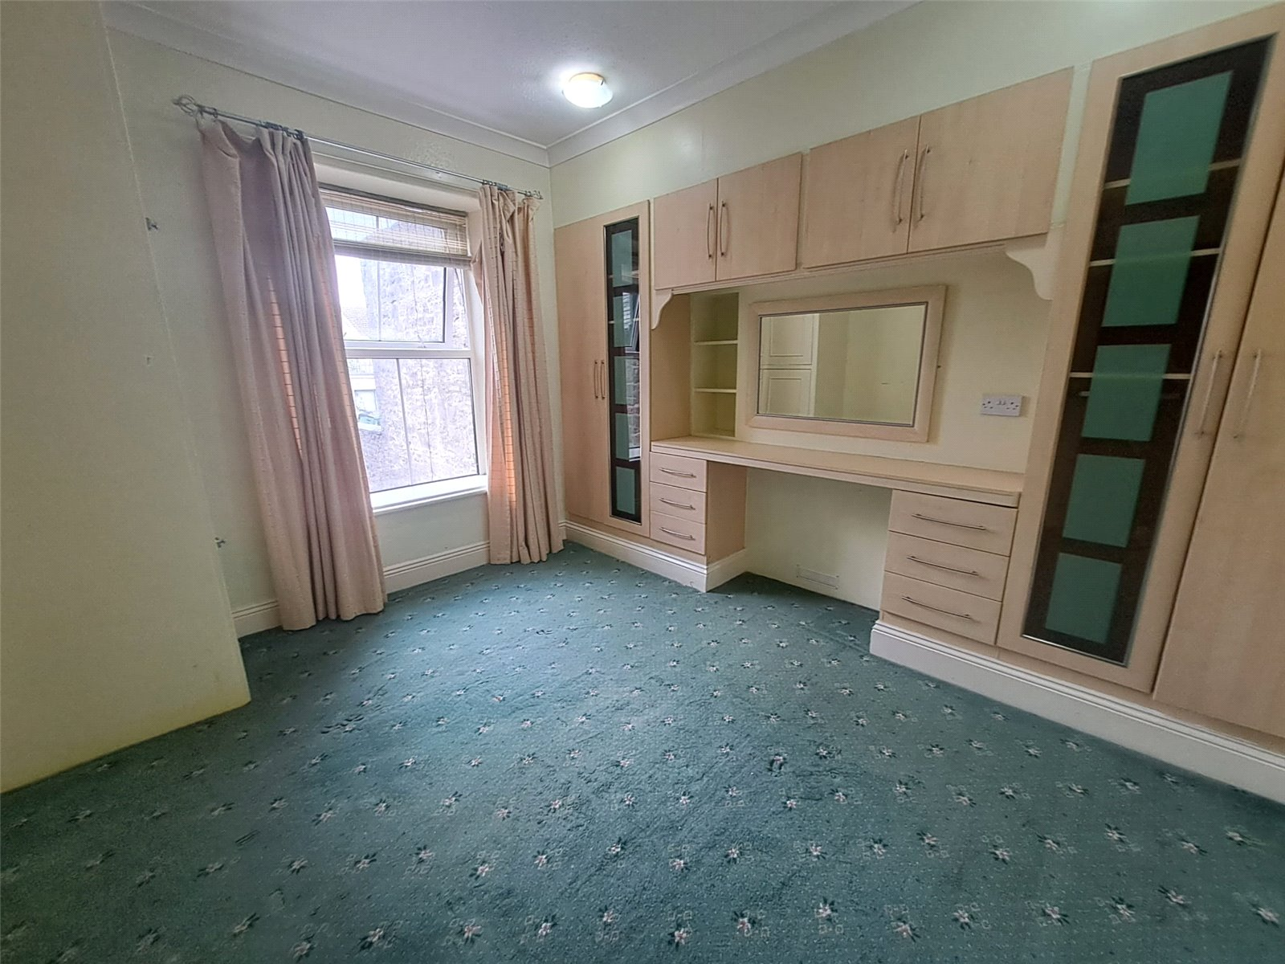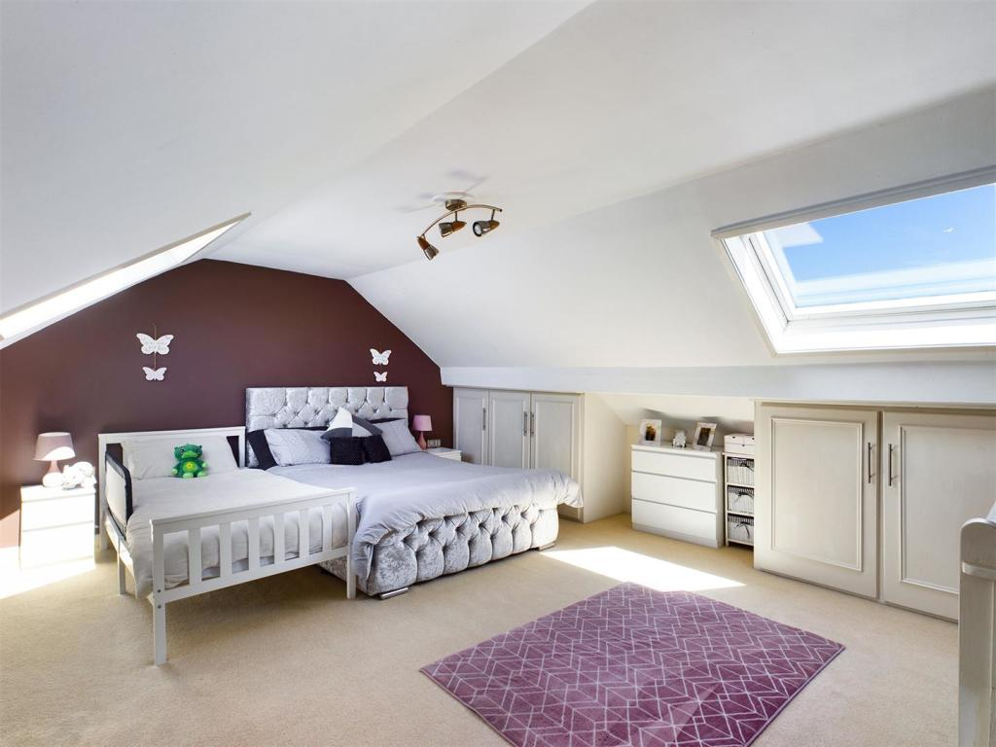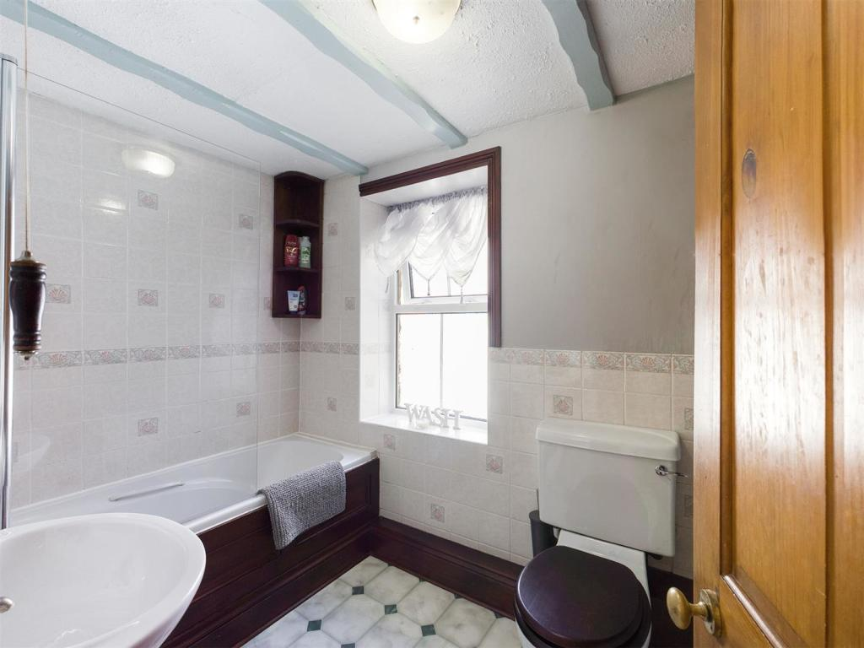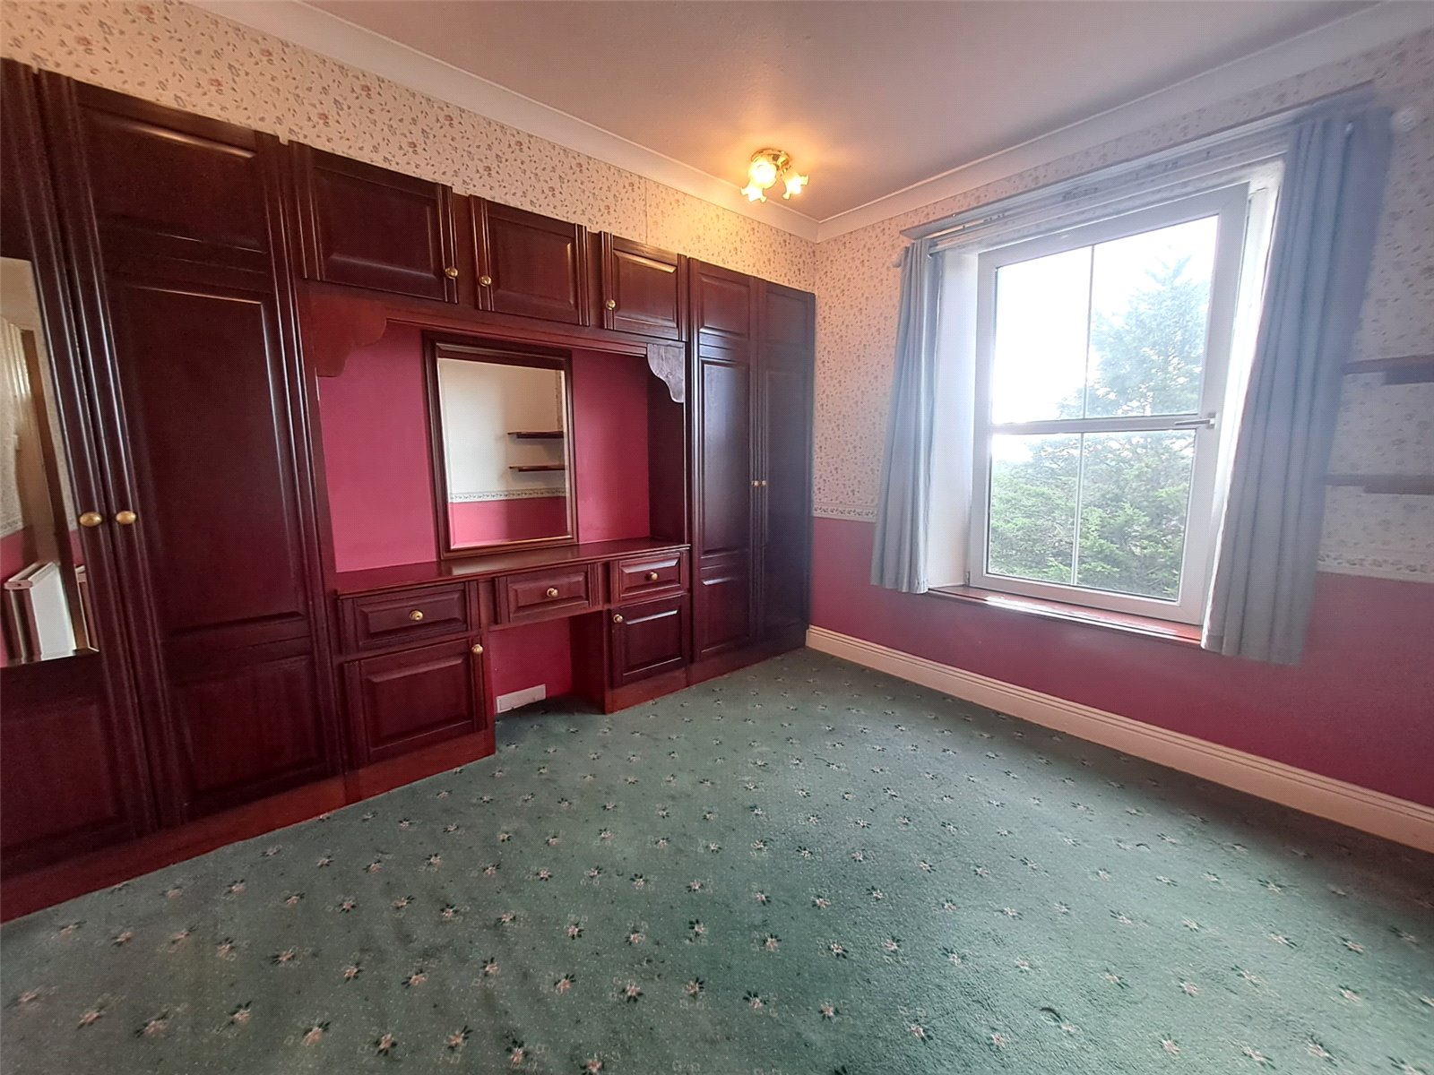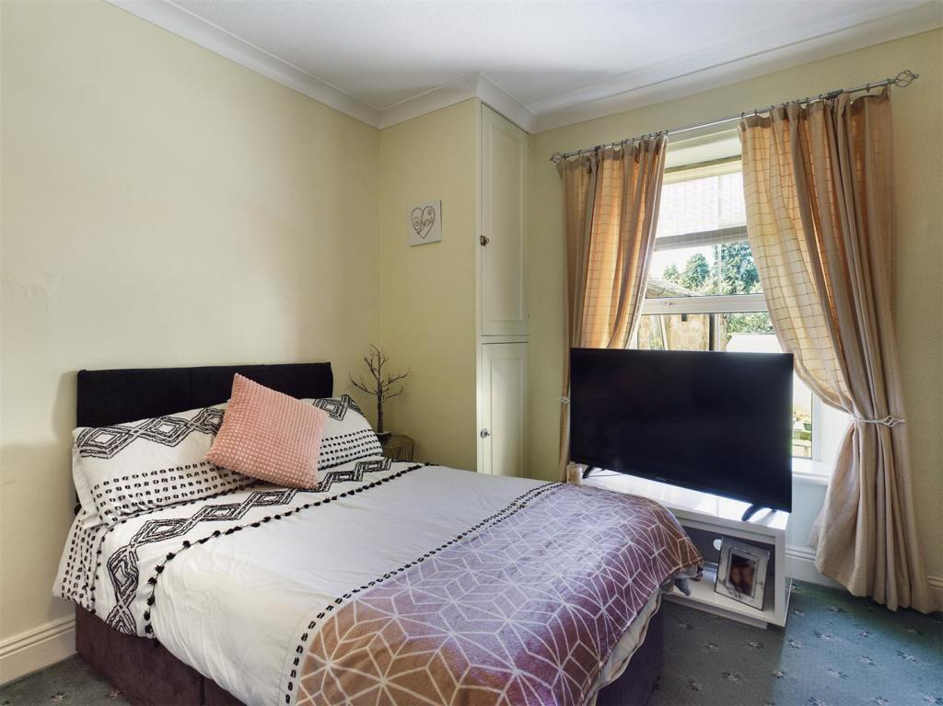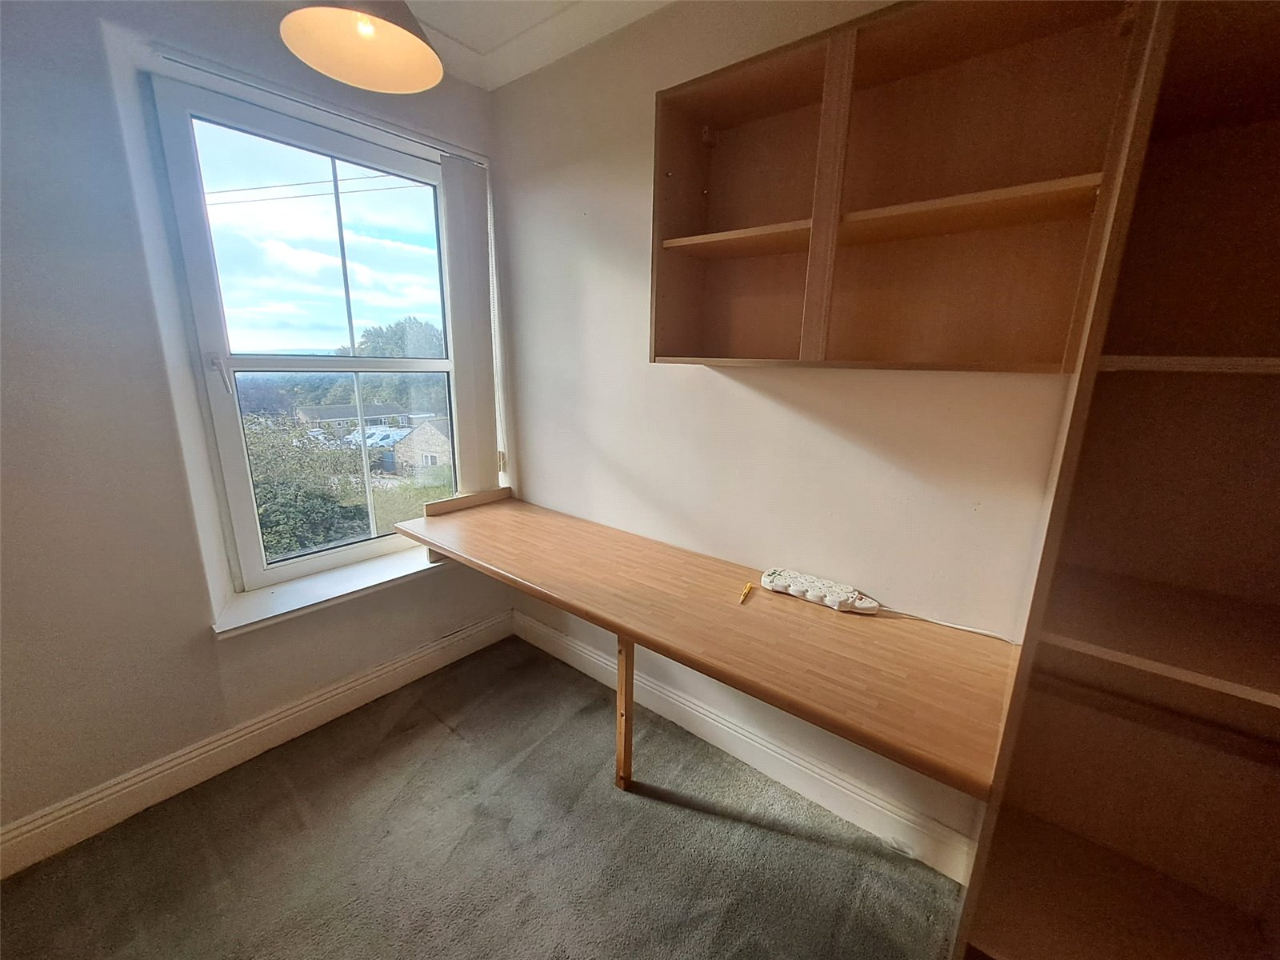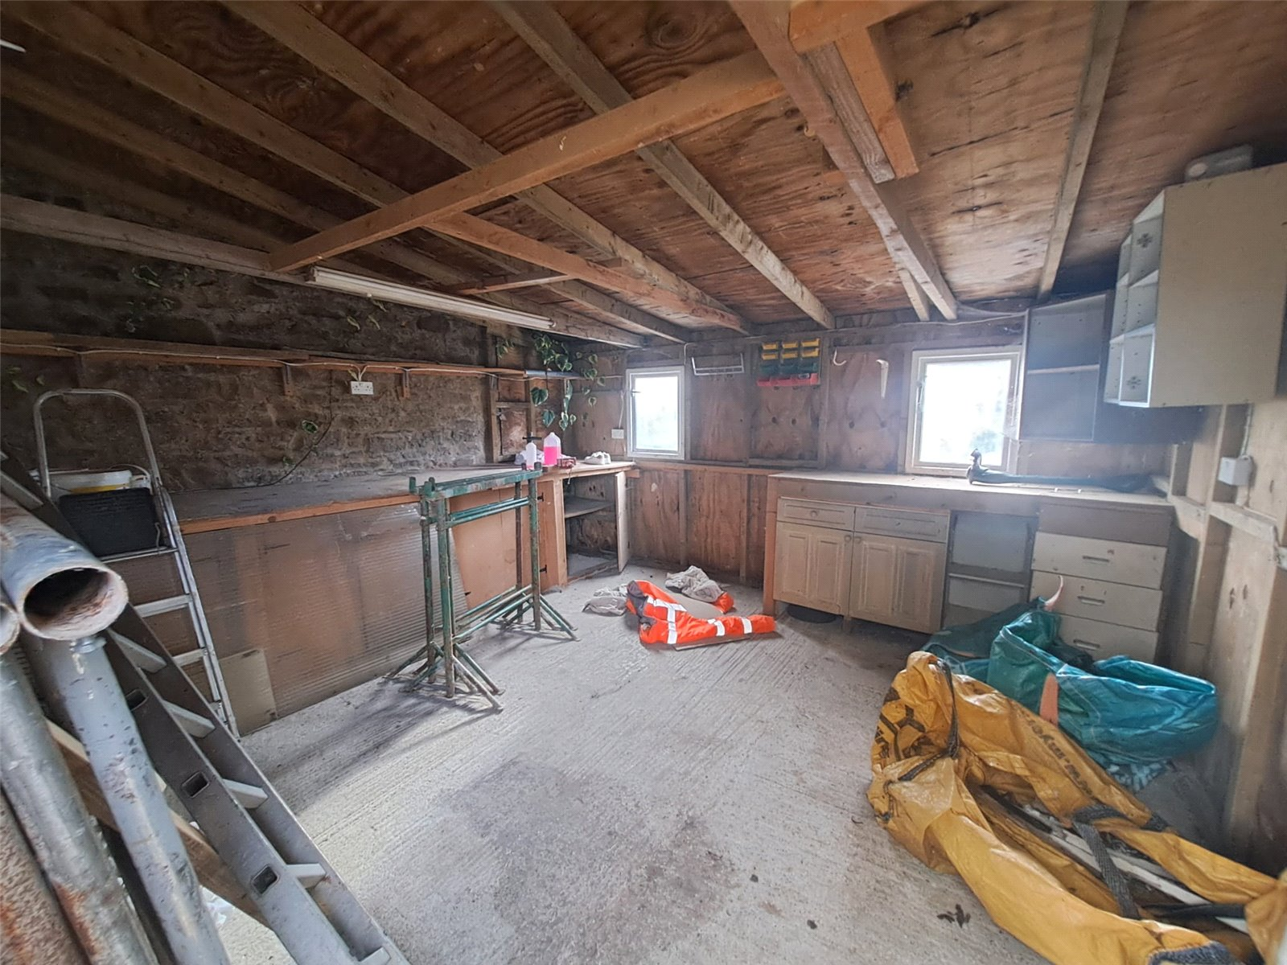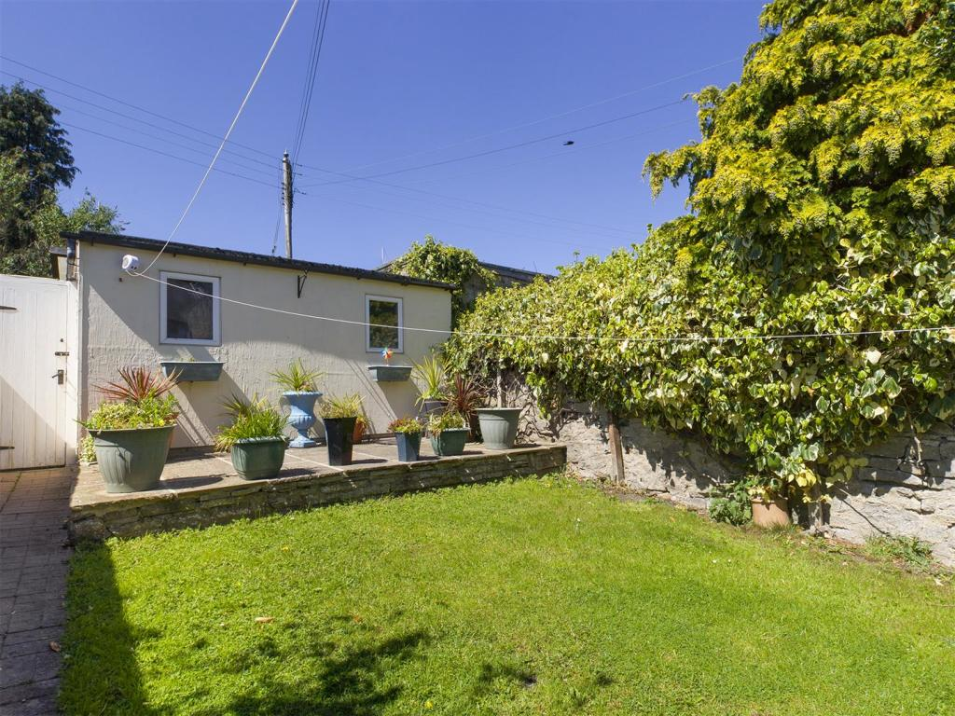
6 The Mount is a spacious and characterful family home set in the heart of Leyburn, just a short walk from local schools, shops, and all the amenities of this thriving market town.
Leyburn offers an excellent community atmosphere with a range of shops, pubs, churches, schools, and sports facilities, as well as convenient access to Richmond, Bedale, the A1, and the stunning Yorkshire Dales.

This attractive three-storey period home provides generous living space throughout. The ground floor features a welcoming entrance porch and hallway, spacious lounge and dining room, bright sunroom flowing into the kitchen and a practical utility room with ground floor WC.

The first floor offers 3 double bedrooms and a house bathroom. The fourth room would make a good single bedroom or ideal home office. The attic has also been converted to make a super double bedroom.
The property is heated by mains gas central heating and is double glazed throughout.

Externally, to the front of the property is a laid to lawn garden, with stone flagged path leading to the front door. To the rear of the property there is a terraced courtyard garden, useful workshop and a carport providing off-road parking for 1 small vehicle.

Ground Floor

Porch & Hallway Fitted carpet. Coved ceiling. Radiator. Understairs cupboard.

Living Room Spacious front room. Fitted carpet. Coved ceiling. Ceiling rose. Radiator. built in TV cupboard. Fireplace, with gas fire. Bay window to front overlooking garden.

Dining Room Spacious dining room. Fitted carpet. Coved ceiling. Ceiling rose. Radiator. built in alcove shelved units. Feature fireplace.

Sunroom Light sunroom. Laminate flooring. Radiator. Shelves. Door to rear garden.

Kitchen Tiled effect vinyl flooring. Range of wall and base units. Stainless steel sink. Undercounter fridge and freezer. Free standing dishwasher. Built in oven, gas hob and extractor hood. Radiator.

Utility Room & WC Useful utility room. Range of units with Belfast sink. Plumbing for washing machine. Wall mounted gas boiler.
Separate WC. Wash basin. Frosted window to rear. Back door to rear patio.

First Floor

Stairs & Landing Fitted carpet. Split landing. Coved ceiling. Built in storage cupboard.

Bedroom1 Front double bedroom. Fitted carpet. Coved ceiling. Built in wardrobes and drawers. Radiator. Window to front with lovely views.

Bedroom 2 Middle double bedroom. Fitted carpet. Coved ceiling. Built in wardrobes and drawers. Radiator. Window to rear.

Bedroom 3 Front single bedroom or home office. Fitted carpet. Coved ceiling. Fitted worktop. Radiator. Window to front with lovely views.

Bedroom 4 Rear double bedroom. Fitted carpet. Coved ceiling. Radiator. Window to back.

Bathroom Vinyl flooring. Bath with electric shower over. WC. Wash basin. Wall mounted cupboards. Frosted window to side.

Second Floor

Bedroom 5 Large attic room. Fitted carpet. Built in wardrobes and drawers. Electric radiator. 2 large bay windows.

Outside

Front Laid to lawn garden, with stone flagged path. Steps up to front door

Rear Flagged patio area. Laid to lawn garden with raised patio.

Workshop Large workshop with power and light.

Parking Off road parking for space for 1 small car, in rear carp port.

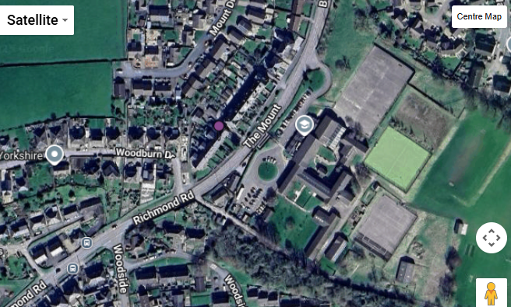
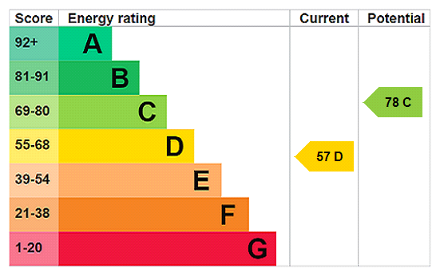
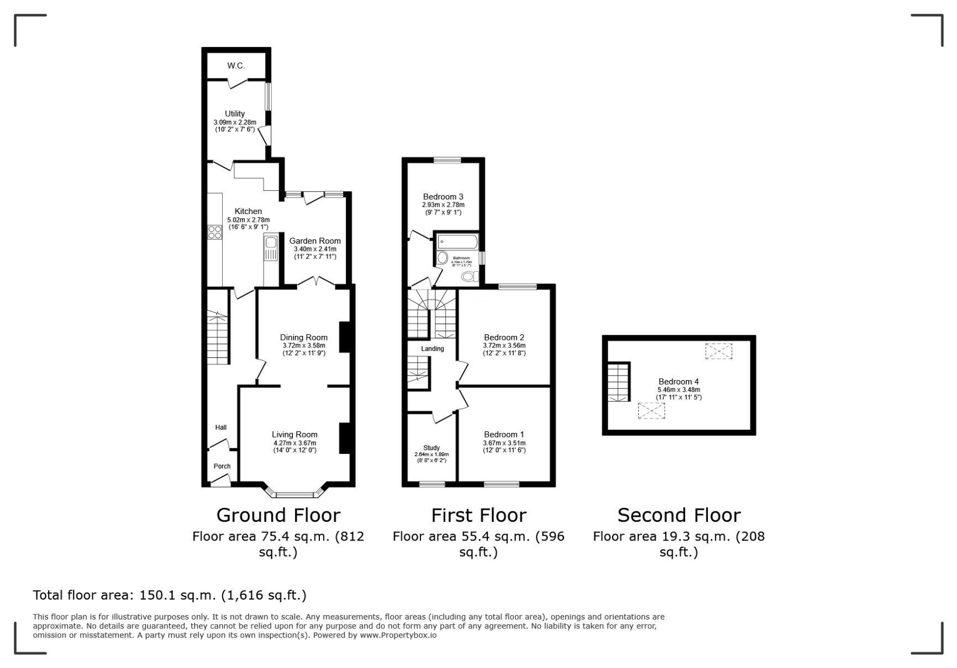
Assured Shorthold Tenancy • Pets Considered • No smoking • No subletting • Photographed items may not be included • Viewings by appointment only • Deposits held with the Landlord in an Insured Scheme • No interest payable on bonds • Referencing requires: holding deposit; gross household income of 2.5x the rent; ID; Proof of Address, Employment & Income; Character & Landlord References • Landlord reserves right to refuse entering into any Lease Agreement • Application procedure in full at jrhopper.com/tenants

