
• Versatile Retail Premises in Prime Location.
• Close To Town Centre.
• Large Ground Floor Space with Separate Office.
• Kitchen Area. • WC.
• Suitable for a Variety of Businesses.
• Good Footfall Area.
• Flexible Layout Options.
• Well-Maintained Interior. • Good Natural Light.
• Easy Access for Customers and Deliveries.
• Competitive Rent Terms Available
• Viewing Recommended. • Available To Let Now
Postcode: DL8 5AW

Deposit: £1200.00

Council Tax Band: TBC

Energy Efficiency Band: D

Local & Planning Authority: North Yorkshire Council

Rent £600.00 PCM
2 Kelberdale Court, Market Place, Leyburn
J. R. Hopper & Co. is a trading name for J. R. Hopper & Co. (Property Services) Ltd. Registered: England No. 3438347.
Registered Office: Hall House, Woodhall, DL8 3LB. Directors: L. B. Carlisle, E. J. Carlisle
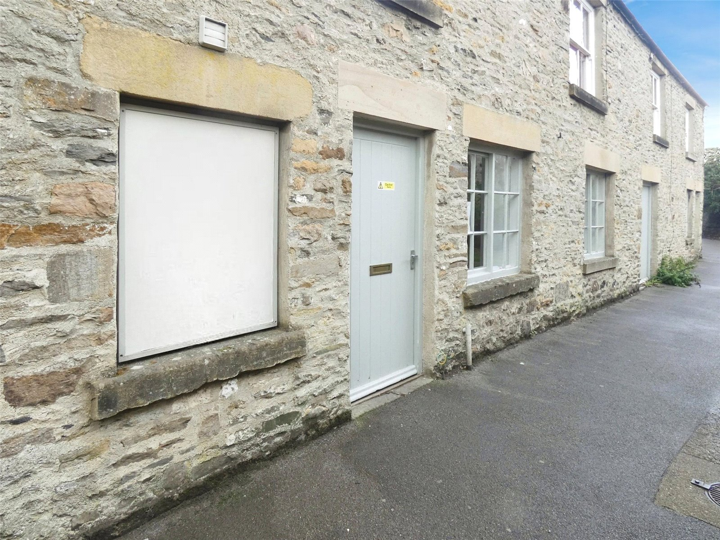
“For Sales In The Dales”
EST. 1886
Central Chambers
Market Place
Leyburn
North Yorkshire
DL8 5BD
Leyburn
Hawes
Settle
Kirkby Stephen
01969 622936
01969 667744
01729 825311
01768 258002
& Co.
www.jrhopper.com enquiries@jrhopper.com
J.R. HOPPER
Prime Retail Opportunity in the Heart of Leyburn – 2 Kelberdale Court

An excellent opportunity to lease a well-proportioned retail premises ideally situated just a short distance from the vibrant centre of Leyburn, a popular and bustling market town in the heart of Wensleydale.

Leyburn offers a thriving local community and an array of amenities including a variety of independent shops, cafés, pubs, and restaurants. The town also features reputable schools, churches, a medical practice, and leisure facilities such as sports grounds and children’s play areas. A traditional outdoor market takes place every Friday, and the well-known Tennants Auctioneers is located nearby. The property enjoys excellent transport links, providing easy access to Richmond, Bedale, Northallerton, and the A1.

The premises comprises a large, light-filled main room, ideal for retail or a variety of alternative commercial uses. In addition, there is a separate smaller room suitable for use as an office or treatment space, along with a kitchen area and WC facilities.

2 Kelberdale Court offers versatile accommodation and would suit a wide range of business ventures. Early viewing is highly recommended to appreciate the potential this property offers.

Ground Floor Retail Premises

Shop Large open space, ideal retail or office space. Laminate wooden flooring. 2 Windows to front. Entrance door to front. Double doors to front.

Office Private office. Laminate wooden flooring. Window to front.

Kitchen Laminate wooden flooring. Base units. Worktop with stainless steel sink and drainer.

WC Laminate wooden flooring. WC. Washbasin. Window to front.

Services
Broadband: Basic17 Mbps, Superfast97 Mbps

Flood Risk: Noted as very low. No history of flooding.

Agent Notes

Lease terms are negotiable.
The ingoing tenant will be required to undergo the necessary credit checks, at a cost of £60.00
The tenant should contribute to the legal costs associated with drawing up the lease, up to £1,000.00

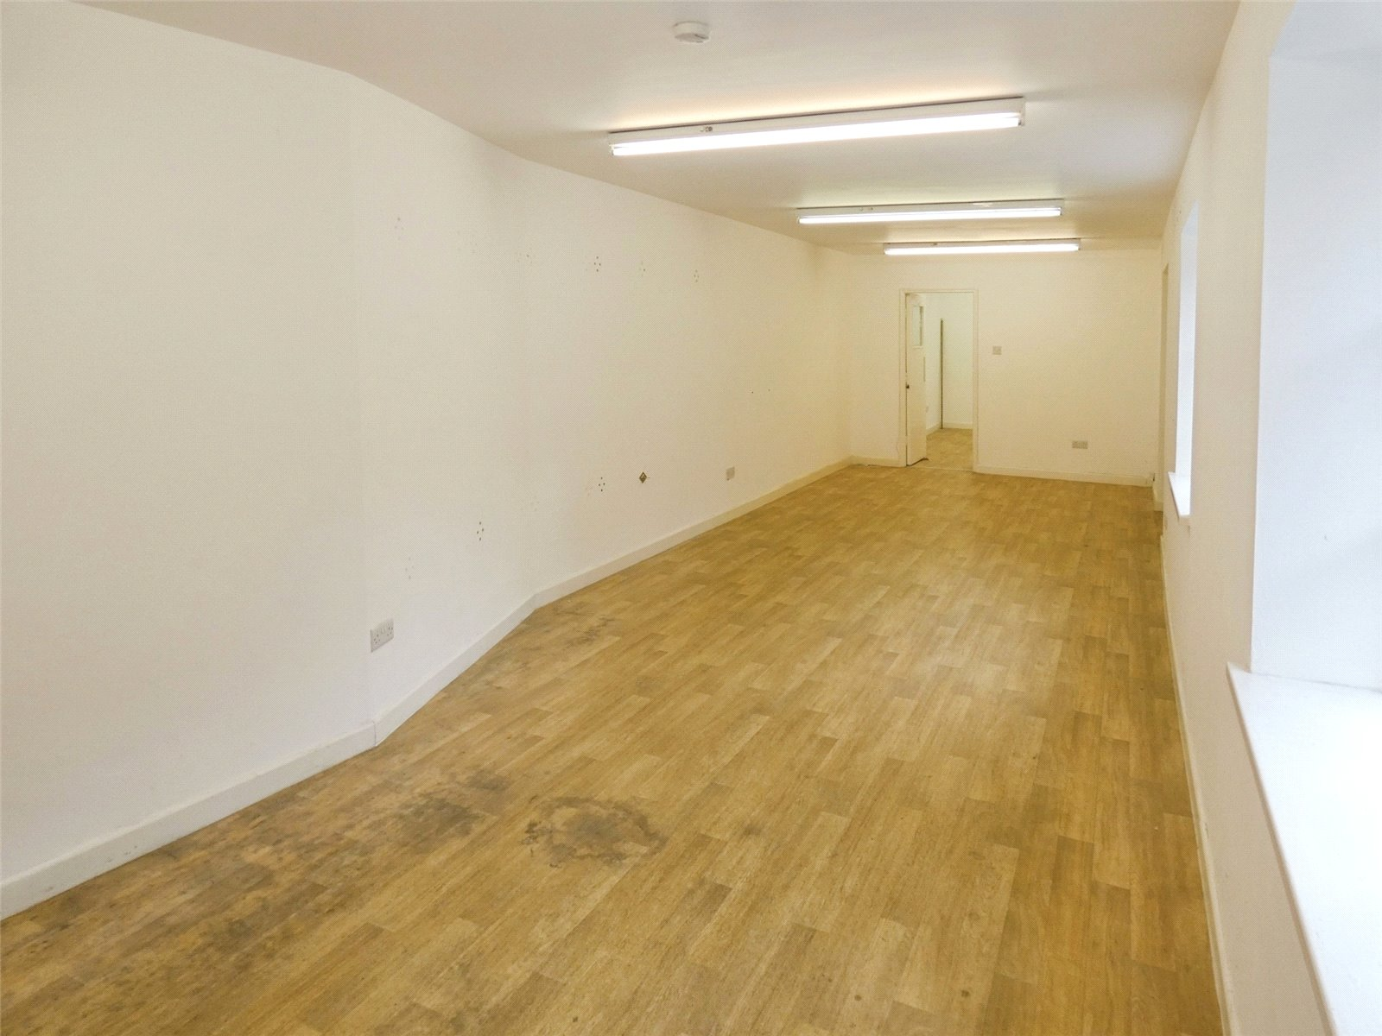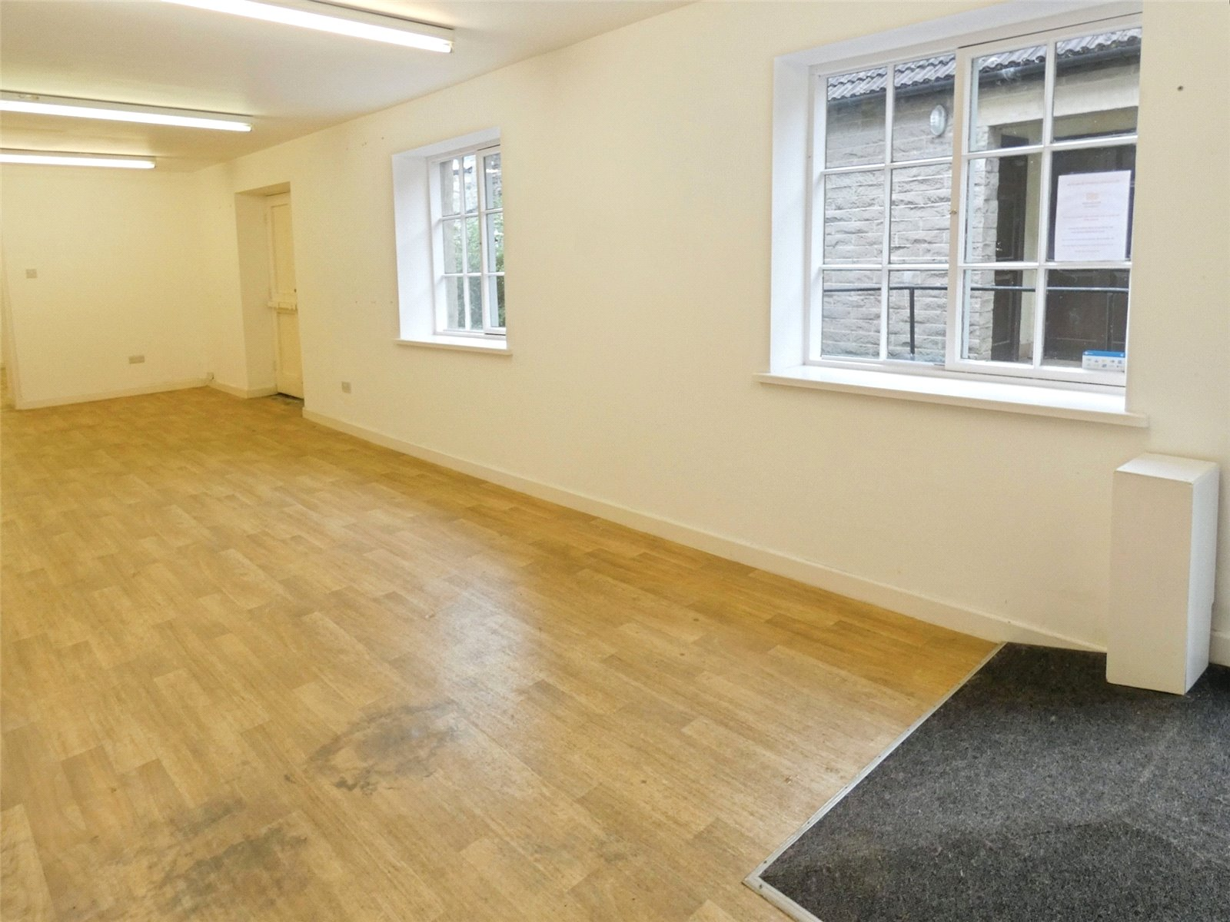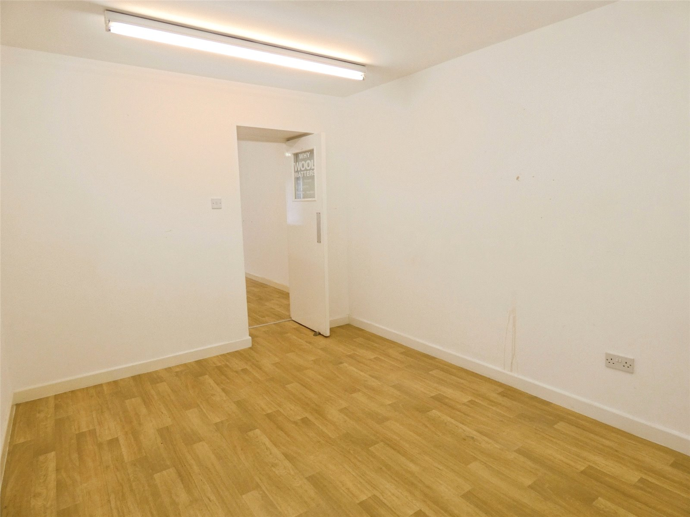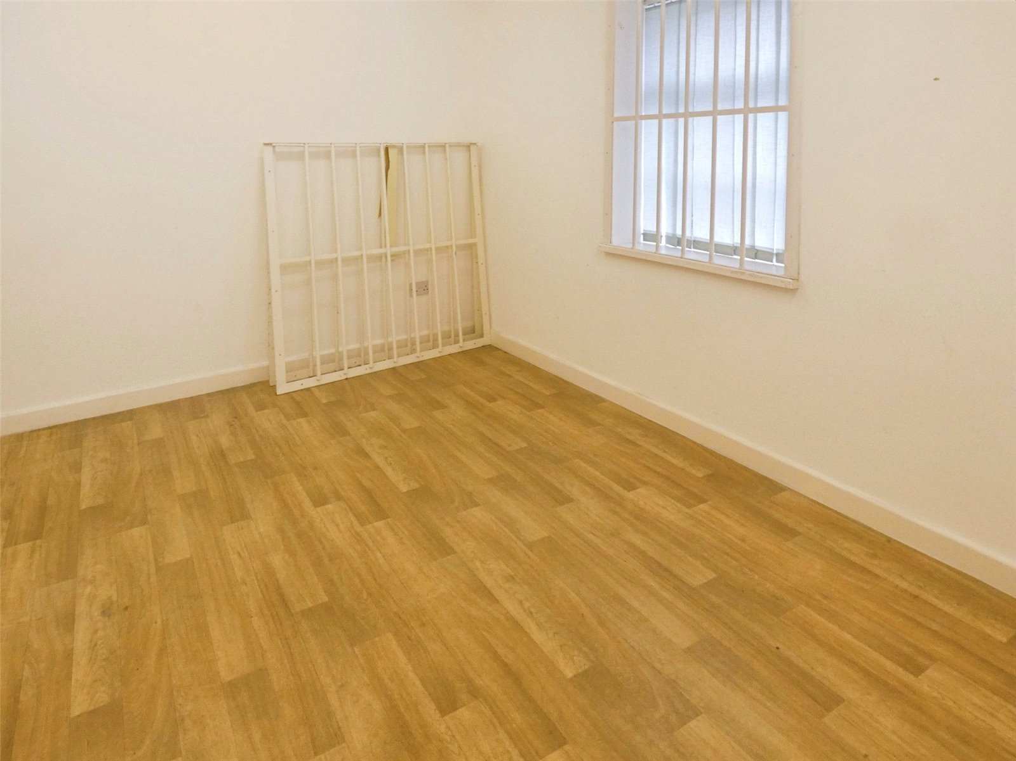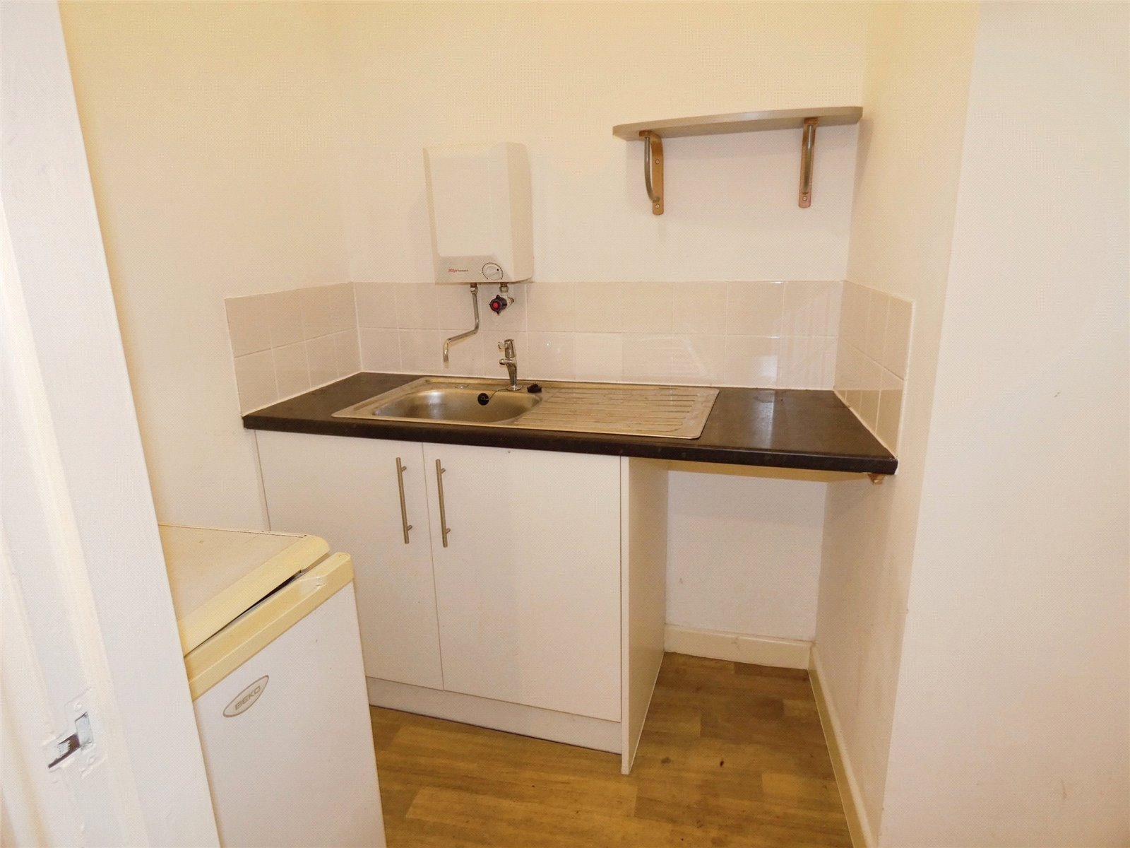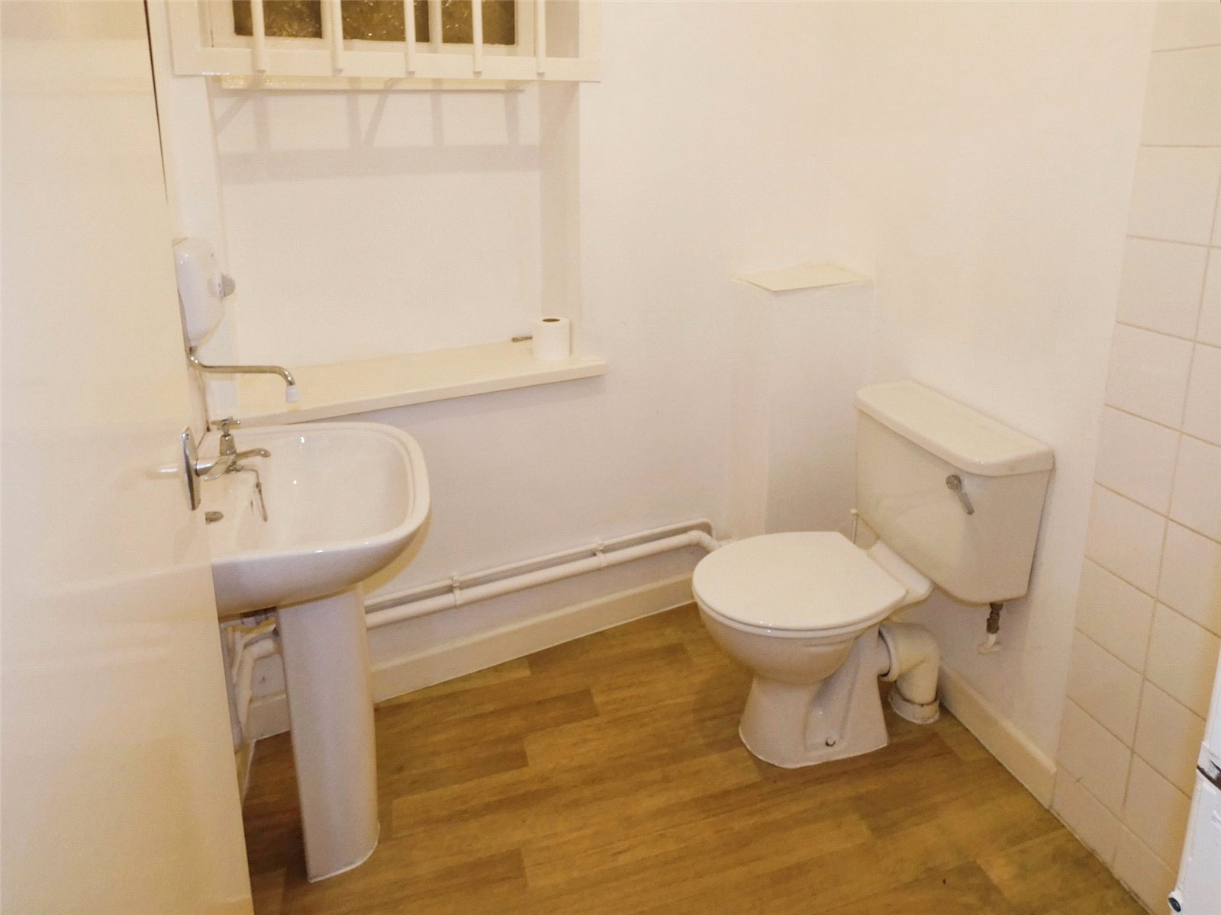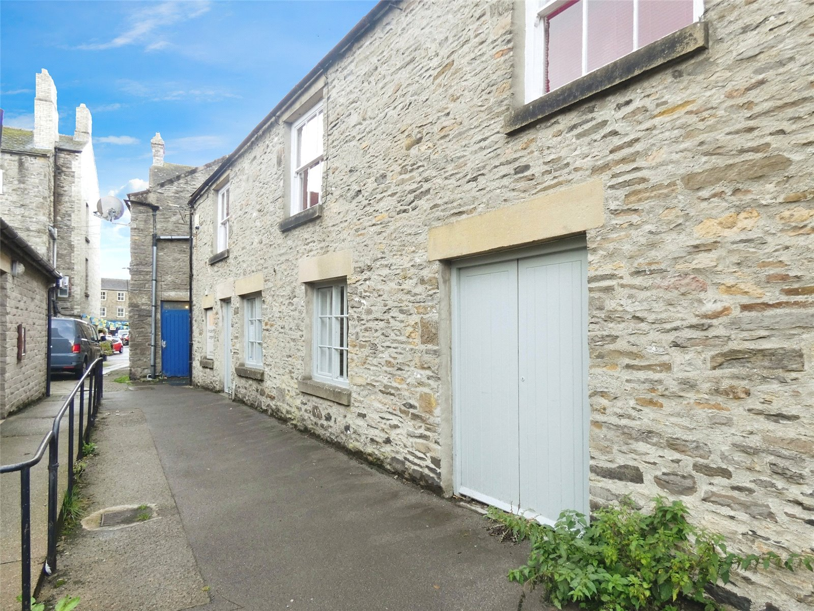
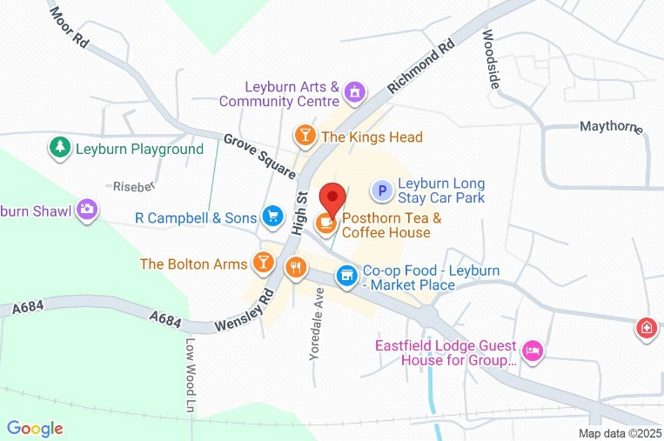
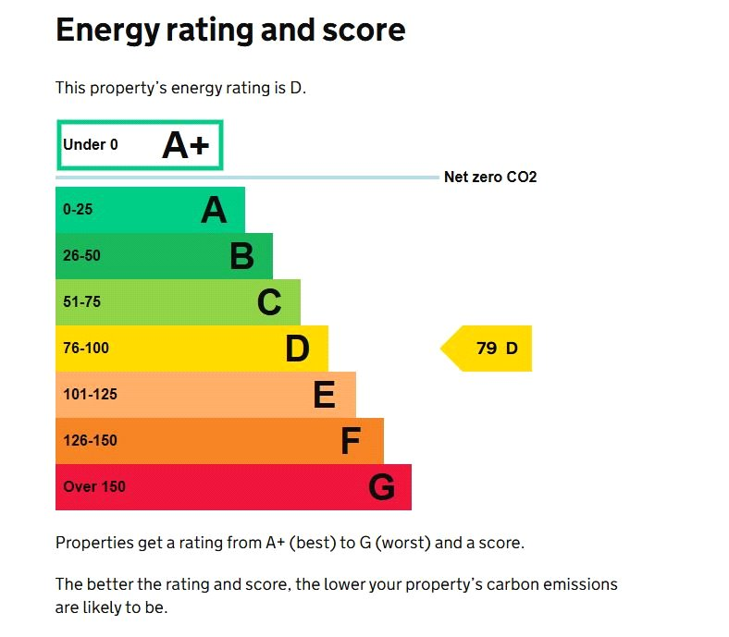
Assured Shorthold Tenancy • No pets • No smoking • No subletting • Photographed items may not be included • Viewings by appointment only • Deposits held with the Deposit Protection Service • No interest payable on bonds • Referencing requires: holding deposit; gross household income of 2.5x the rent; ID; Proof of Address, Employment & Income; Character & Landlord References • Landlord reserves right to refuse entering into any Lease Agreement • Application procedure in full at jrhopper.com/tenants

